1997
January 10th 1997
19.- Members of the Foundation and APAR Association celebrated the International Day of Religions with a Group Prayer Week. The Week started from the Lutheran Church and continued each day in other church. A press conference took place.

January 16th 1997
20.- A conference day has been organized entitled “International Day of Religions” for stirring sensitivity of the mass media and press representatives towards the importance of the inter-religious project, and better understanding and peace between people, ethnics and religions.
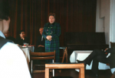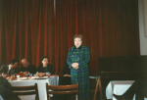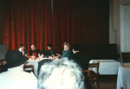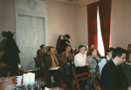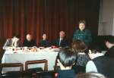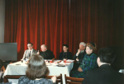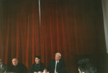

January 23rd 1997
21.- To the seat of the Foundation a members meeting was organized. The participants debated the 2007 activity projects, and the organization of a religious creation festival in May.

March 7th 1997
22.a.-With the occasion of the “International Day of Prayer” a joined prayer was organized at the Lutheran Church, entitled “As the seed becomes the tree”, followed by a word of peace from the representatives of religions. Ms. Marcela Ghiulbenghian, President of FAPTE Association, Sacred Treasure Foundation and Peace of Romanian Religions Association, Ft. Univ. Prof. Dr. Alexandru I. Stan and APAR members were invited to participate.

22.b.- Ms President of the Women’s Association Godeanu invited Ms. Marcela Ghiulbenghian, to see the Pitesti Pyramids. Here, Mrs. Marcela met Ft. Prof. Onu Constantin, the creator of Grigore Parma Foundation, who named her Vice President of his Foundation.

April 5th 1997
23- After a membership meeting, the A.P.A.R. administration council called by Ms. Marcela Ghiulbenghian, President of FAPTE Association, Sacred Treasure Foundation and Ft. Univ. Prof. Dr. Alexandru I. Stan decided the publication of a “religionum PAX”: an informative paper with all reMr.etter days of various cults, and summary of the Sacred Treasure Foundation’s Events and actions.

April 10th 1997
24.- A press conference has been held regarding the Religious Creation Festival due in may 1997 organized by Ms. Marcela Ghiulbenghian, President of FAPTE Association, Sacred Treasure Foundation. High figures like Minister of Cults, A.P.A.R. and Foundation members, various religions representatives, press and Media attended the conference.

May 8th – 20th 1997
24.a.- The jury deliberation of the “Thine is the Kingdom and the Power ” Festival artistic programs took place. For two weeks the deliberation process has been made along various religions and ethnics representatives.
In the musical jury structure we find: Ft. Orthodox Constantin Dragusin, Mr. Ioan Serbu, Mr. Carpanceanu Stefan, composer Duru Popovici, Ms. Dr. Univ. Prof. composer Mihaela Vozganian, Mr. Ion Tugui, Father Albu Zoltan Zagoni, Mr. Cati Camil, Mr. director Gall Eugen, Mr. Constantin Popescu, Mr. Izu Gott.
In the art jury structure we find: the president of the jury Mr. Parizescu Vasile, Mr. Liviu Tudor Samuila, Mr. Albert Poch, Mr. Gheorghita Alexandru, Mr. Daradici, Mr. Augustin Constantinescu, Mrs. Mala Beldiman Zamfirescu, Mr. Constantin Dumitru, Mr. Lupu Topciu.

May 22nd 1997
25. - “Yours is the Kingdom and Power” Religious Creative Festival and the awards were held at the Children’s Palace. The awards were reserved for the following fields:
-religious musical composition
-religious musical rendition
-religious literary creation
-religious literary interpretation
-religious fine arts
To the Festival, the children awarded for the religious musical creation and interpretation contest performed and sang the winning peaces. The religious literary creations and interpretations were also recited and awarded. Prizes were also given to the winners of the paintings contest.
Ana Maria Covaser and Valentin Ionescu hosted the show.
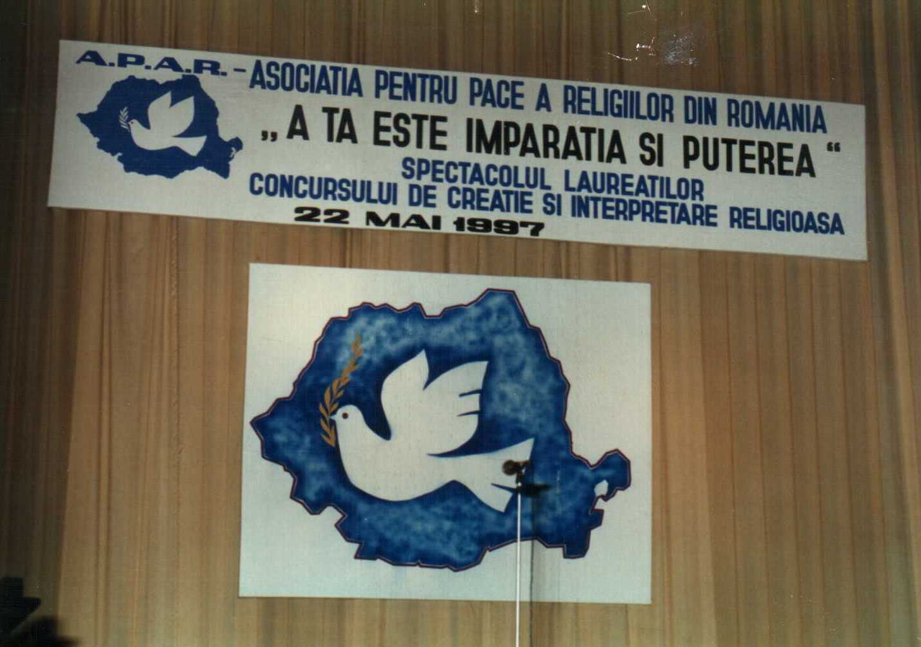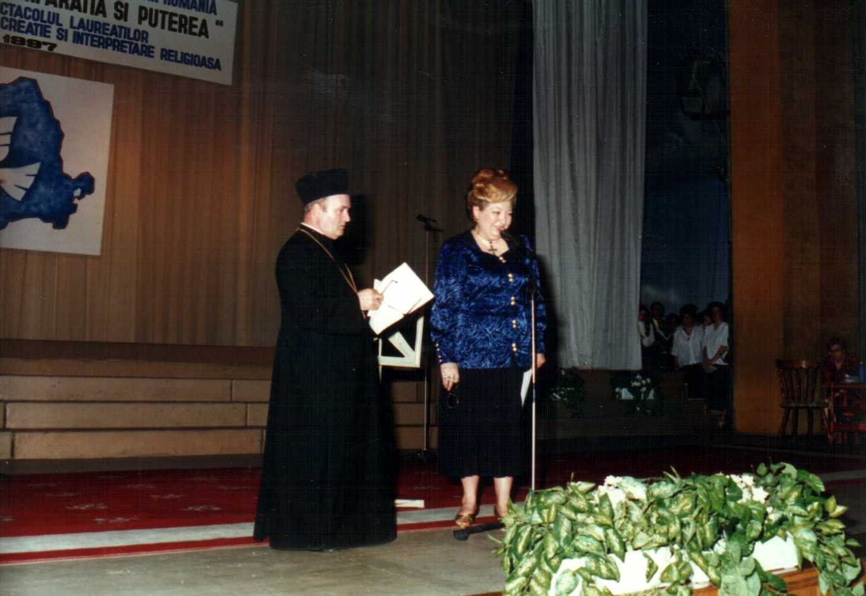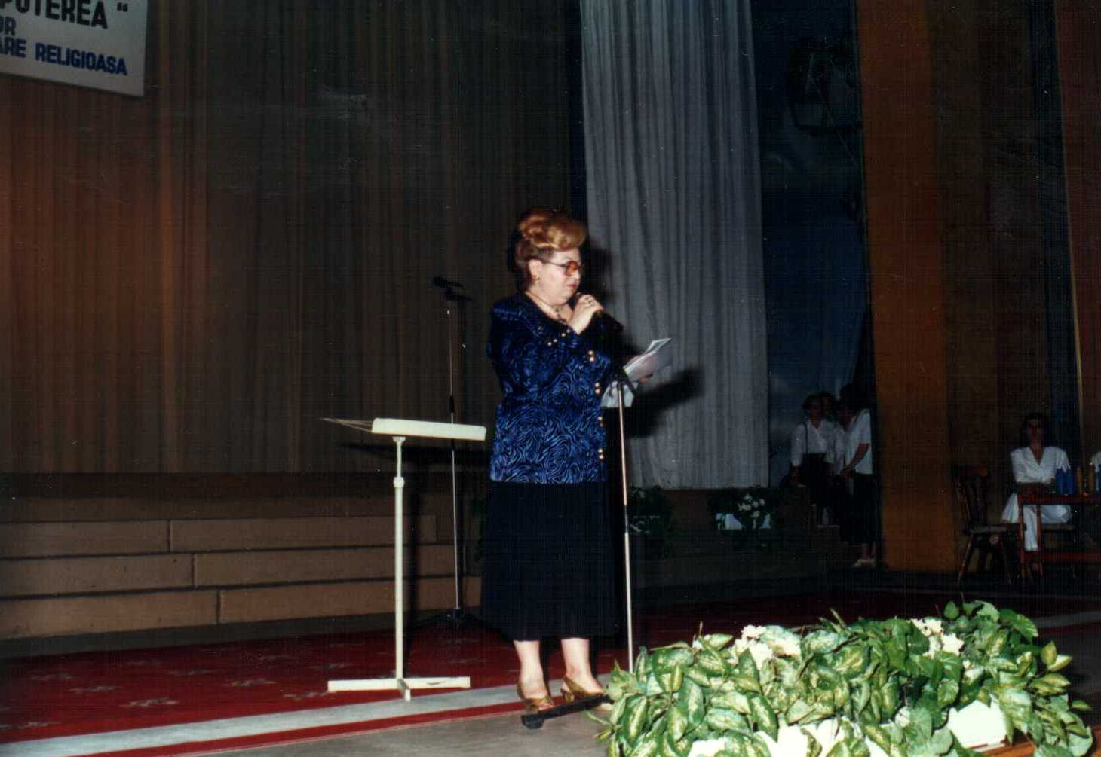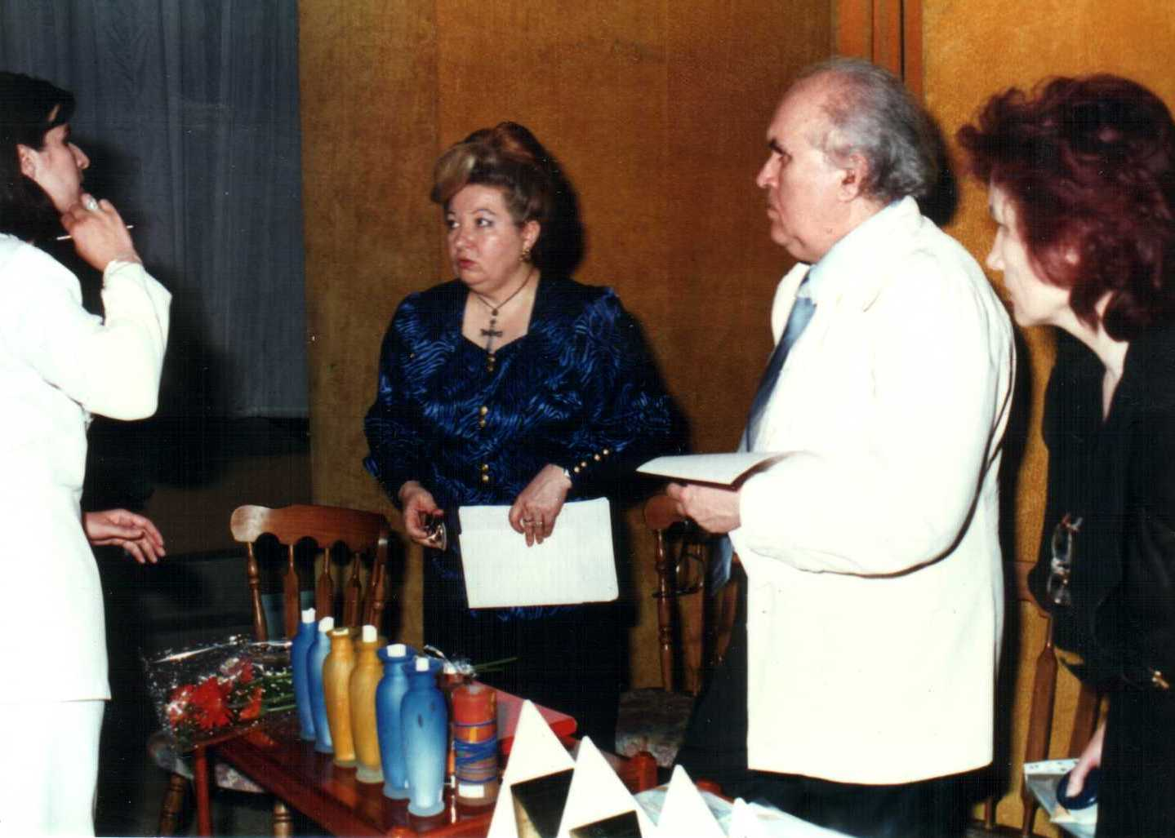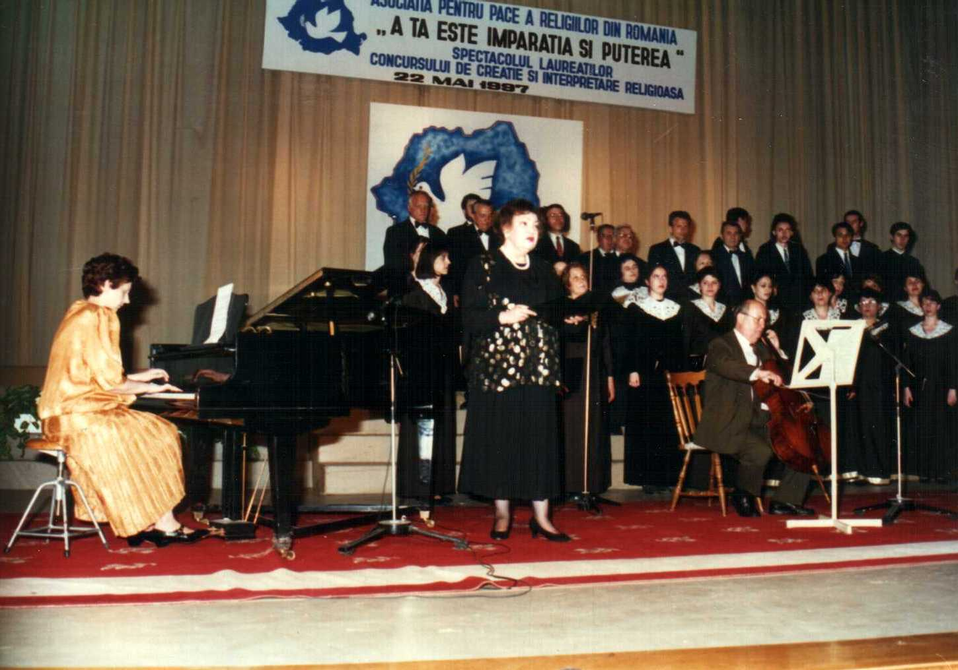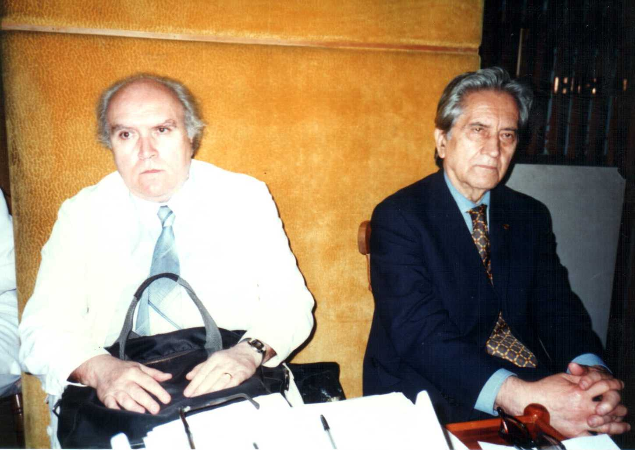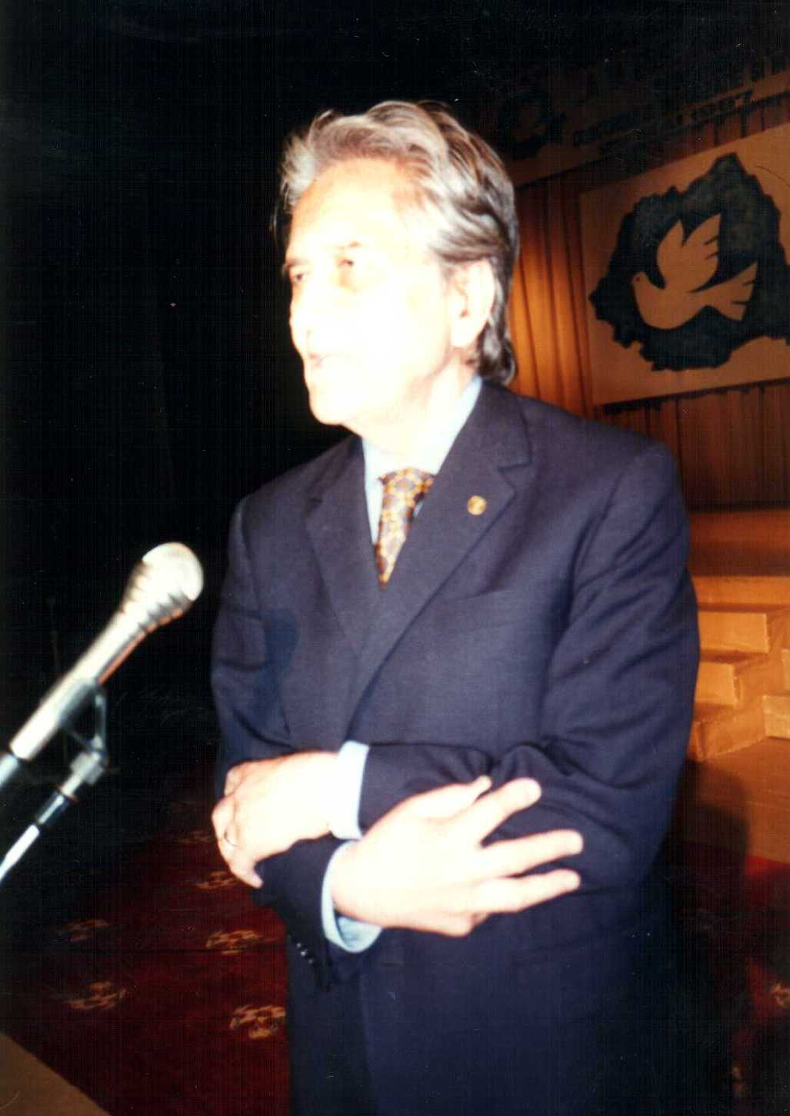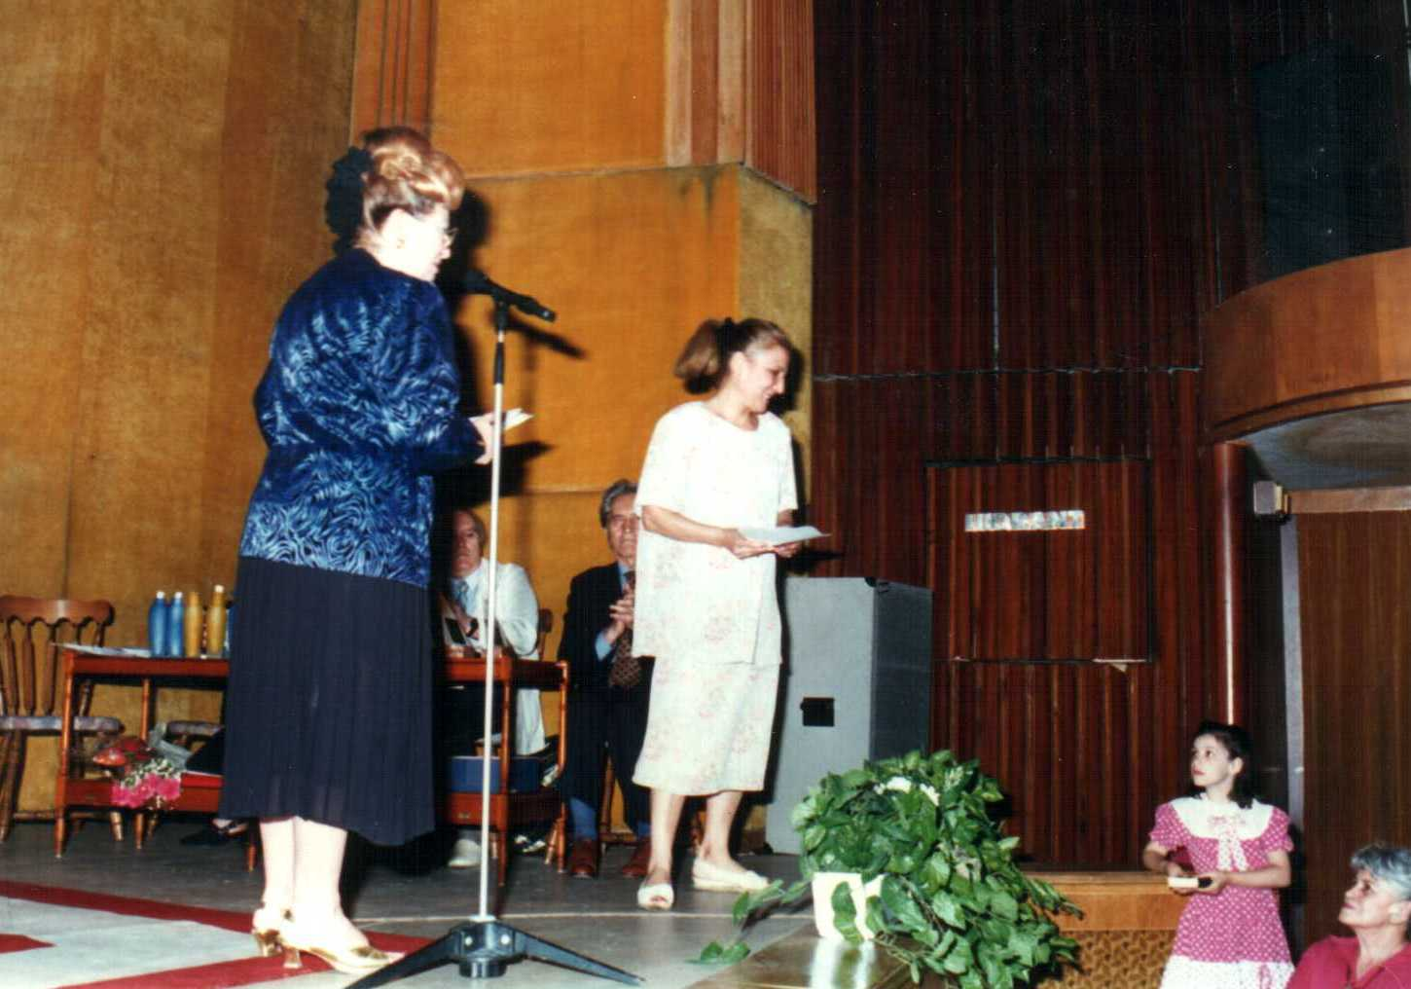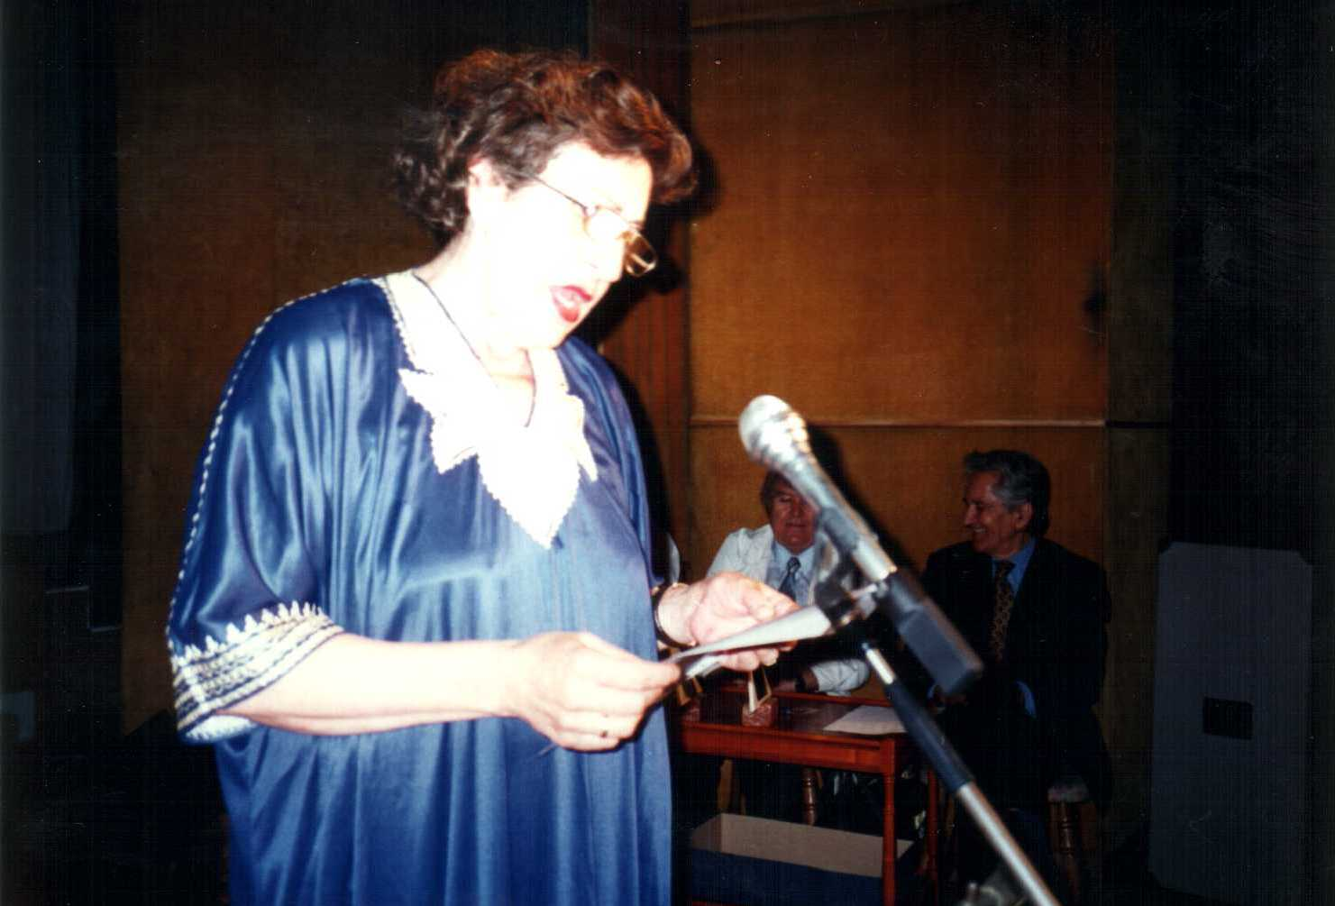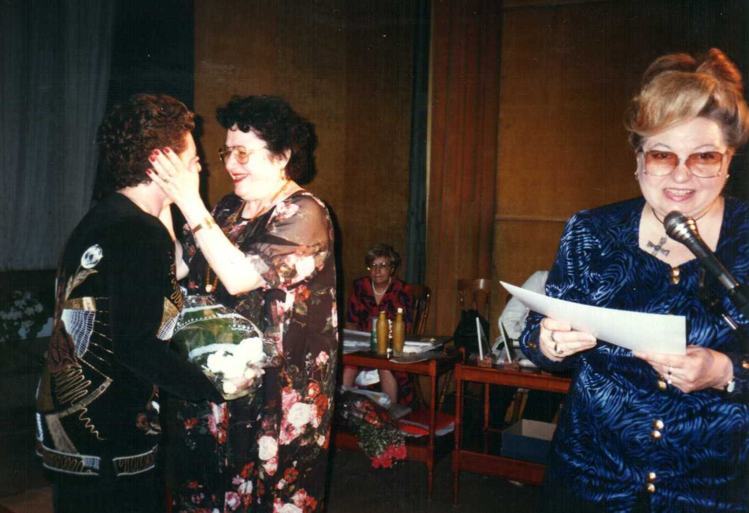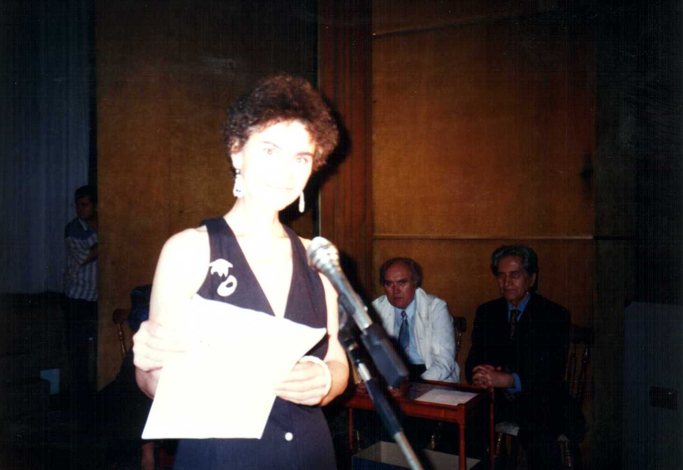

Marcela Ghiulbenghian and Ft.Conf. Dr. Alexandru I. Stan gave the opening speech of the Festivity. Participated and were awarded: Mrs. Maria Nistor Slatinaru, Mr. Alexandru Morosanu- cello, Mrs. Tatiana Morosanu – piano, Mr. Izu Gott, conductor of the SiraVezimra Choir–Mosaic Cult, Academician Mr. Alexandru Balaci- President of the literary creation jury, Mr. Doru Popovici – president of the jury, Mrs. Latif Beinaz, Mrs. Dr. Maria Ciochirca, Crintana Zancu, Mrs. Marilena Caraghiaur

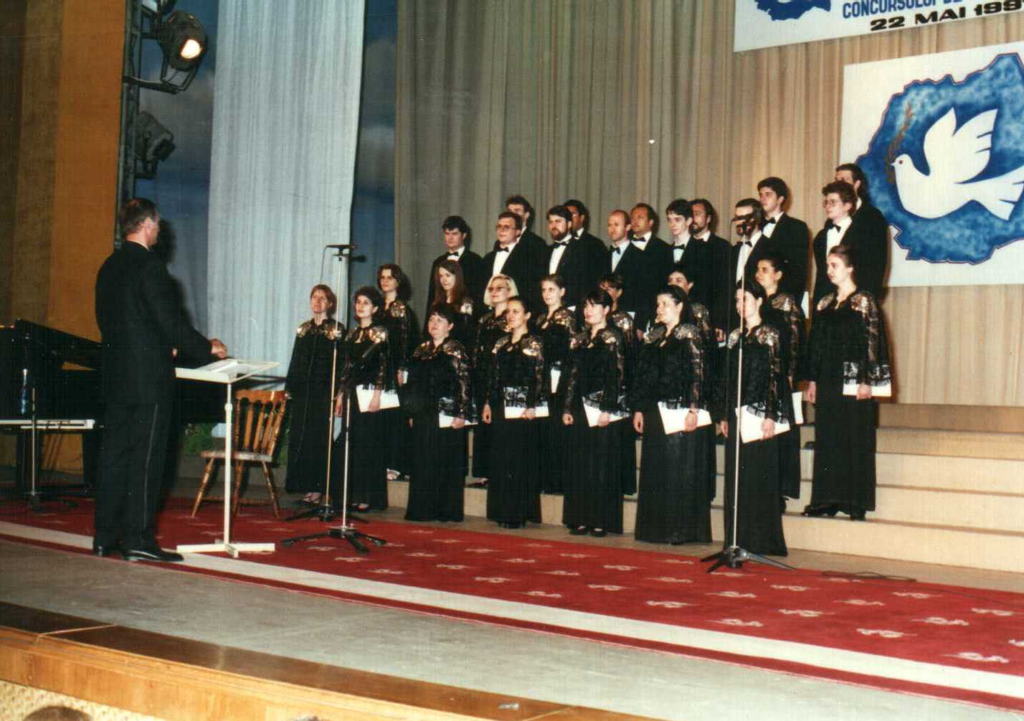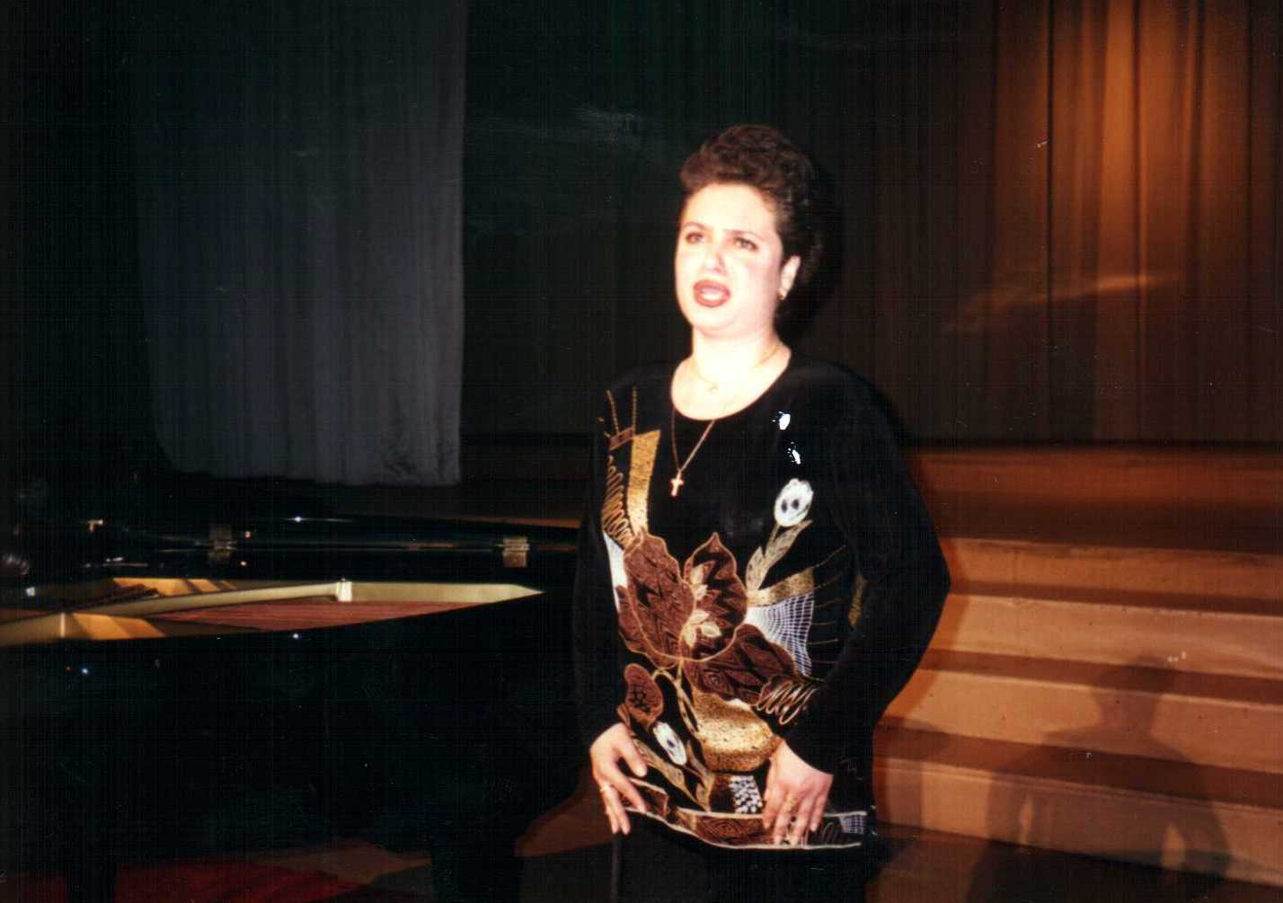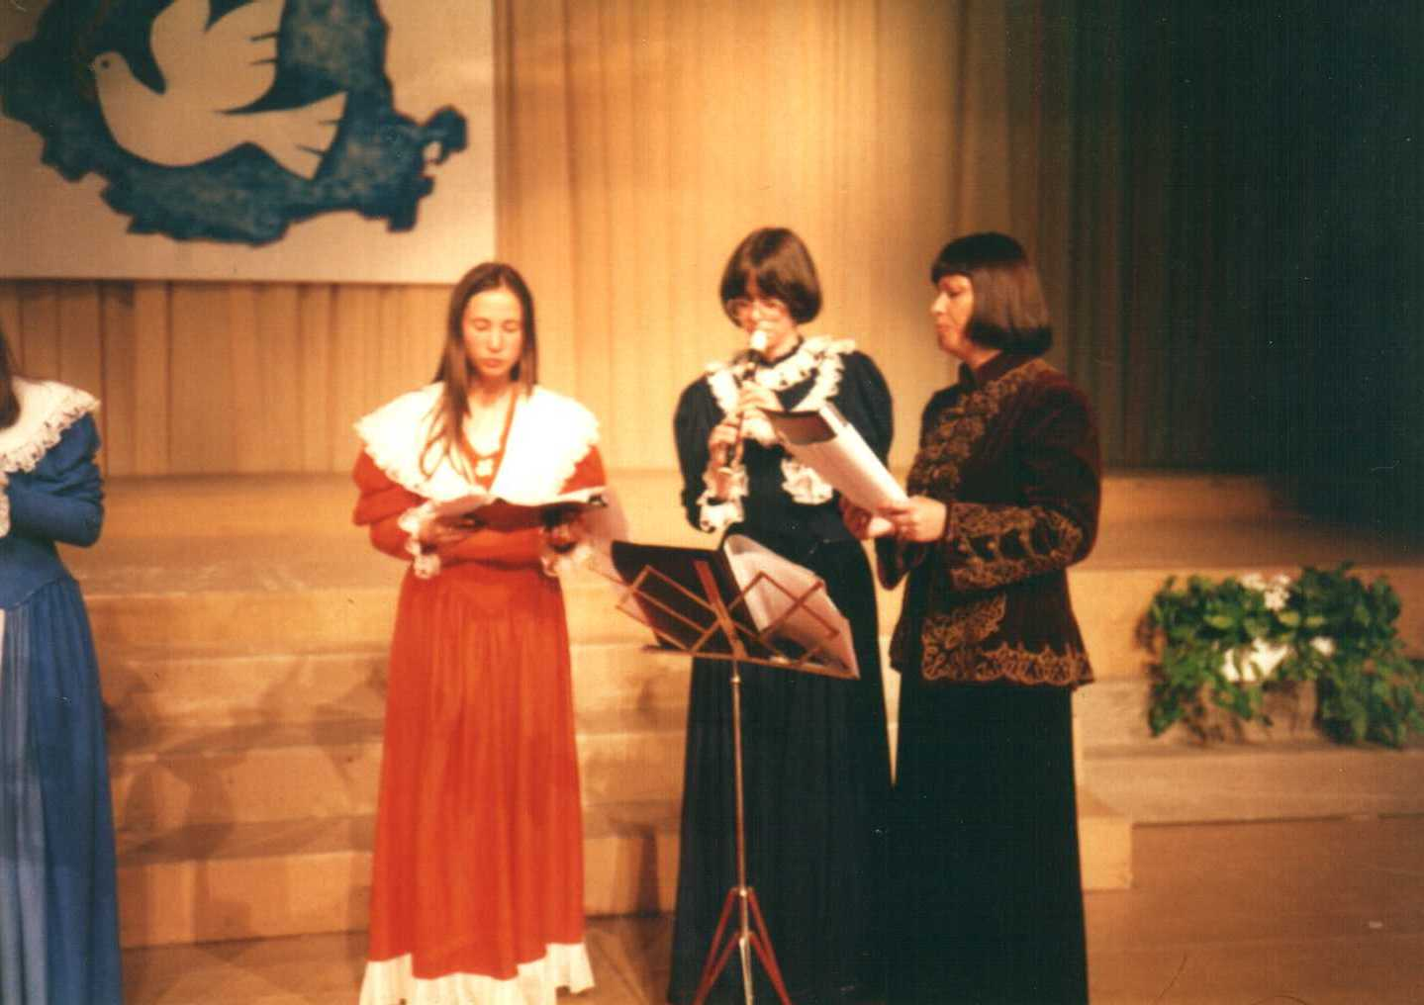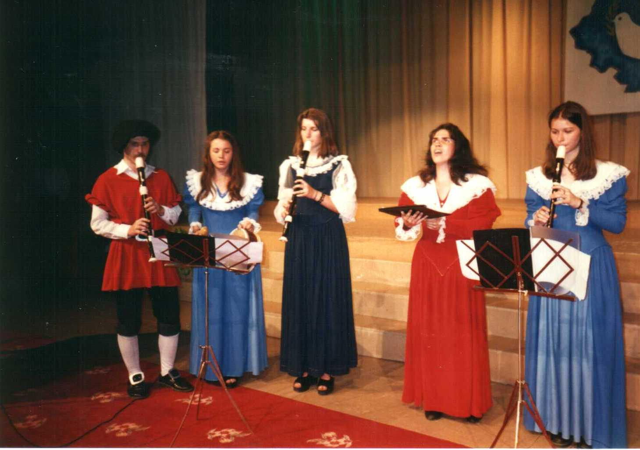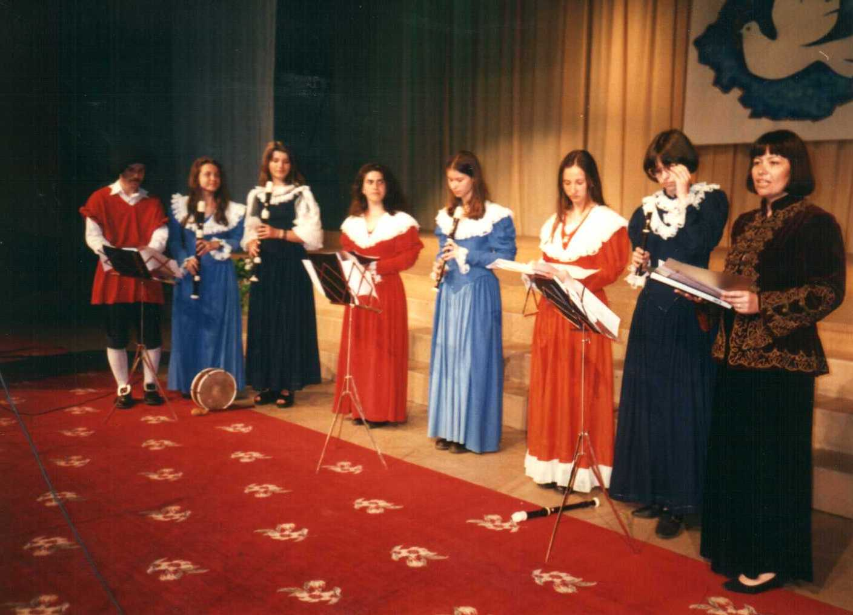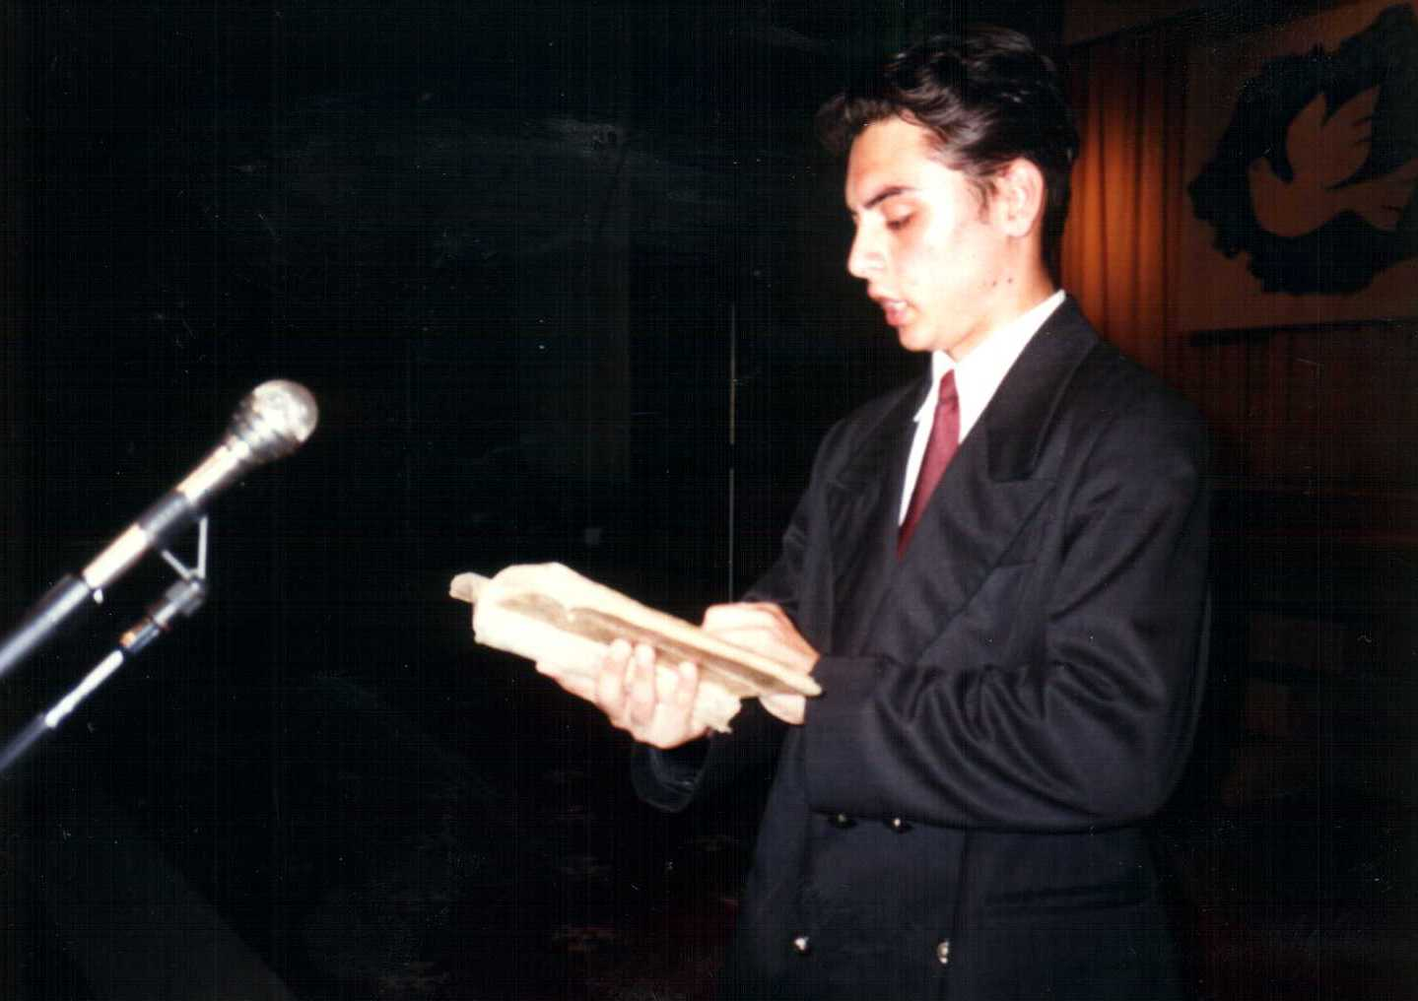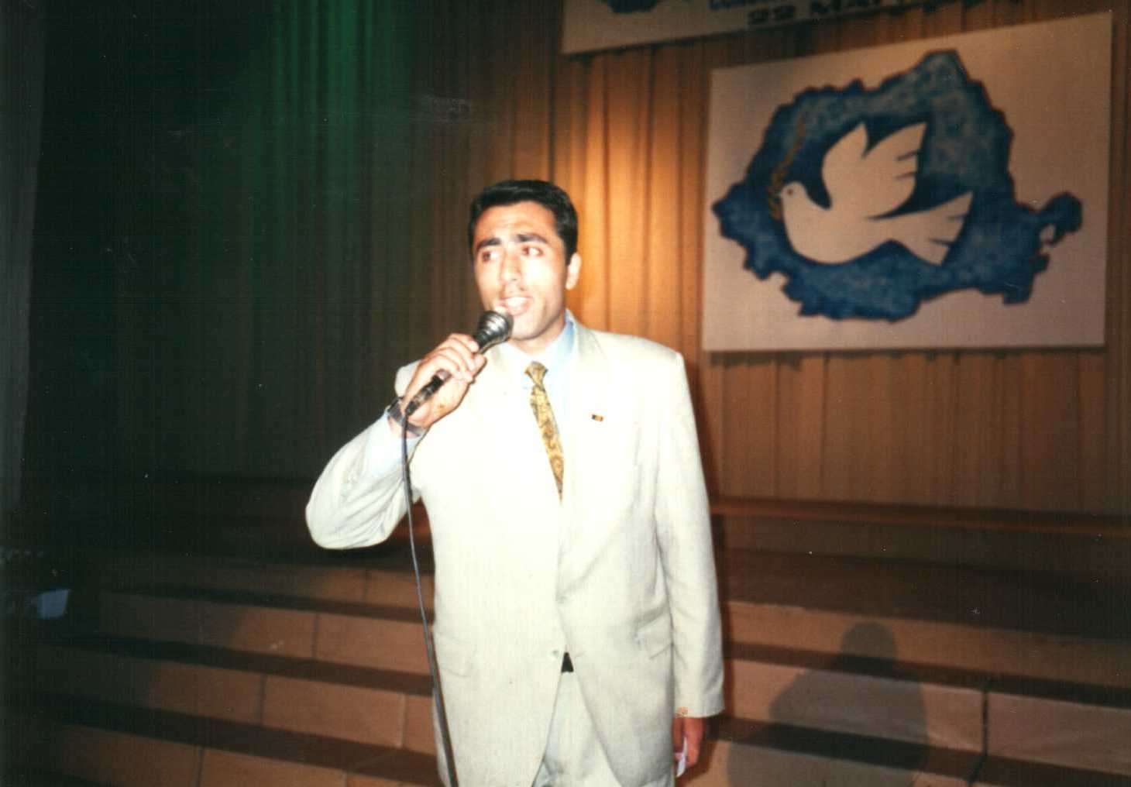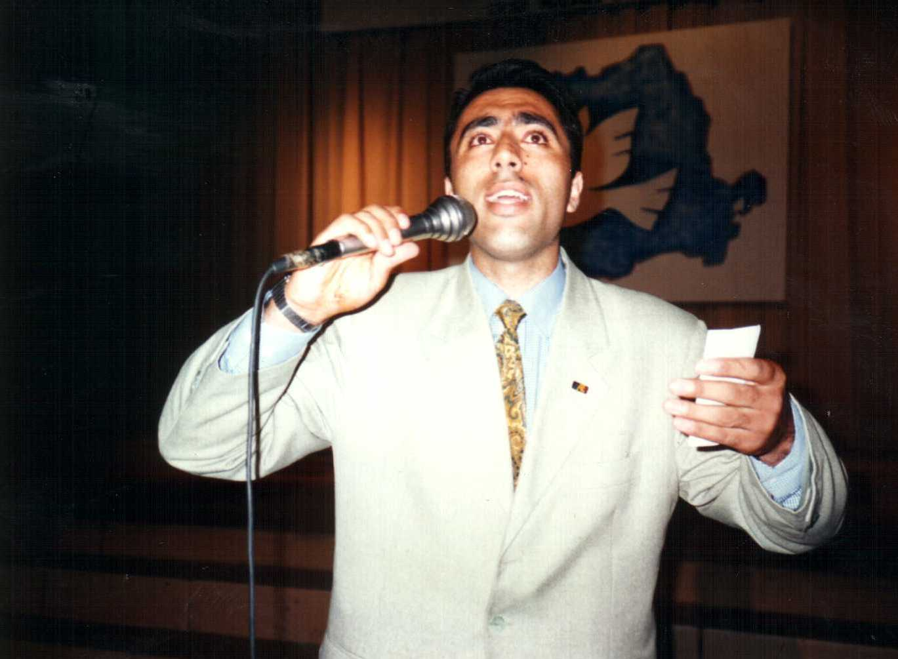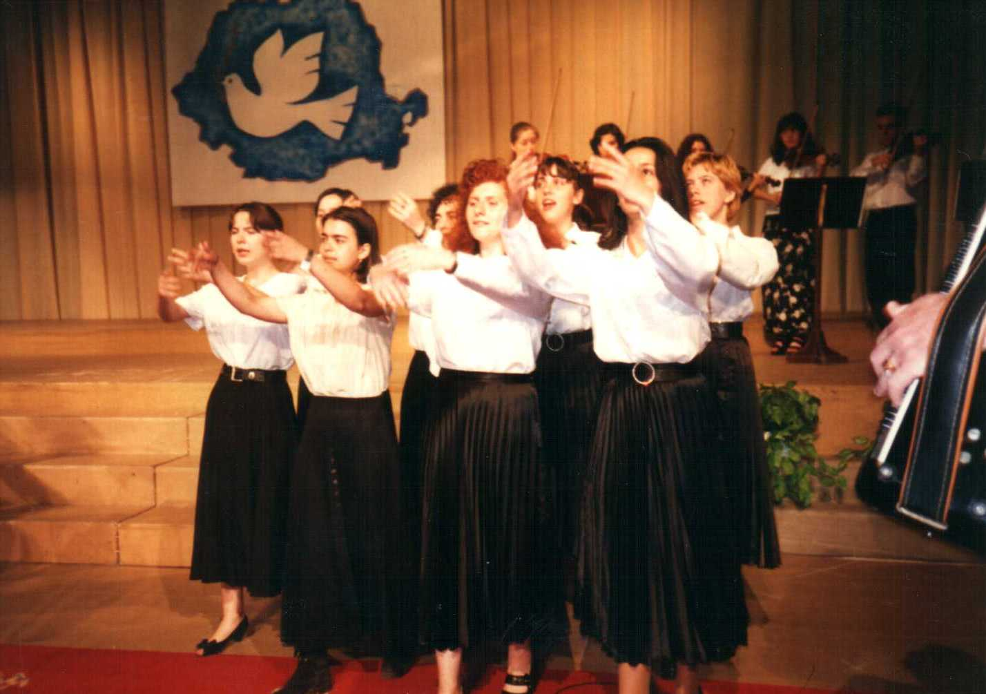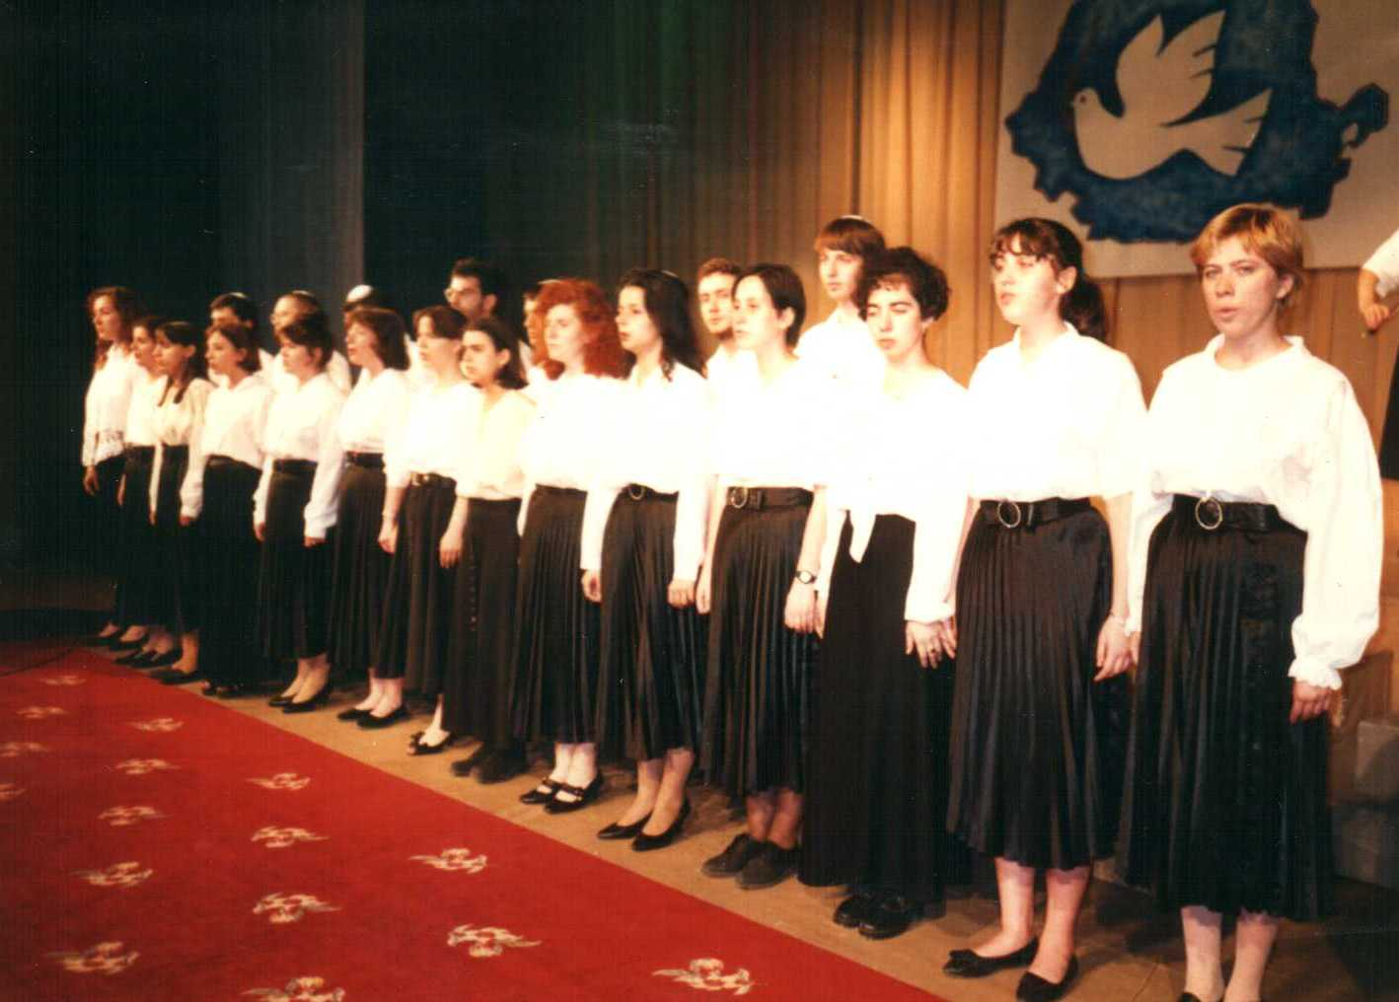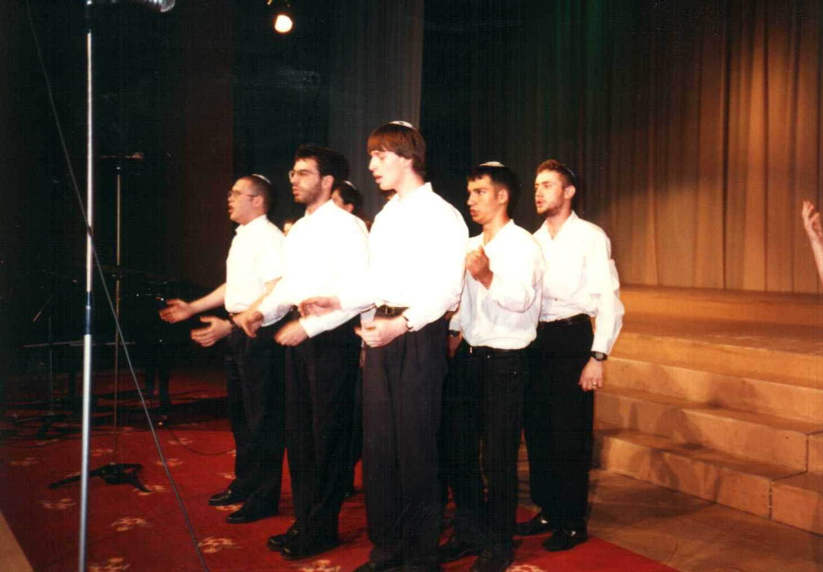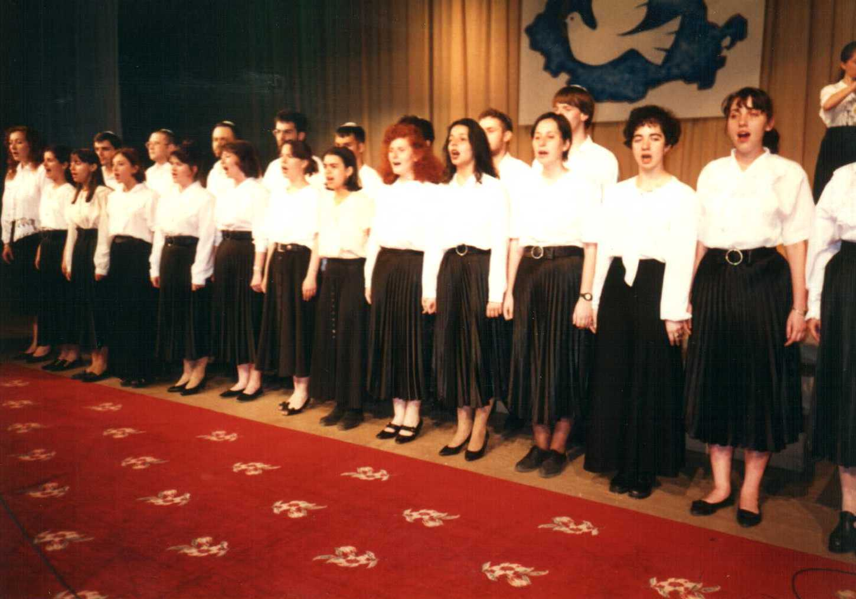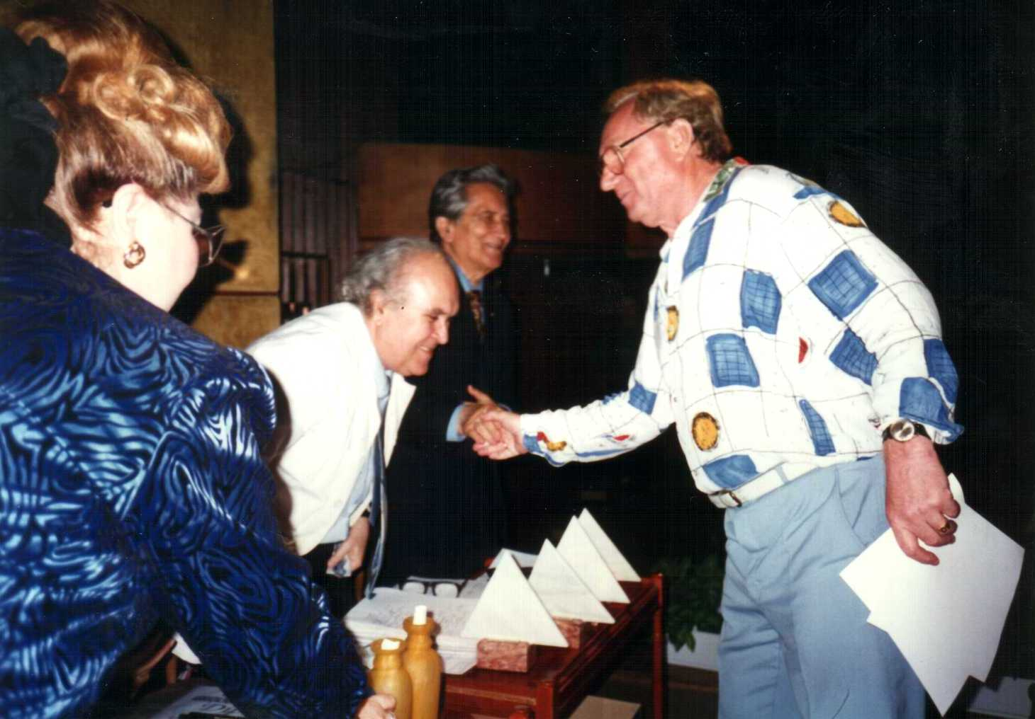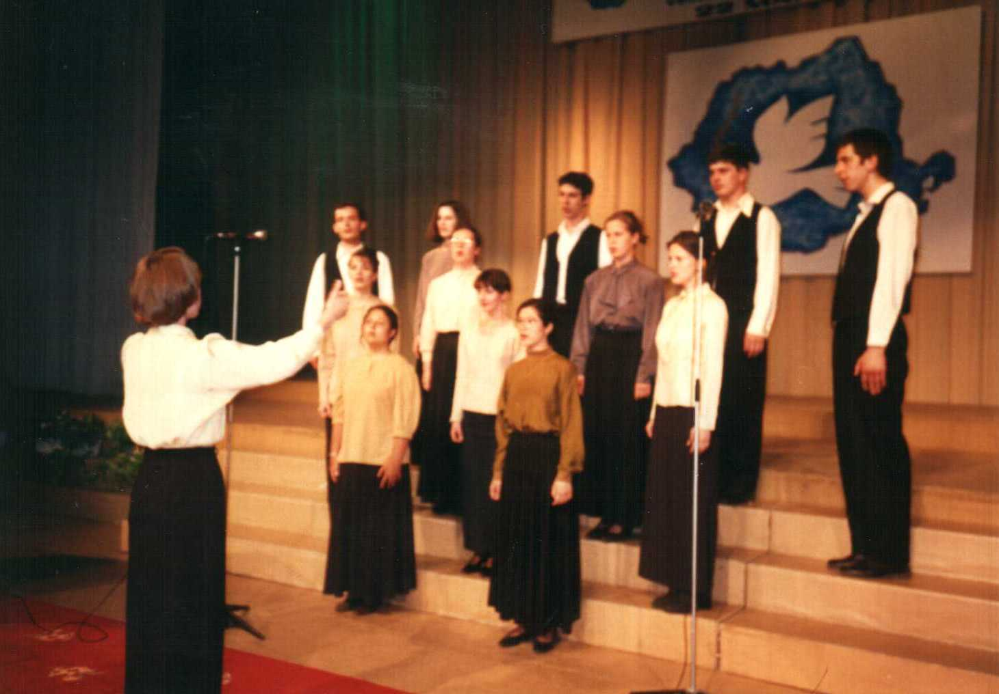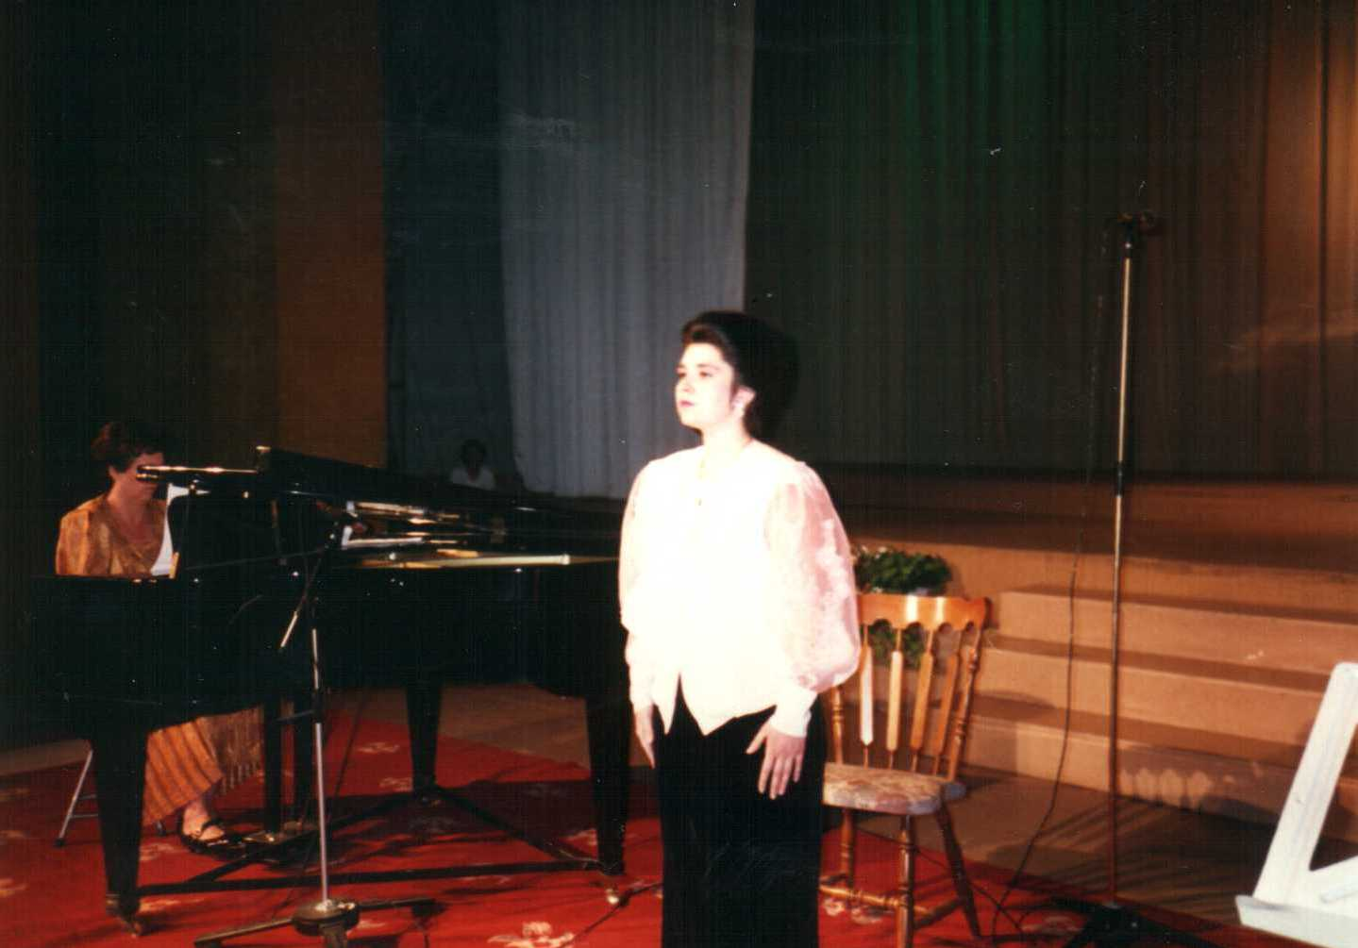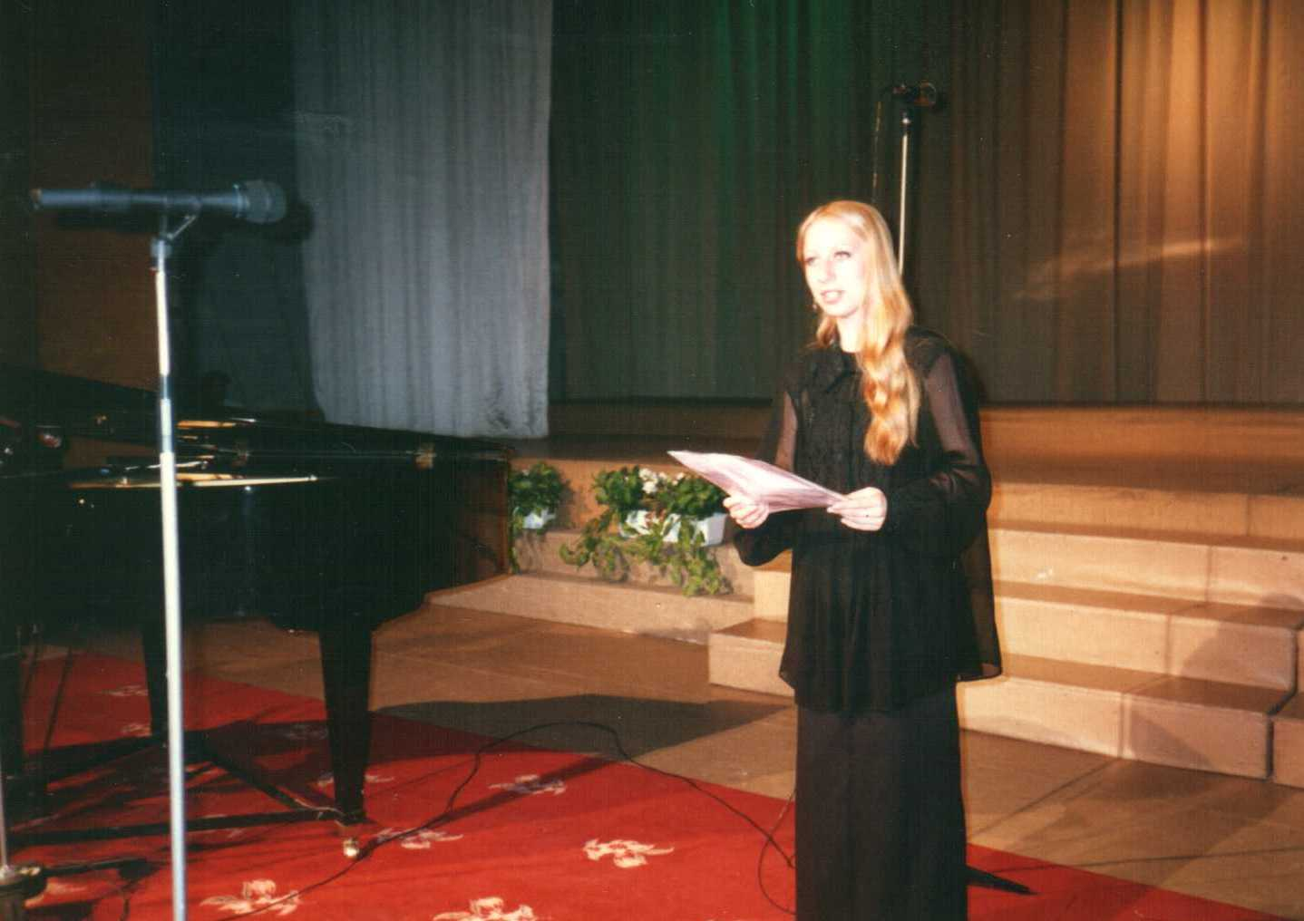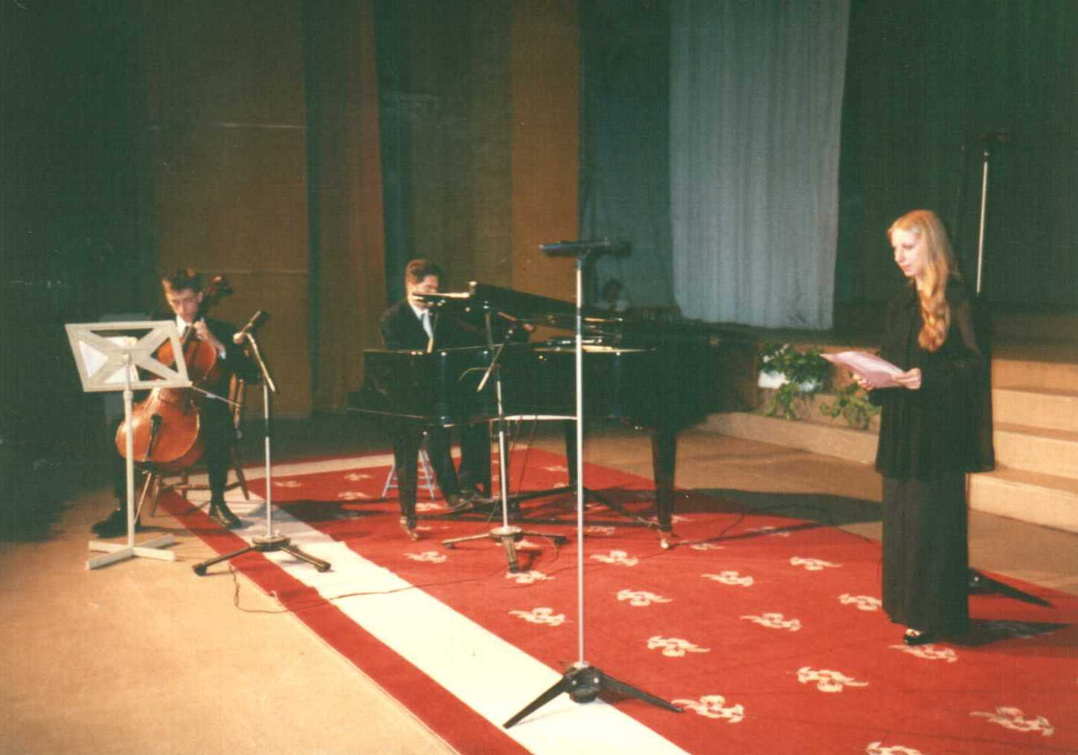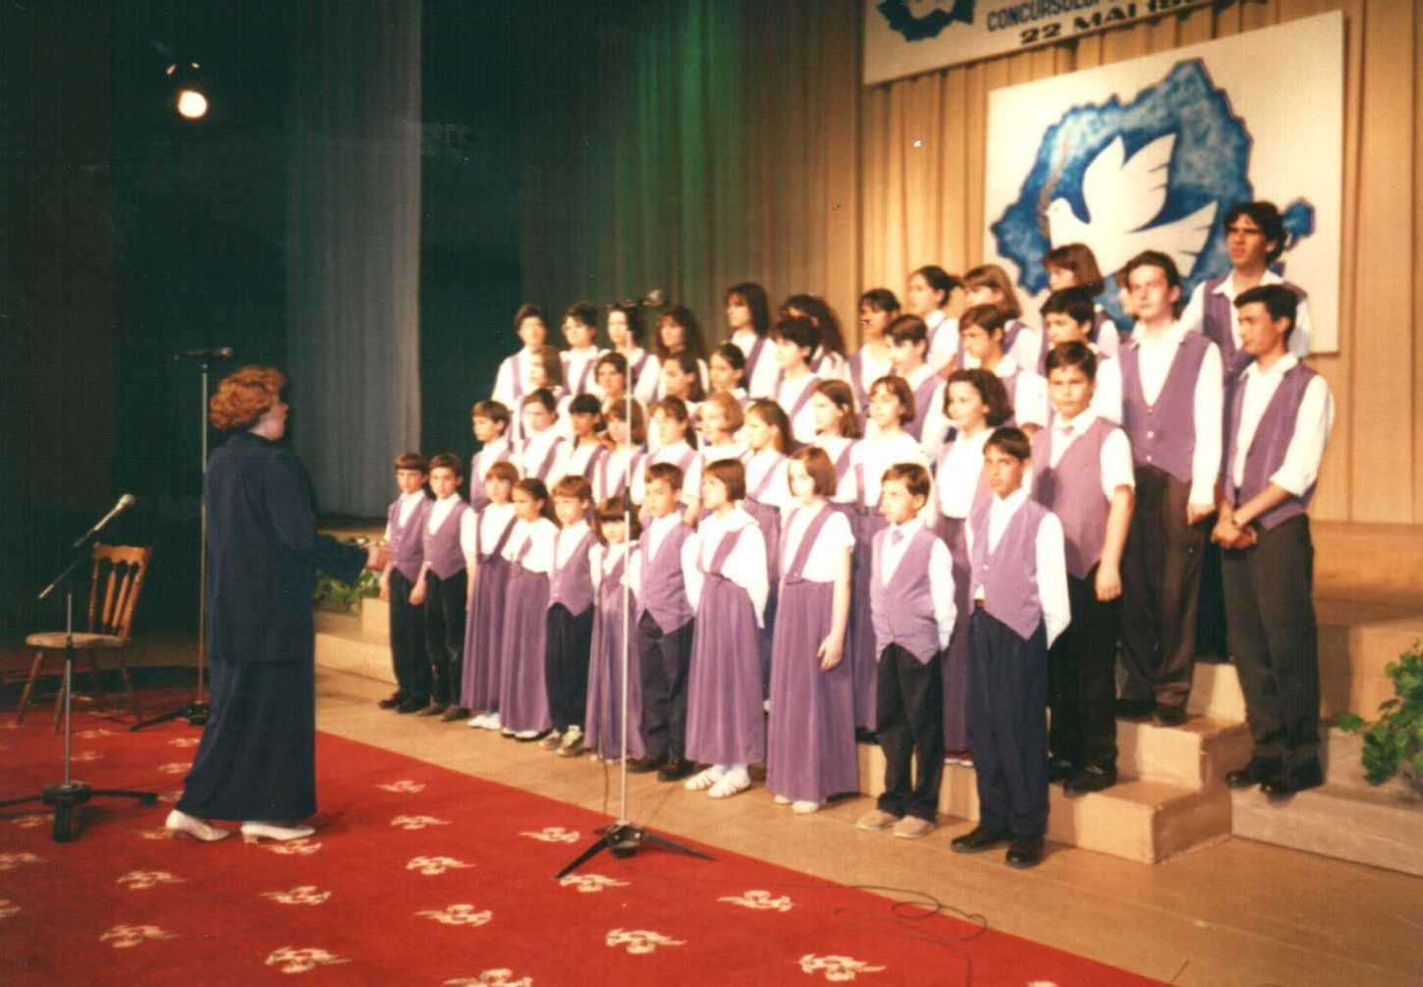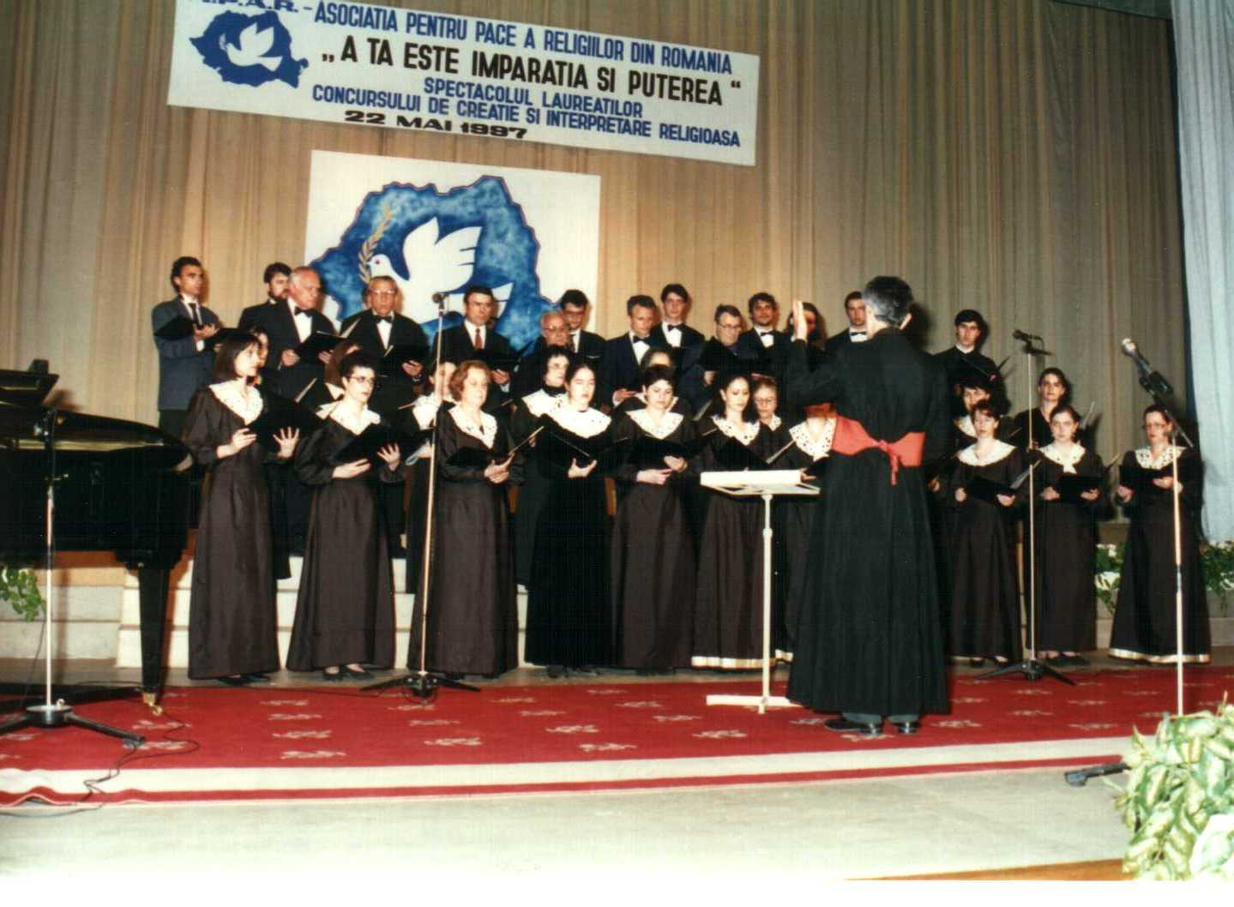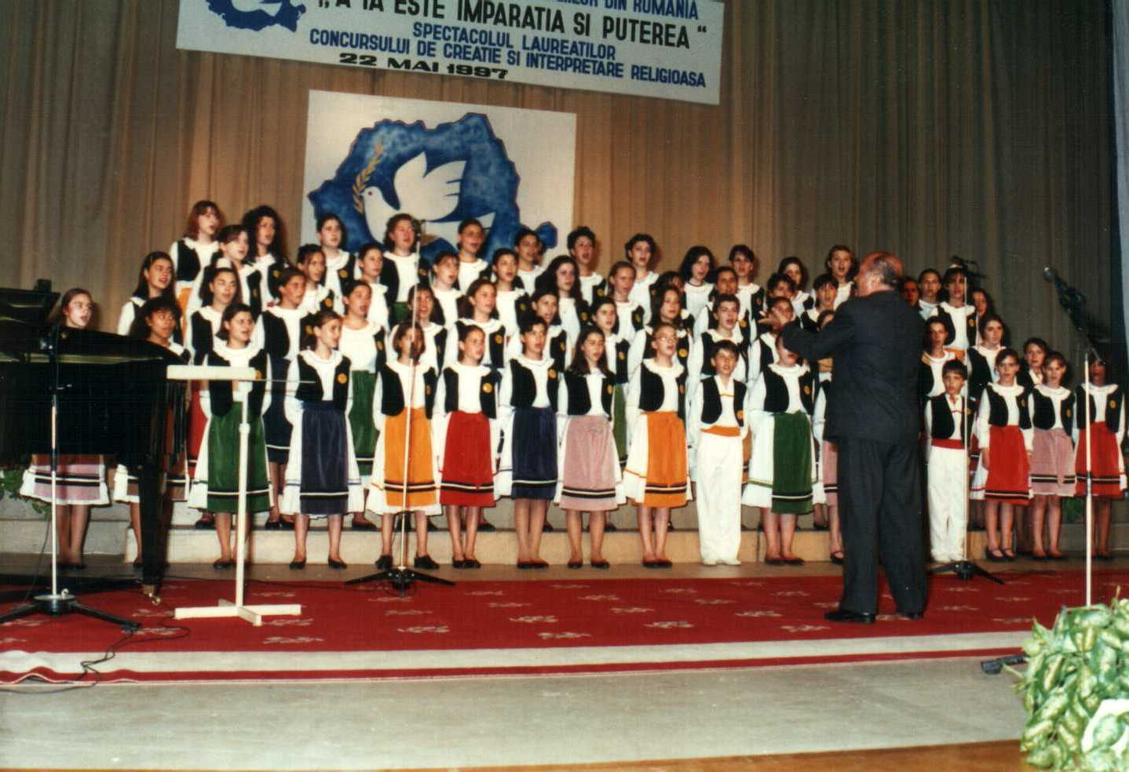

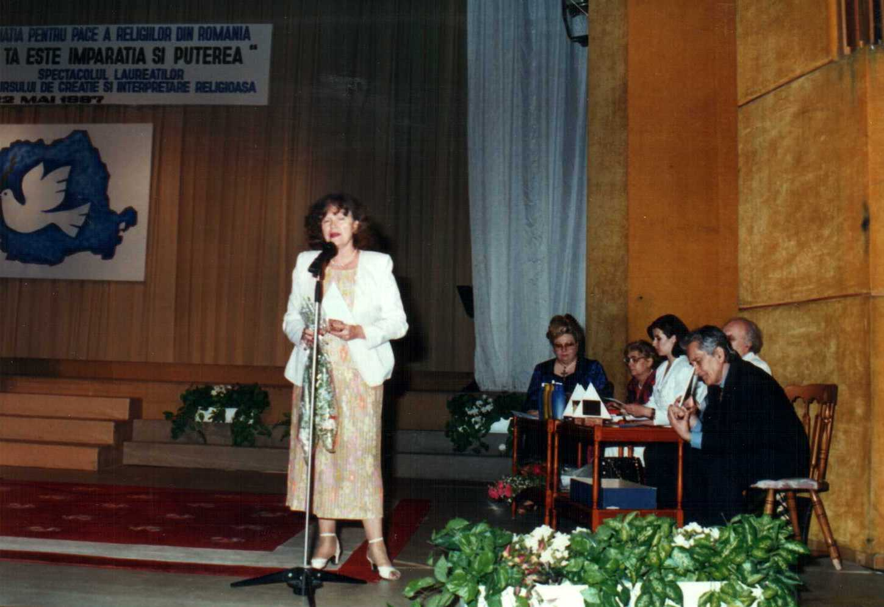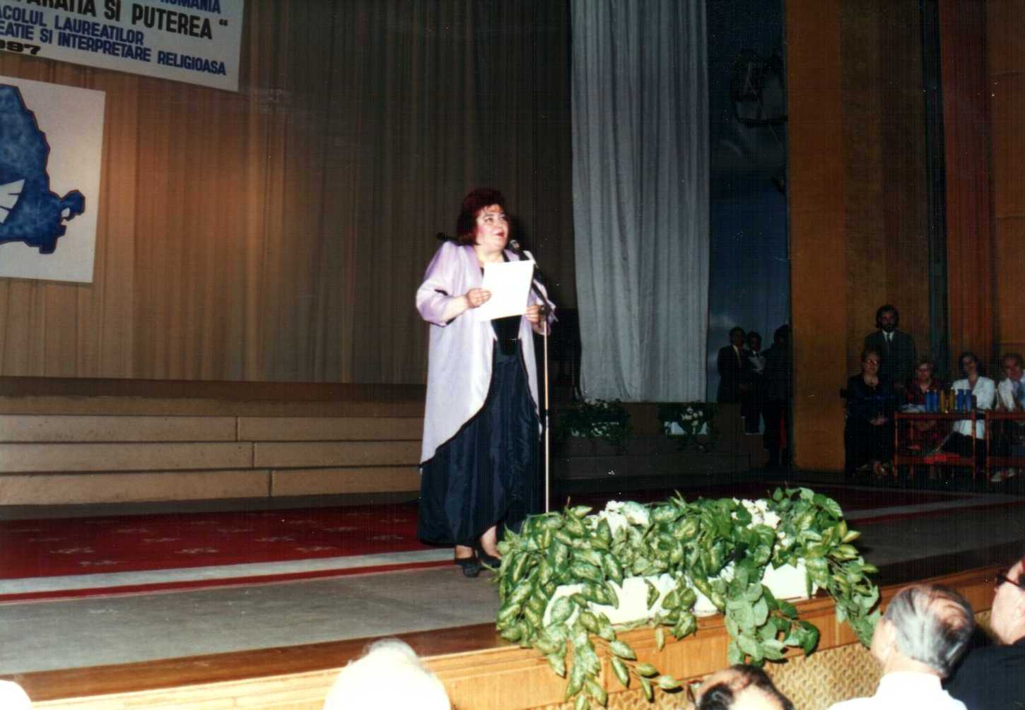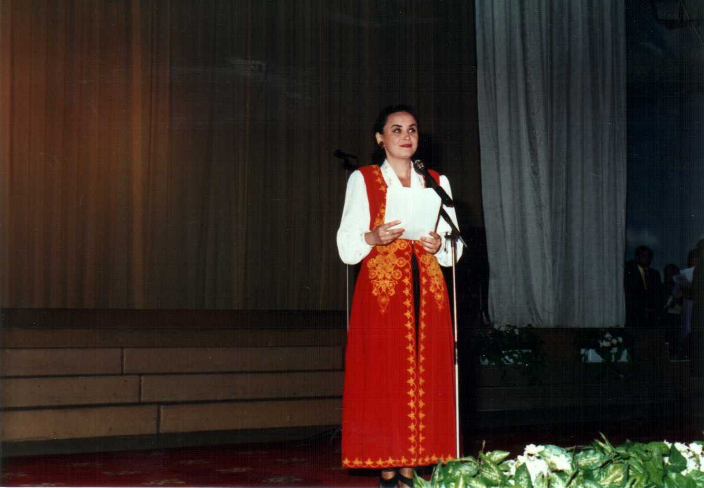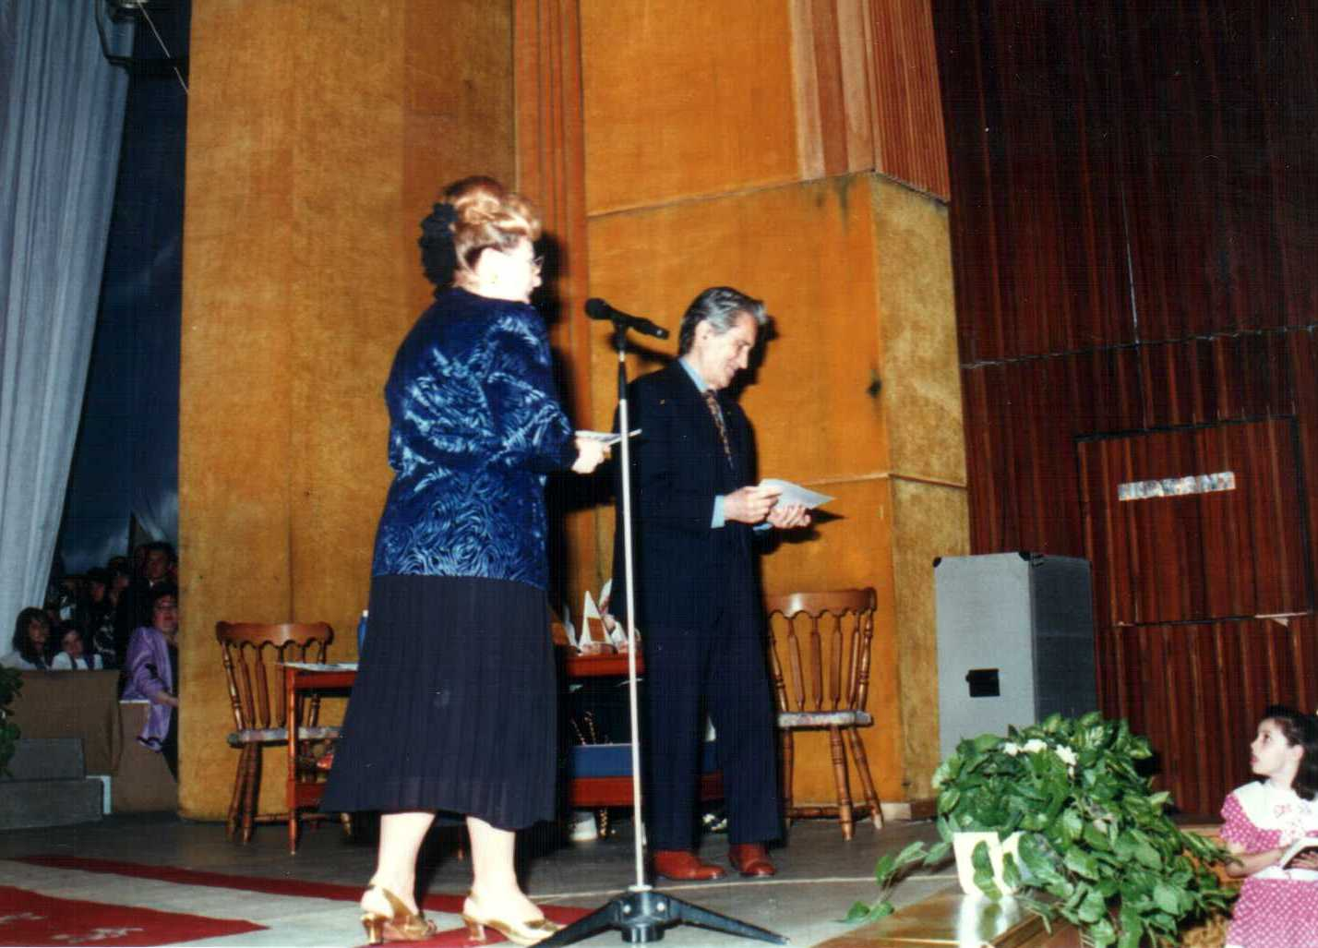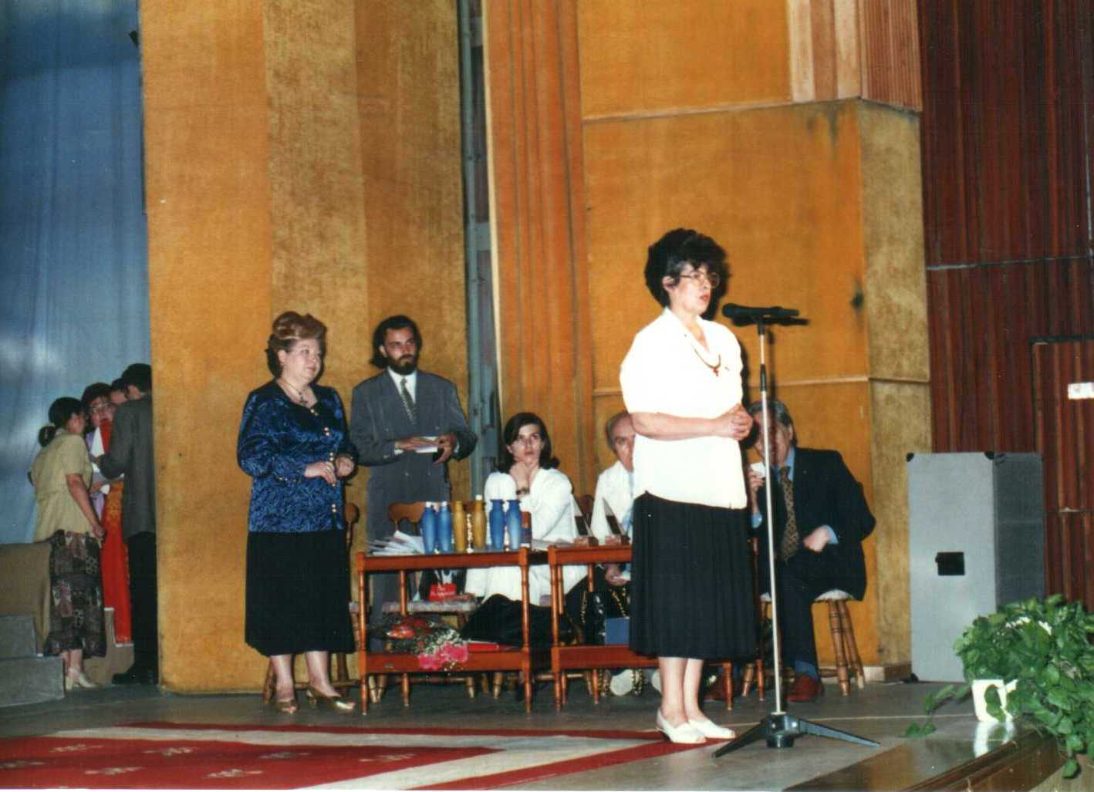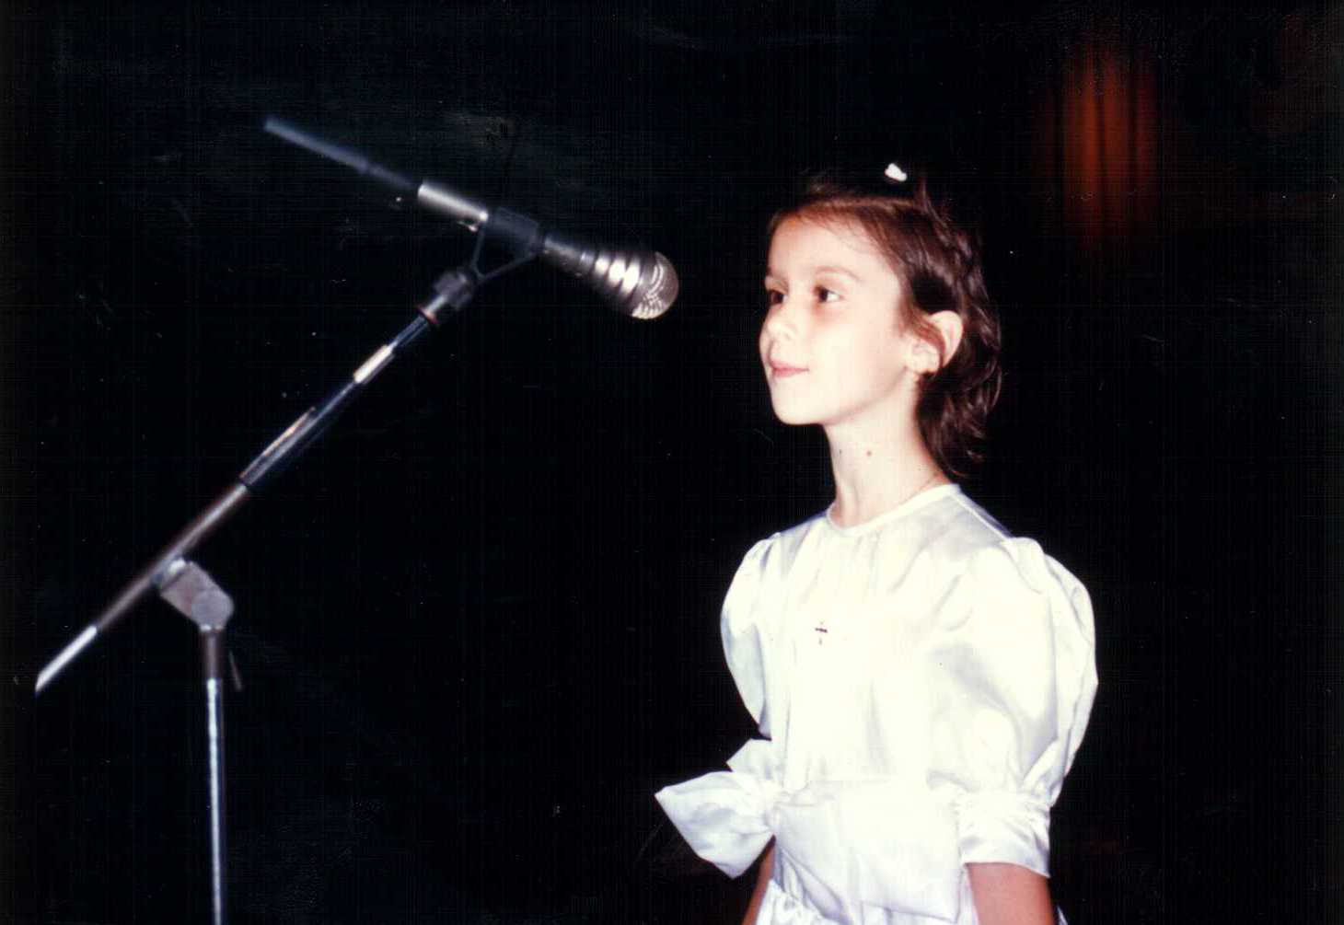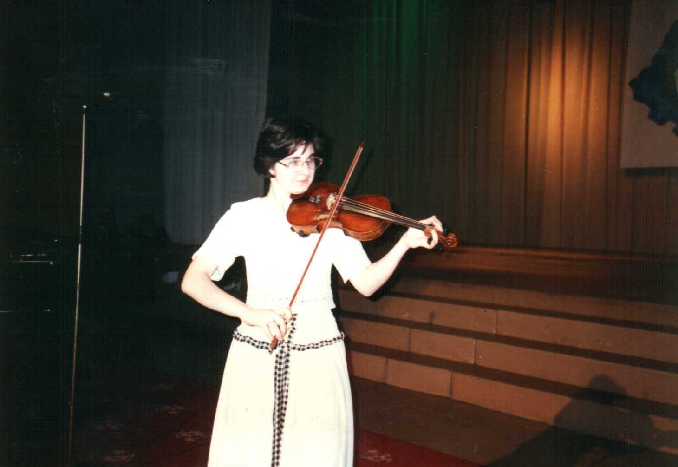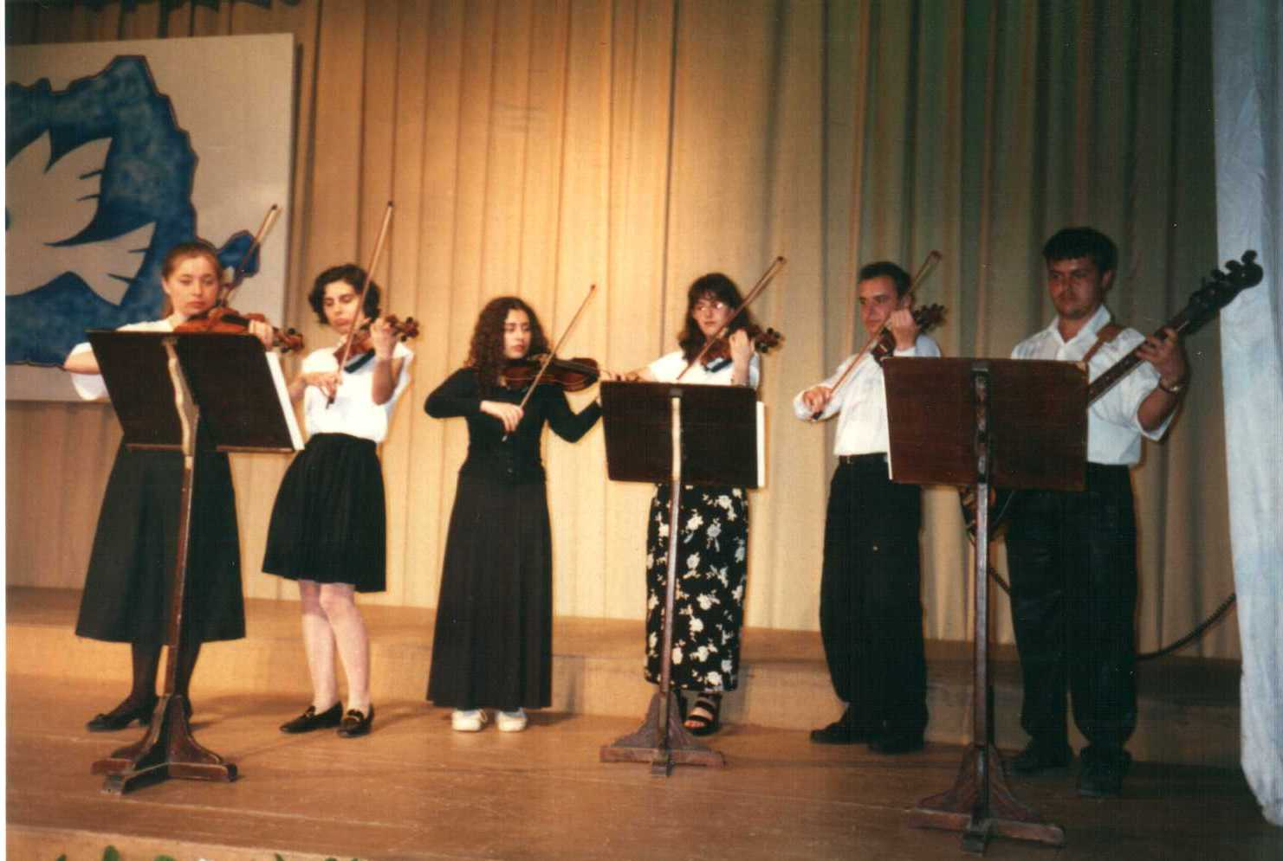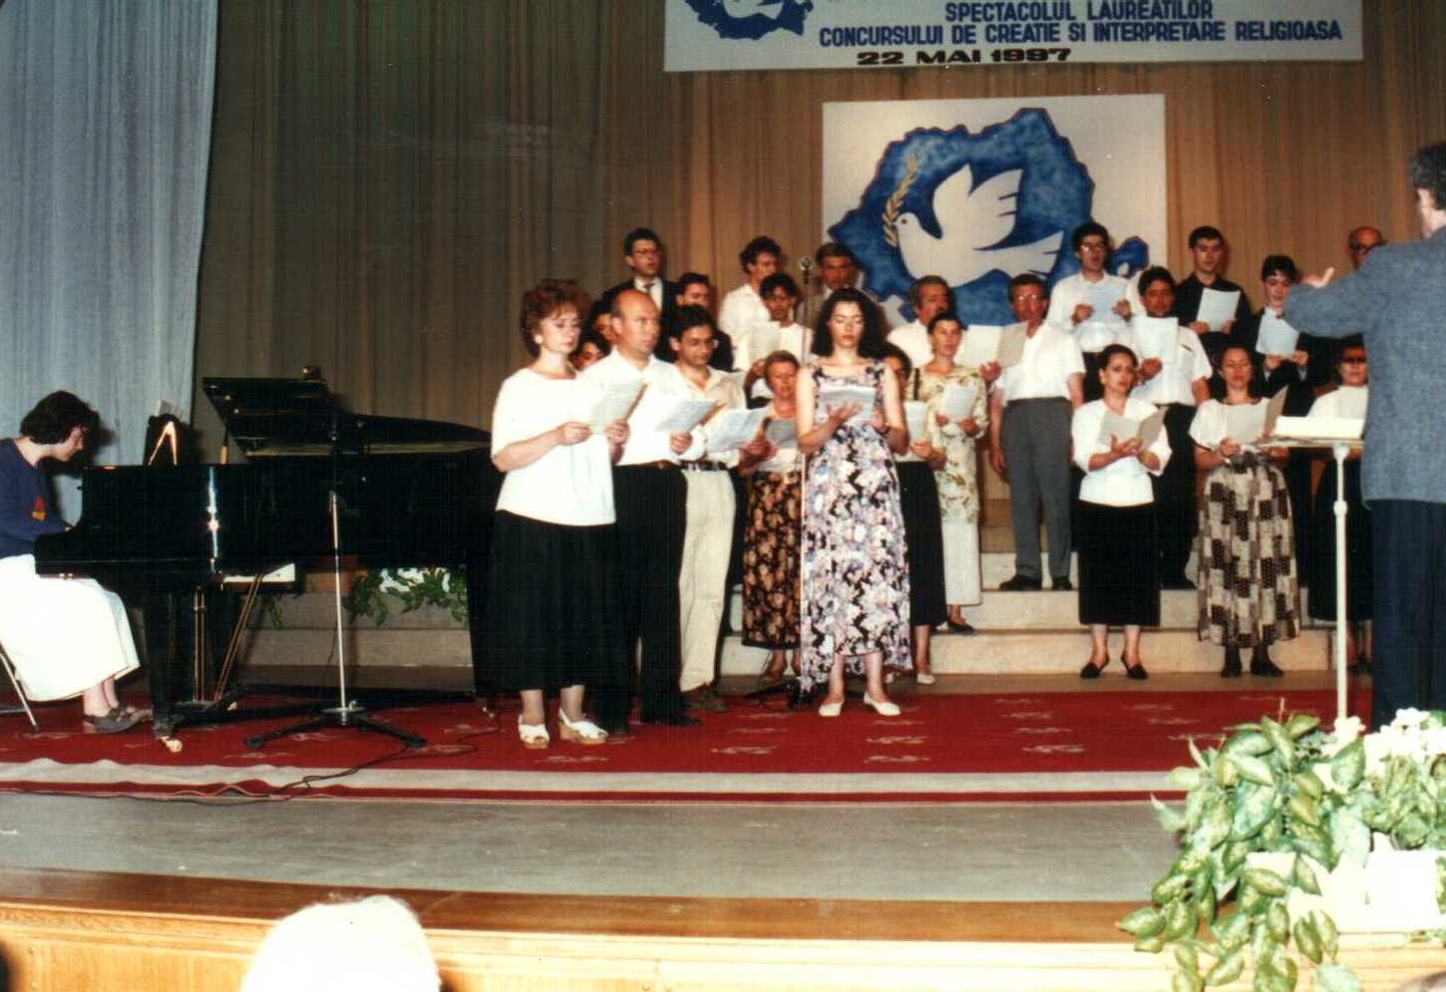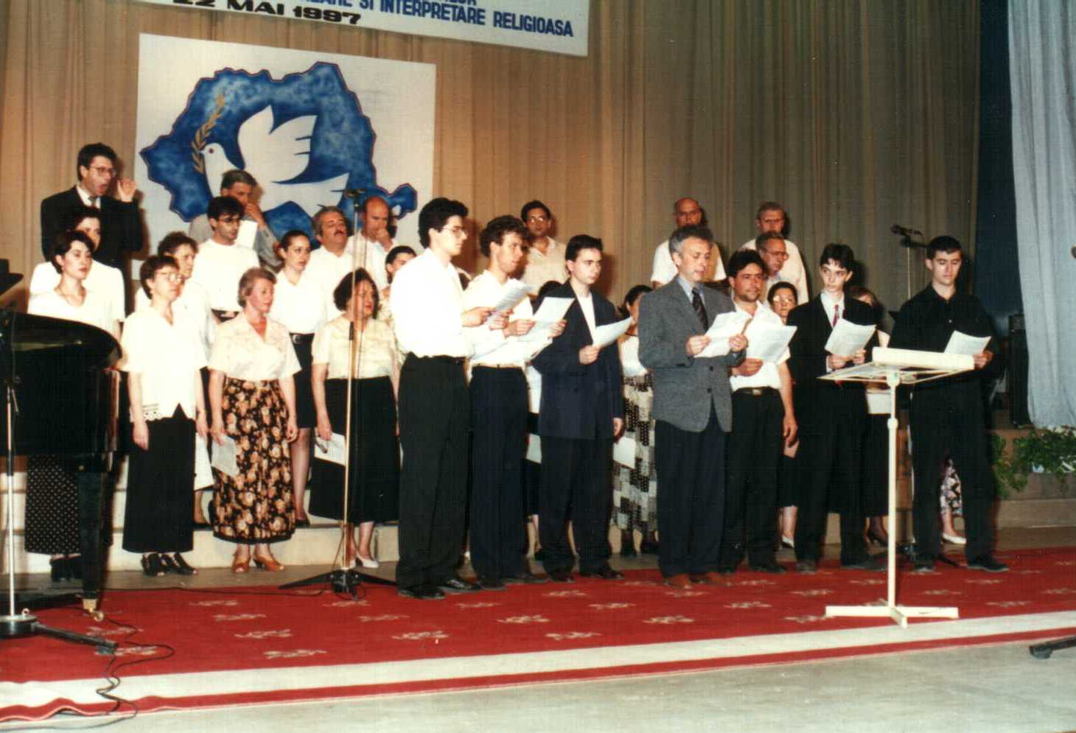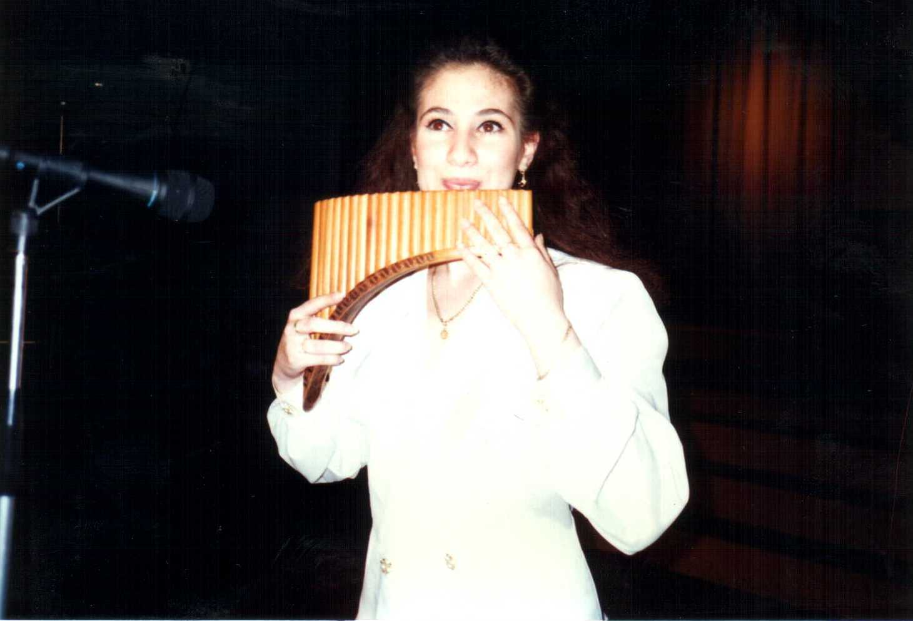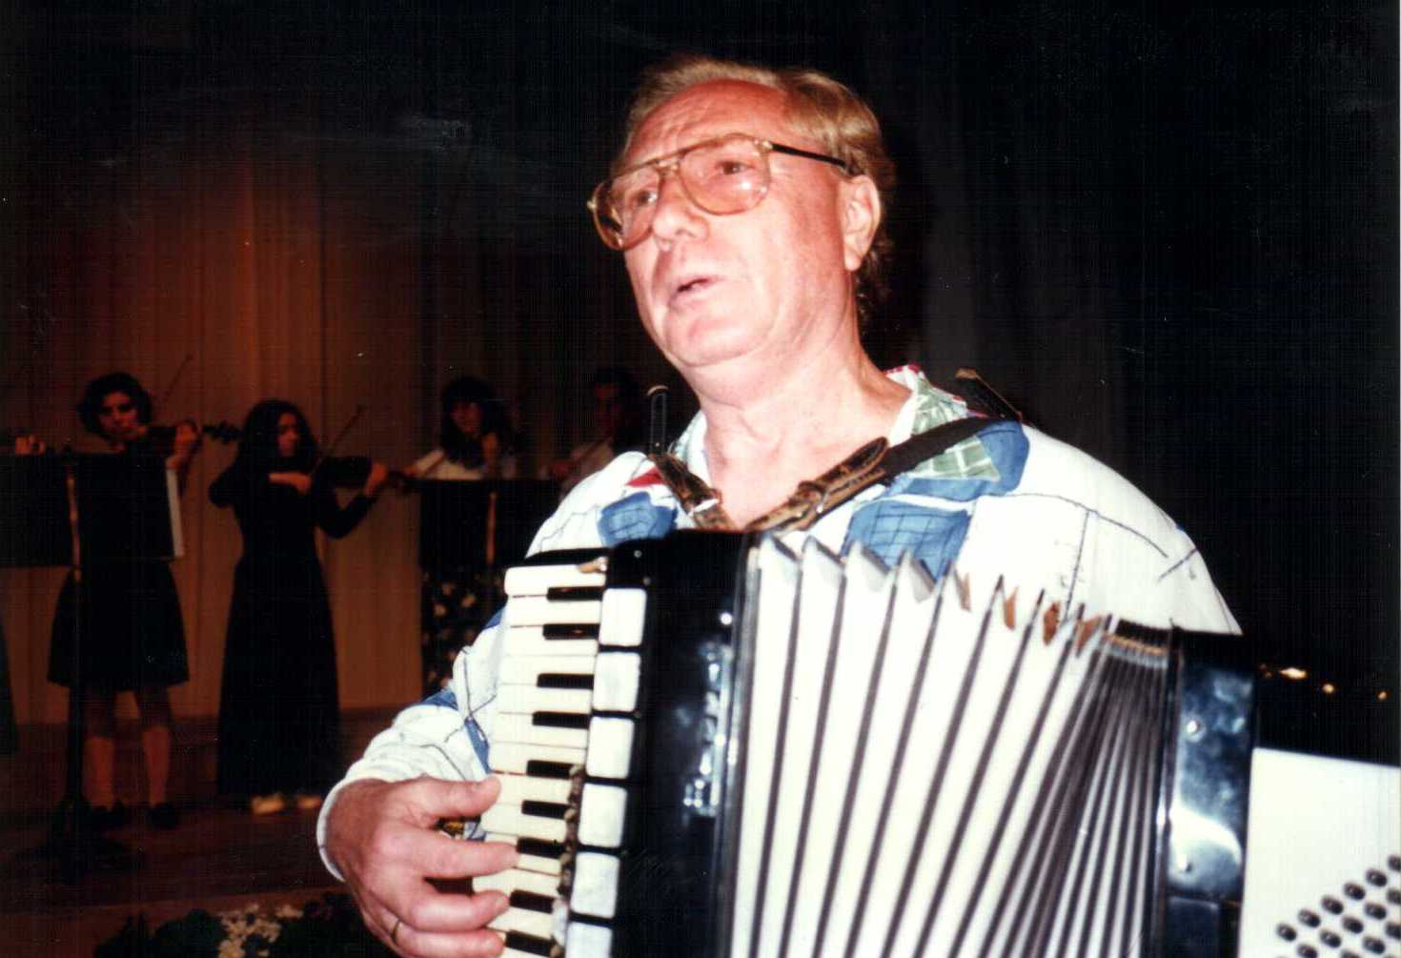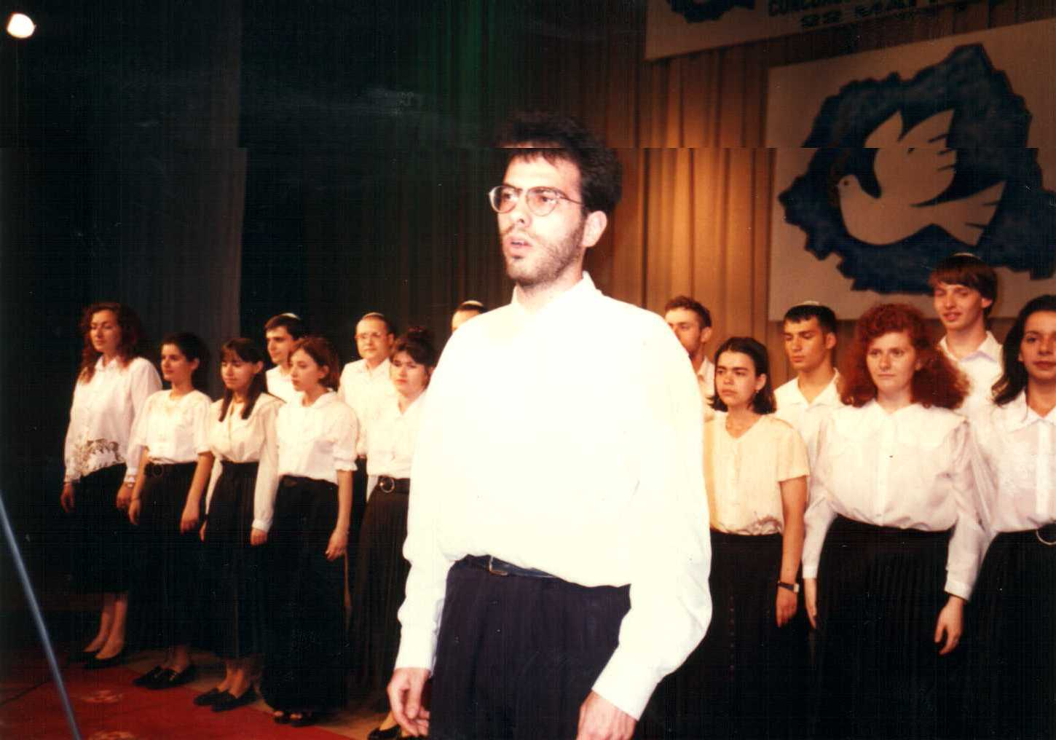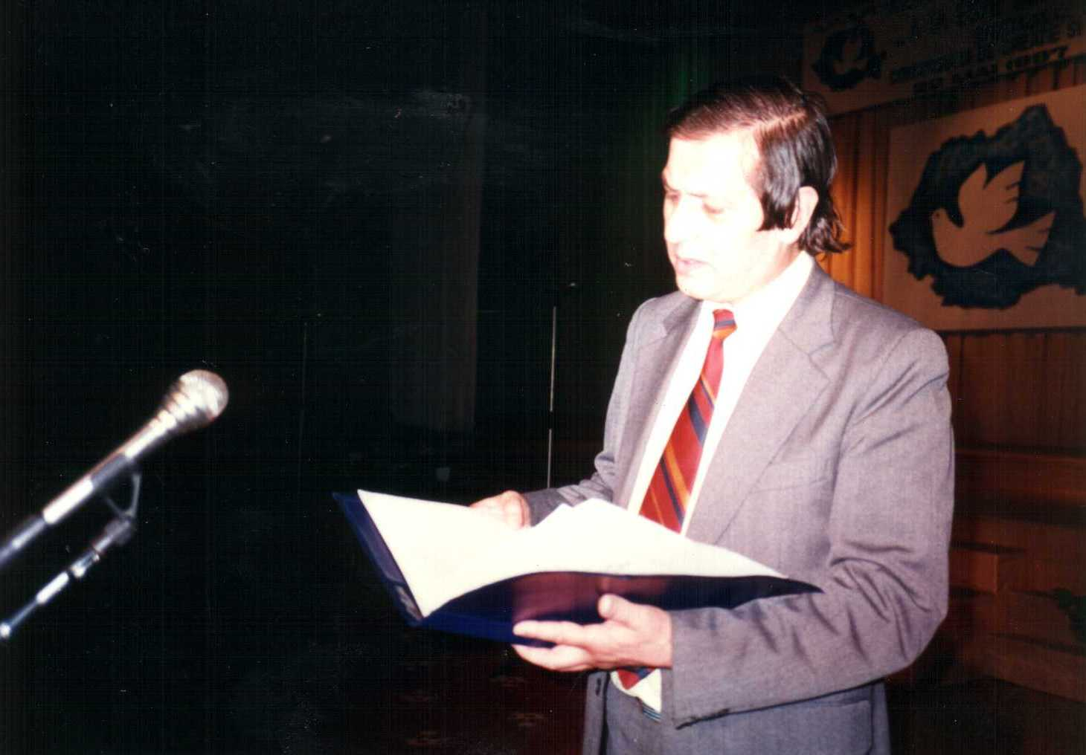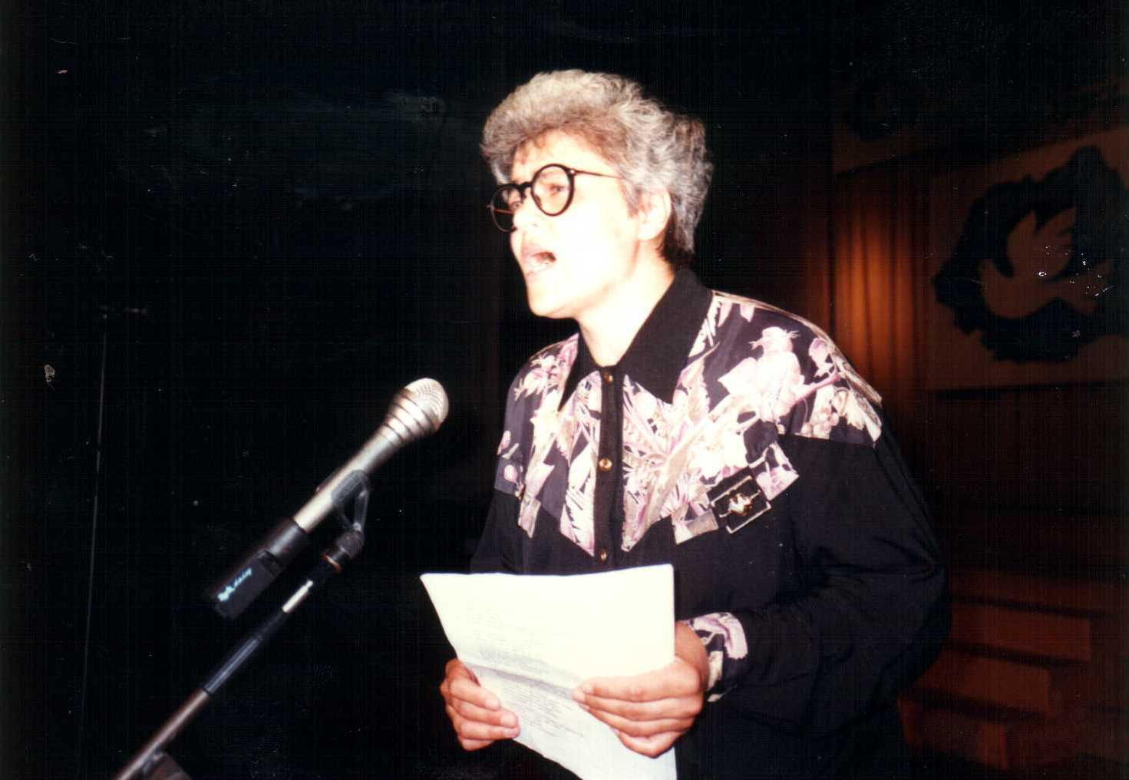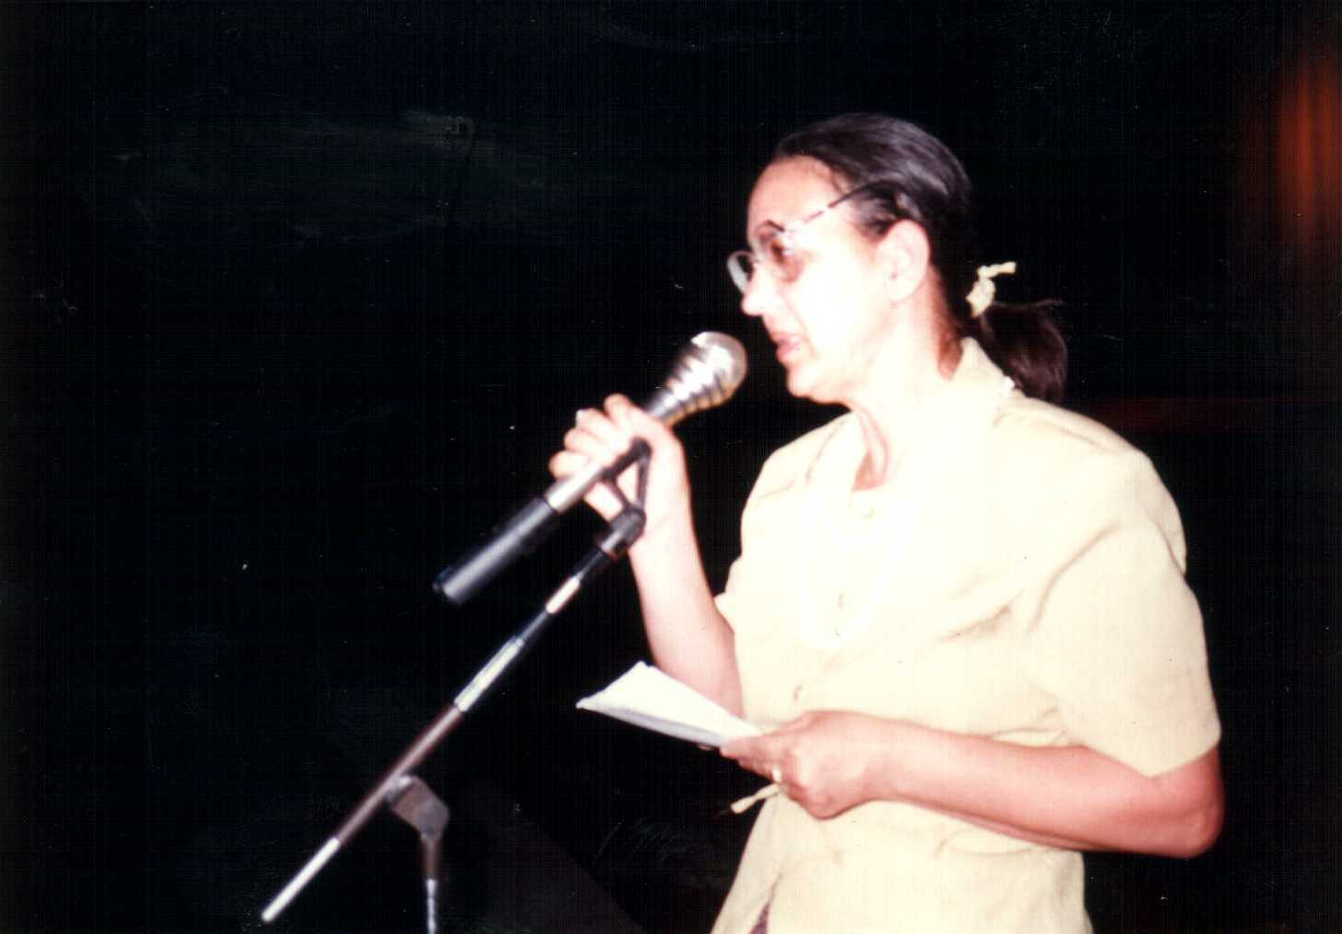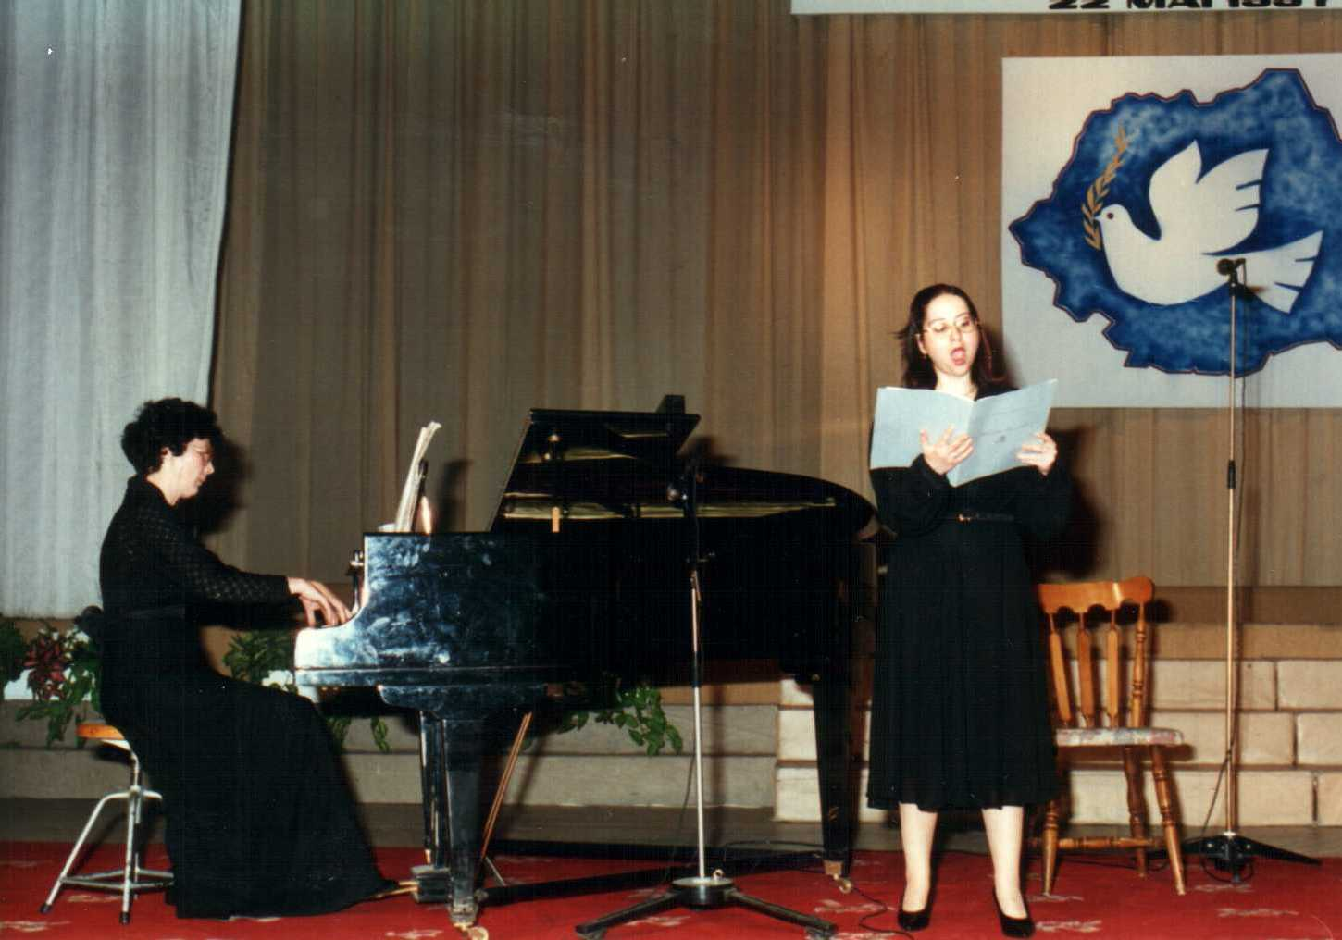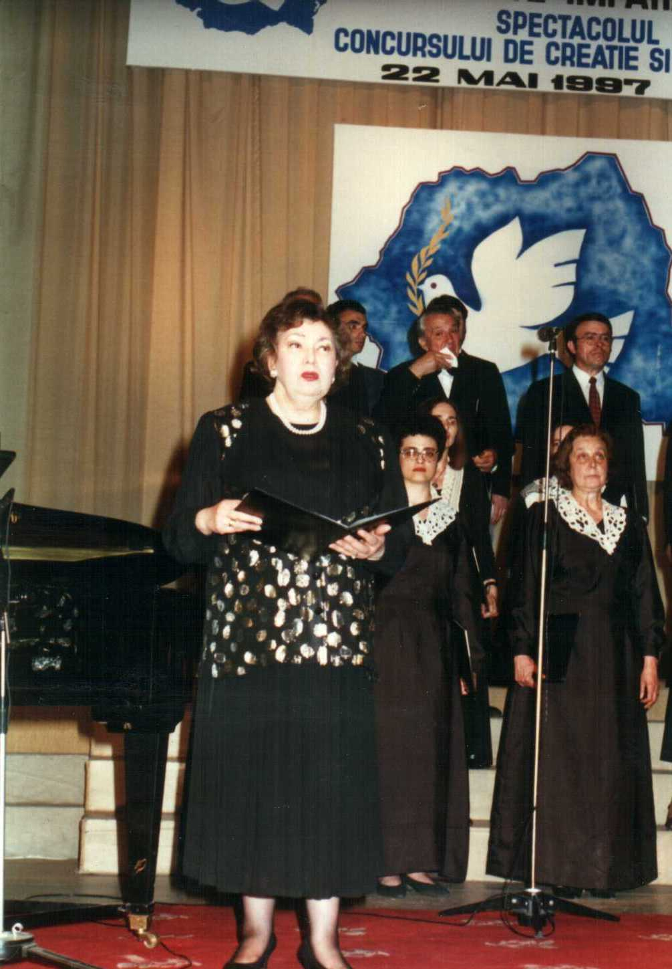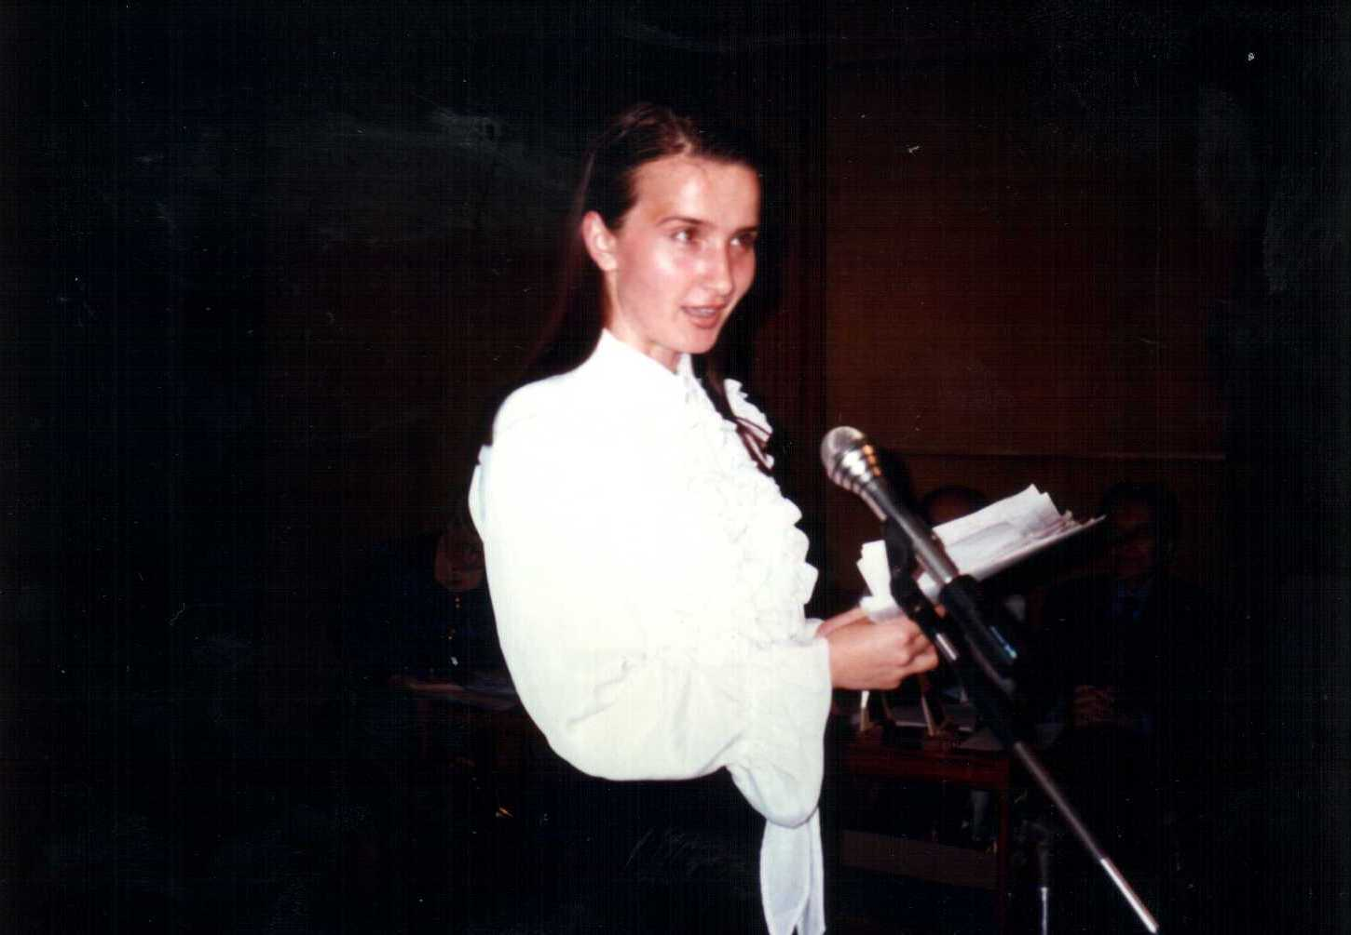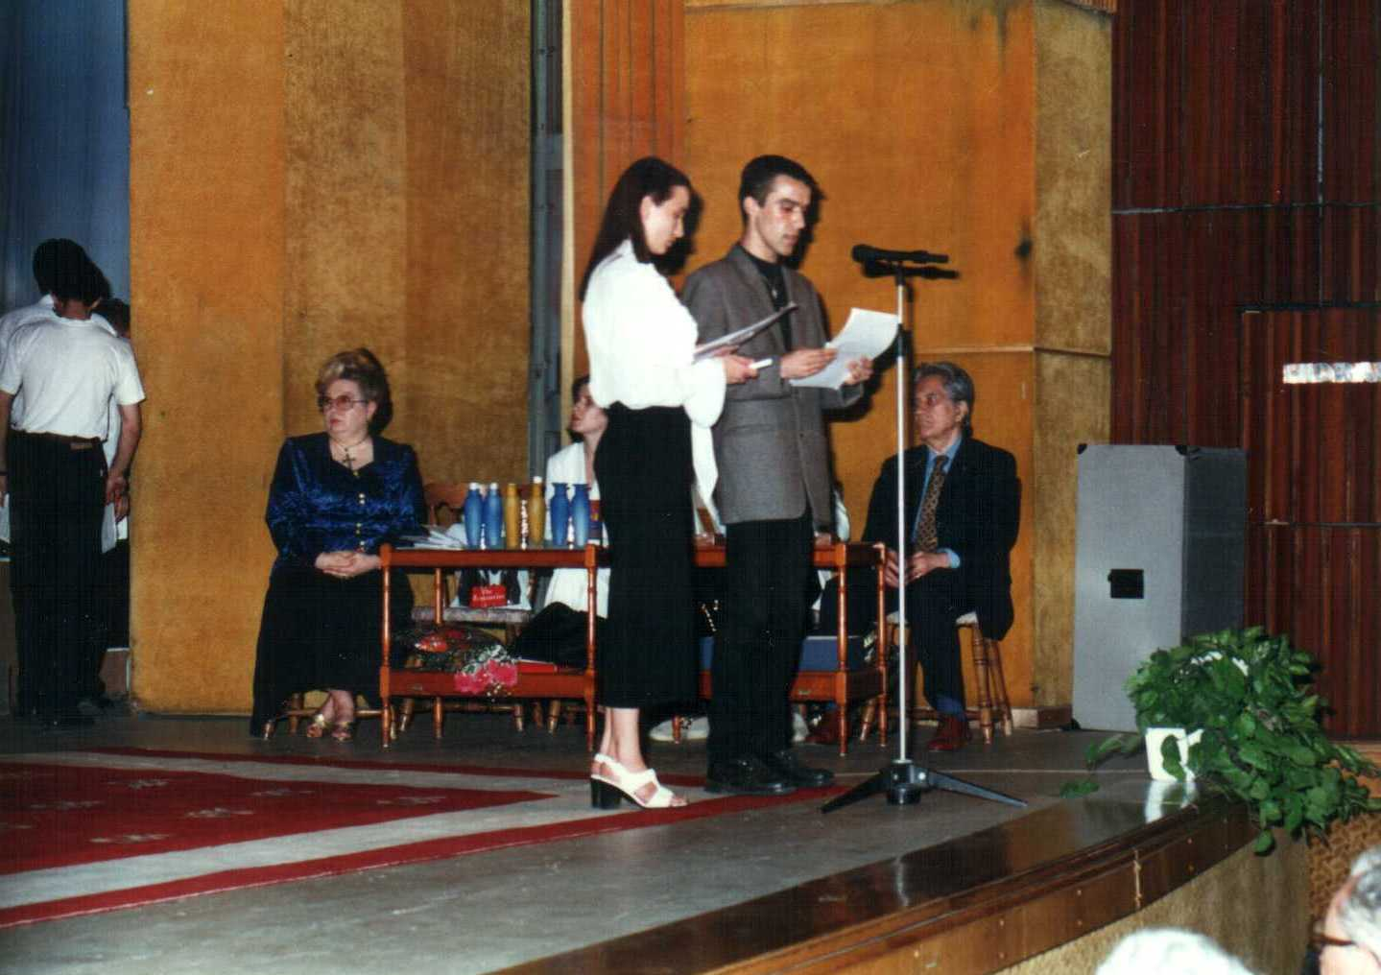
The Academy of Music Choir, conductor Mr. Mihai Diaconescu, Aurelian Gugu – Theology Seminarian from Slobozia City. Trio Dragoi, Razvan - piano, Postolache-cello , Orthodox Church Choir- “Corala Nicolae Lungu”- conductor Constantin Dragusin, Children’s Choir “Carmina Tenera”- Children’s Palace- conductor Constantin Popescu, Oana Manolecu, Irina Odagescu Tutuianu, Mihaela Nicoleta Preda, Marta Murnai, Mrs. Mirea, Yldiz Imdat, Choir Orchestra “Sira-Vezimra” –Coral Temple, Georgiana Pana- guest- performed “Coral” by I.S. Bach, Conductor Izu Gott, “Coral” Temole – Choir Sira-Vezimra, Mrs. Doina Ghitescu, Tihon Vasile, Catana Maria, Abdula Ghiulten, The Corala of “Sf. Iosif” Cathedral from Bucharest, conductor Marcel Octav Costea, Consortiu Choir - Ady Endre high school – CALVINEUM Protestant, Church conductor Ollerer Agnes, Adventist Christian Church , Crina Zanc, Carla Musat, Mrs. Maria Nistor Slatinaru, the Festival Hosts: - Ana Maria Conaser and Valentin Ionescu, Angeli Choir - Greco-Catholic, conductor Onisor Oana.

Aspects from the audience – Persons of consequence present to the Contest Awards Gala

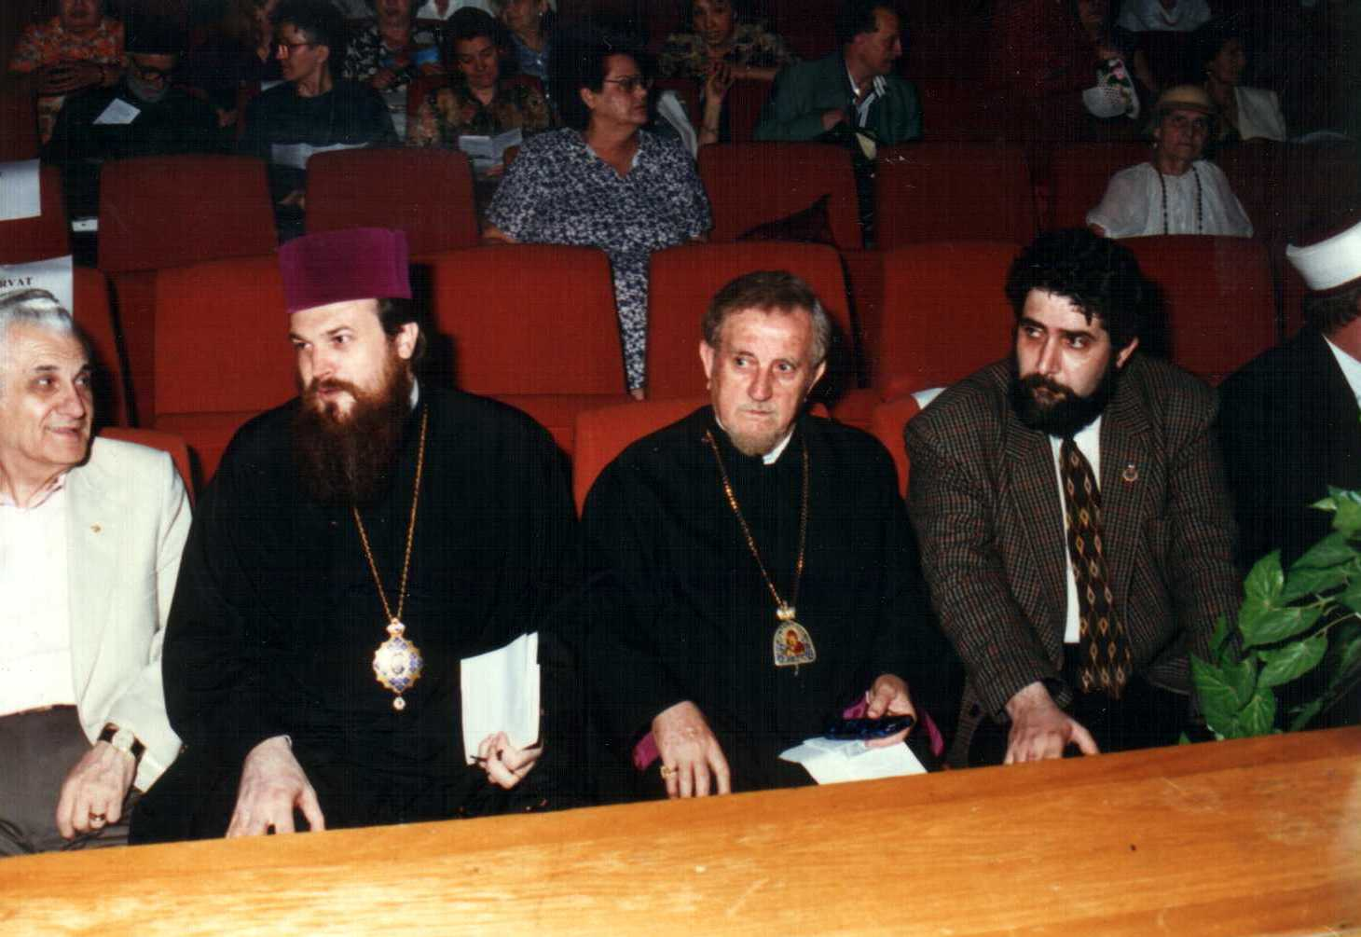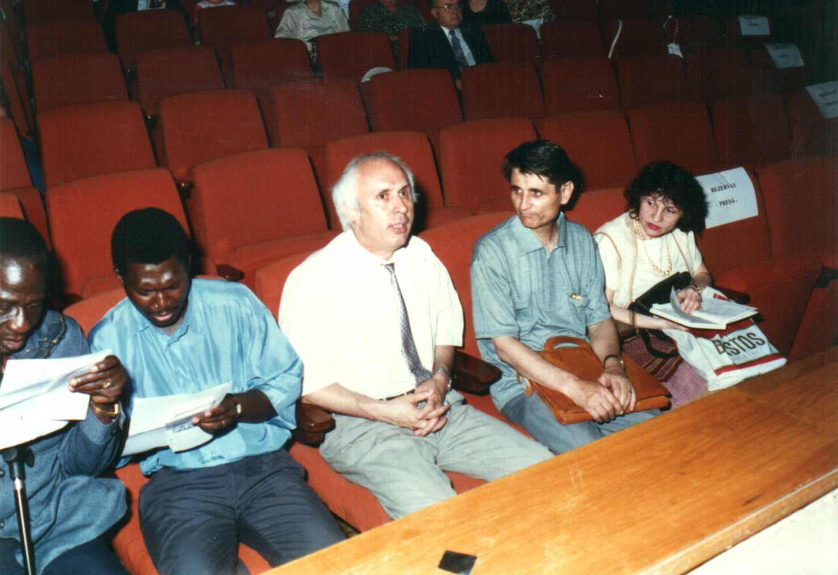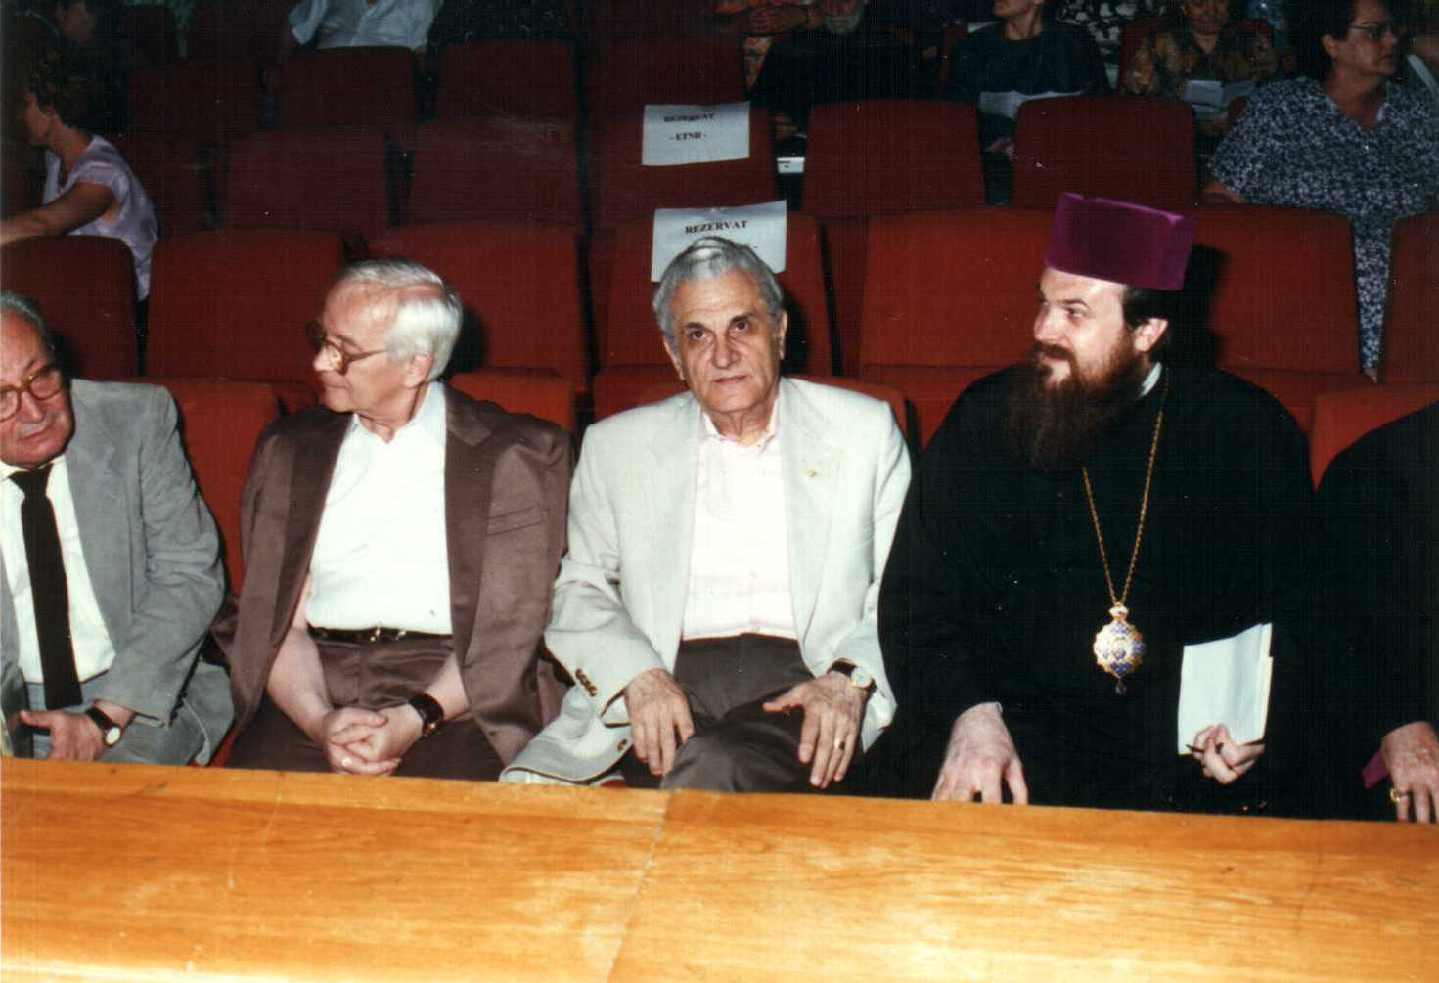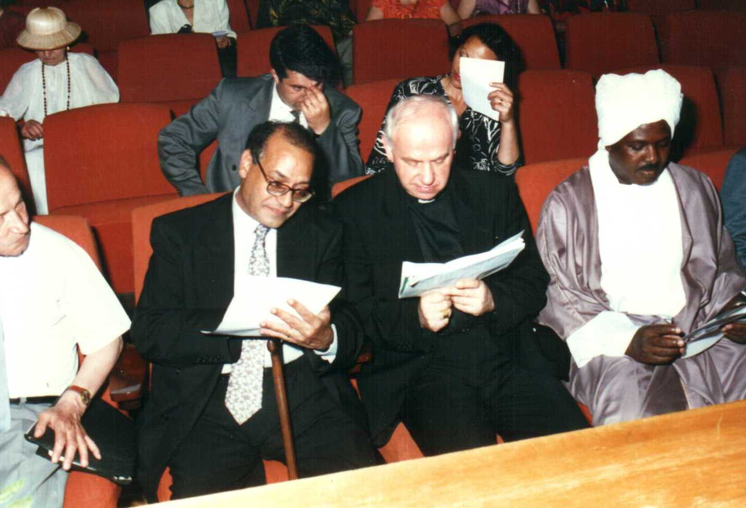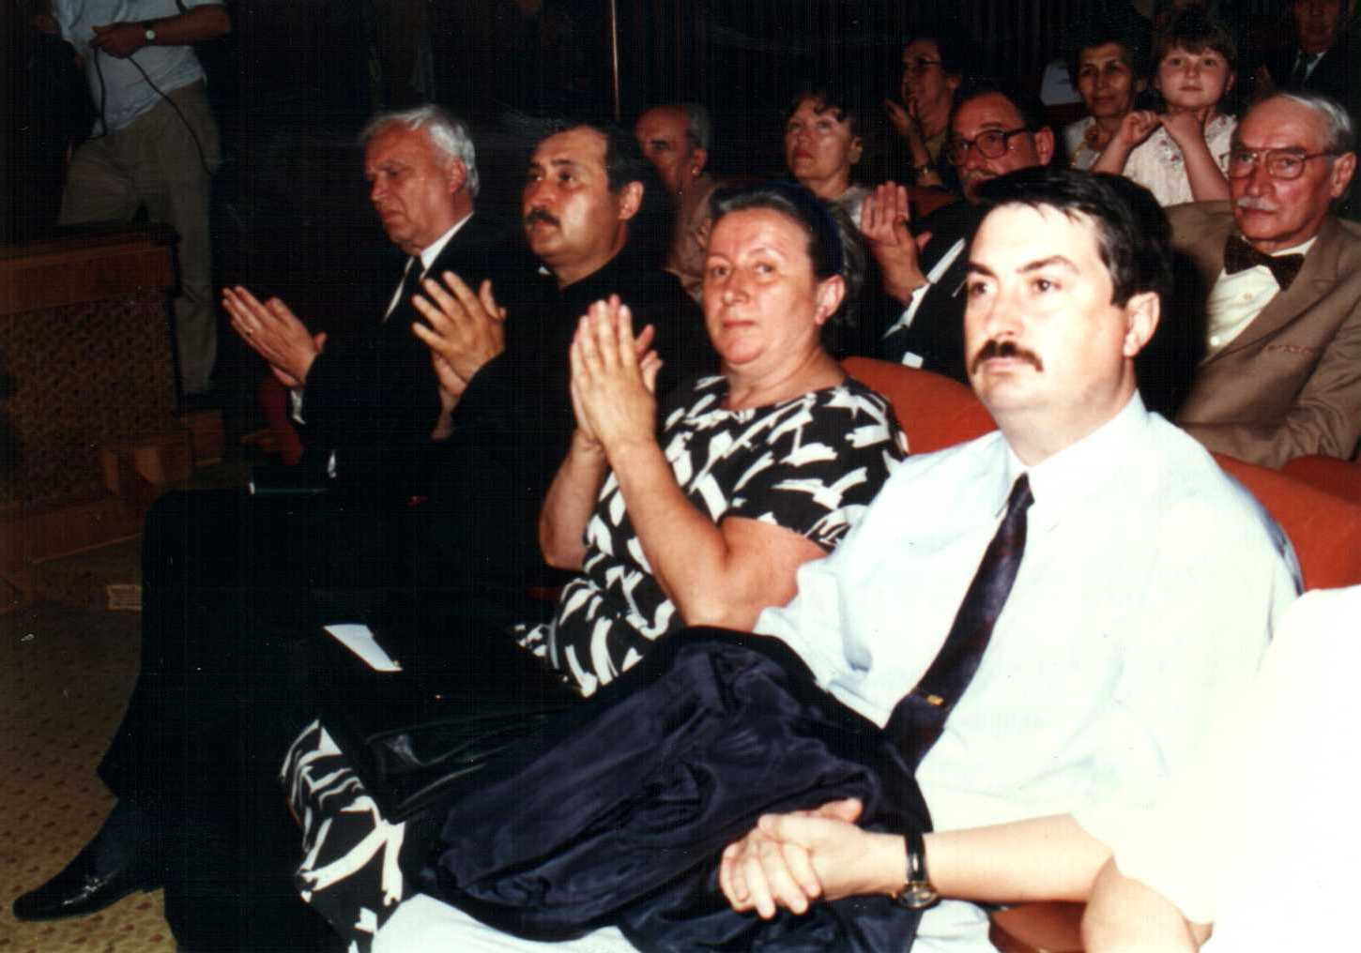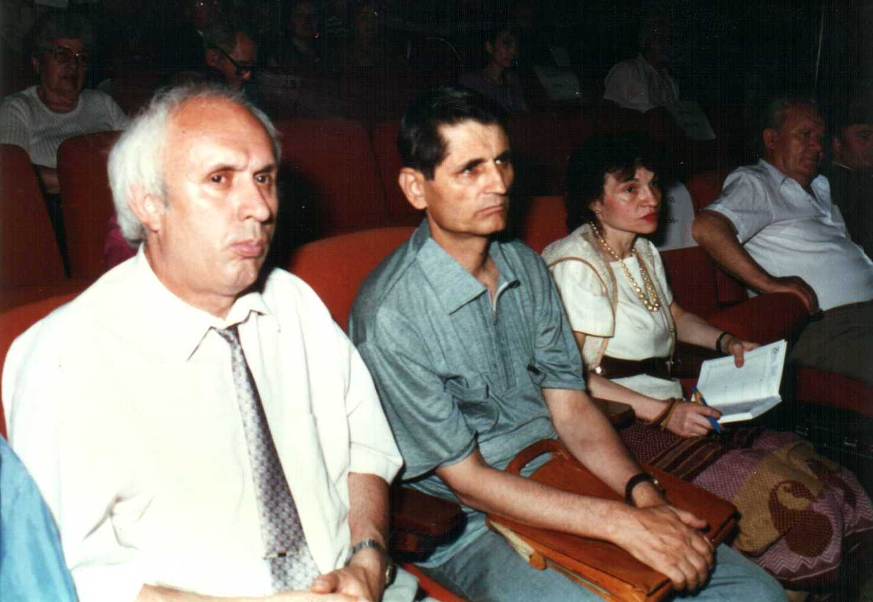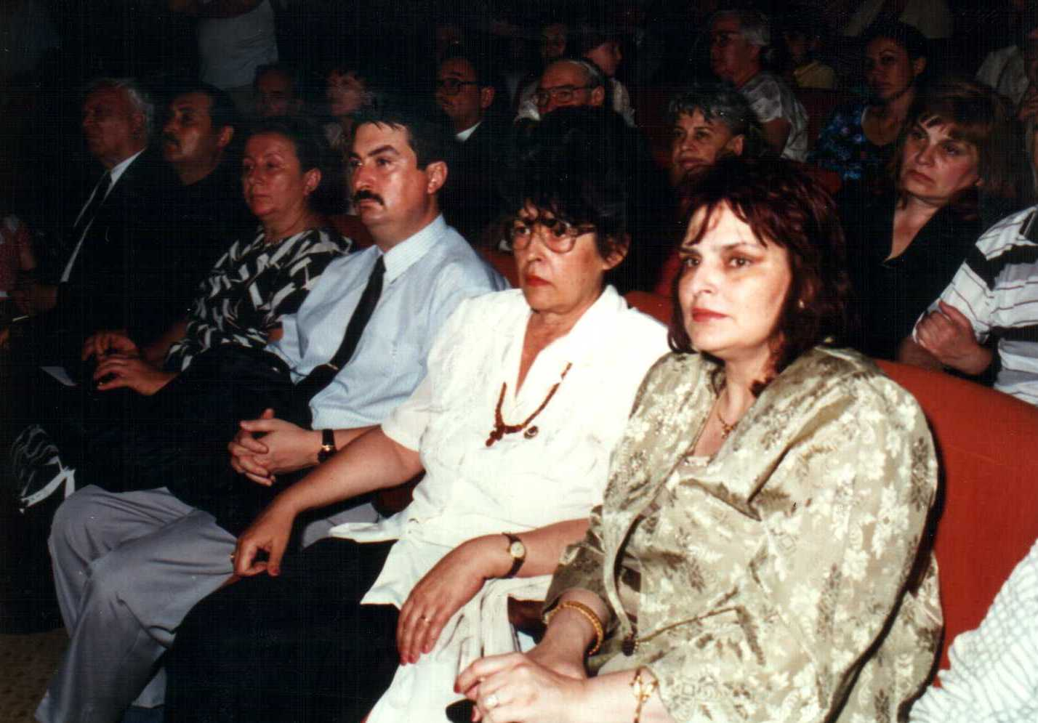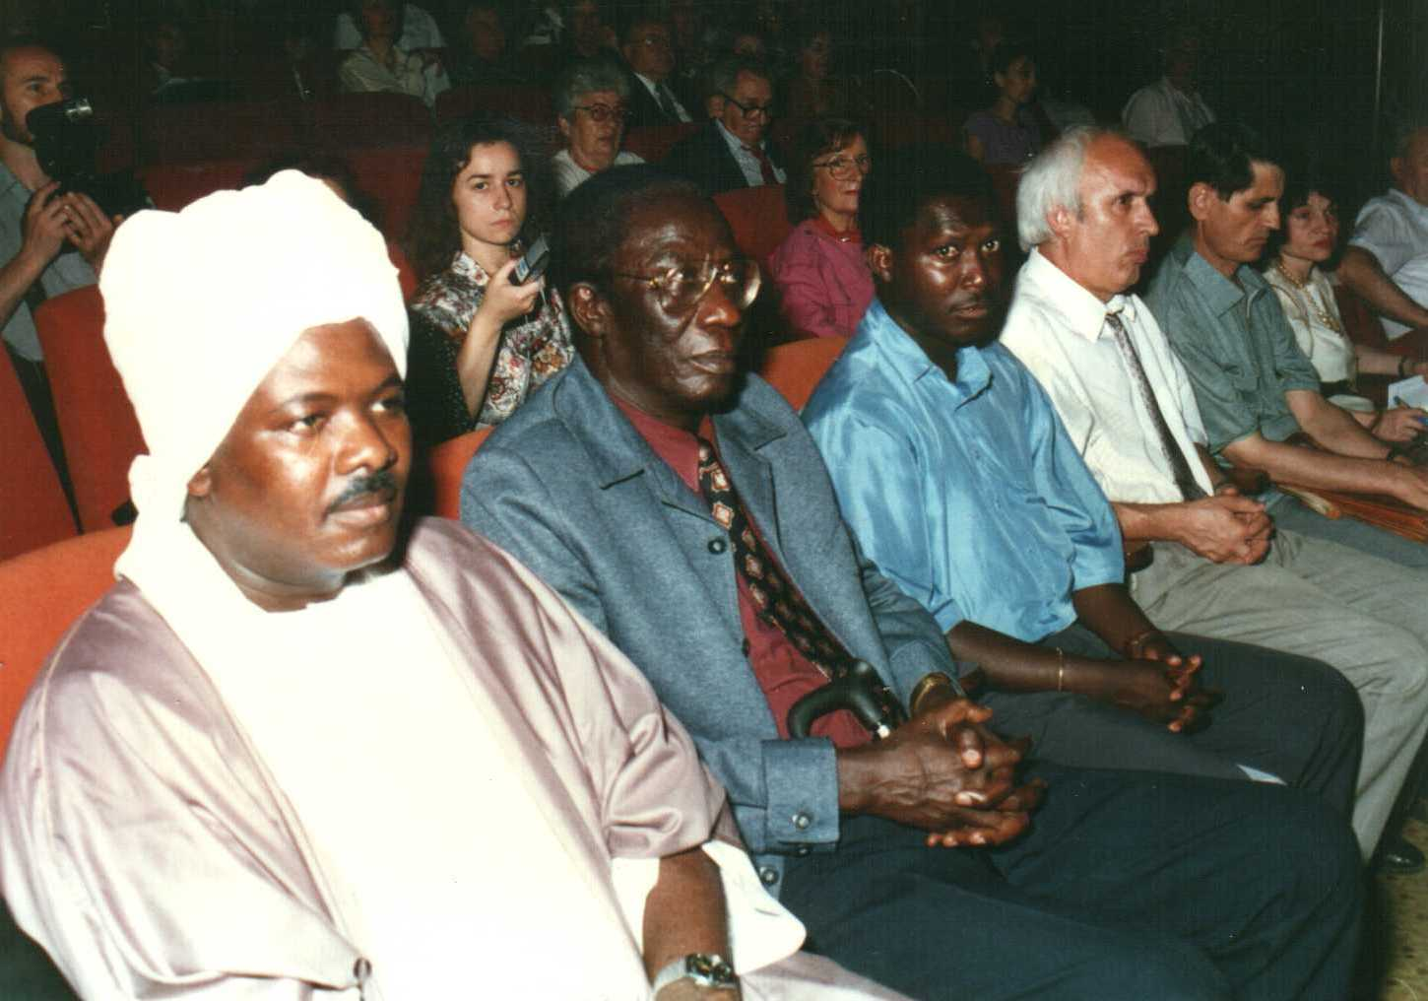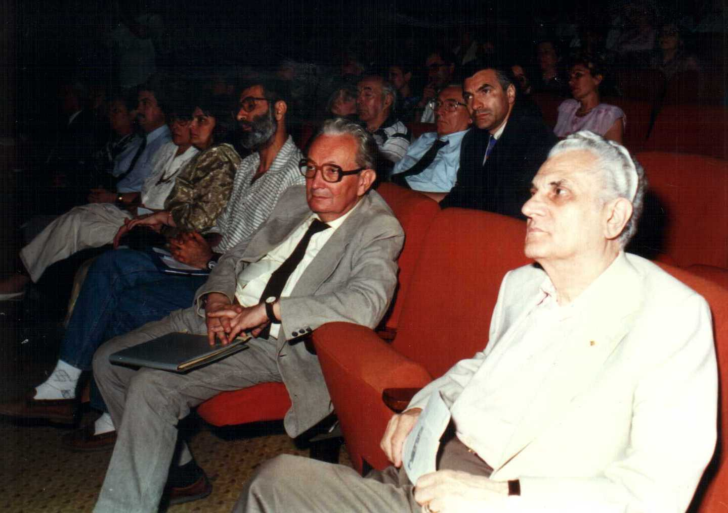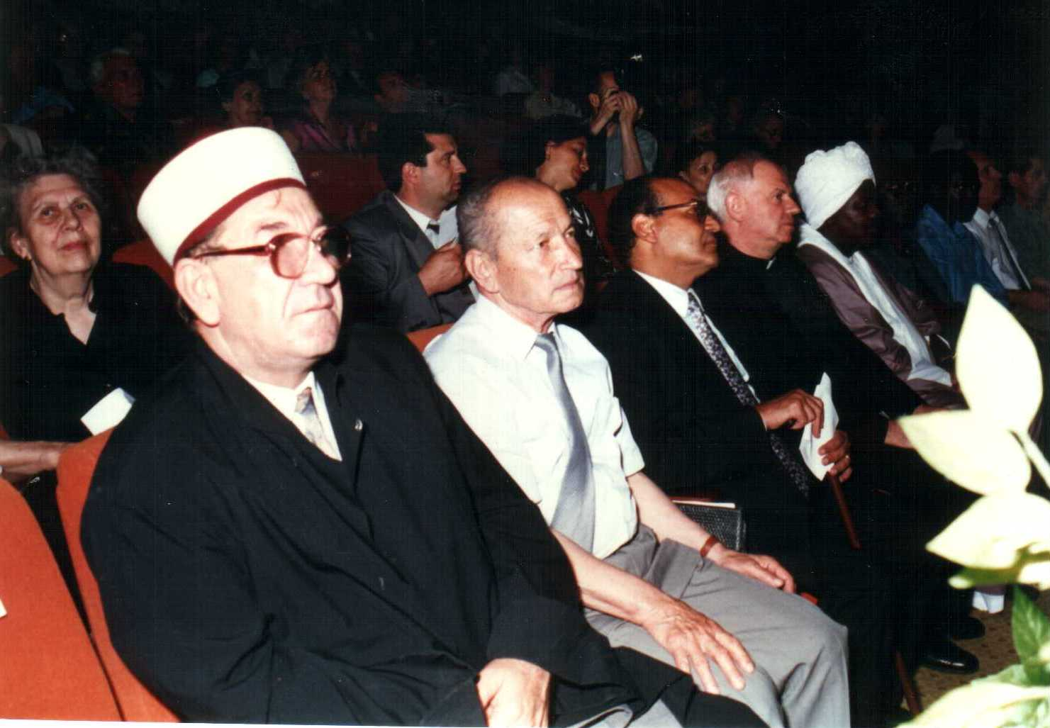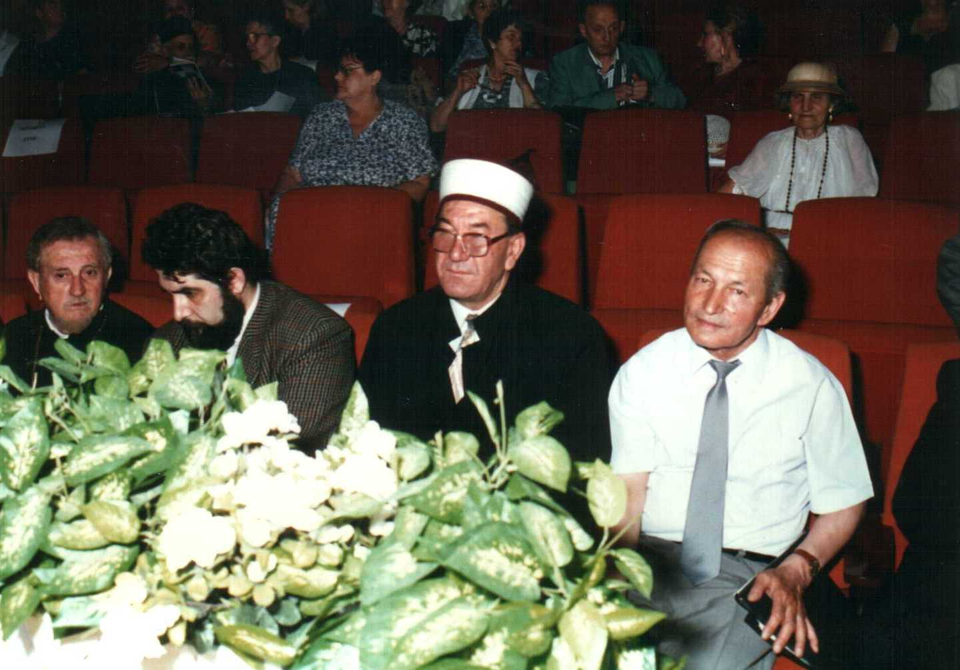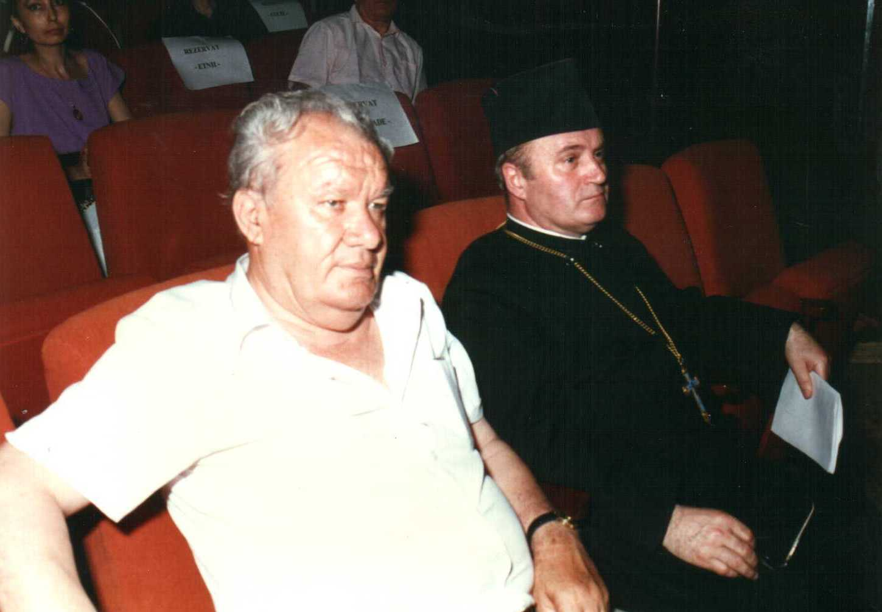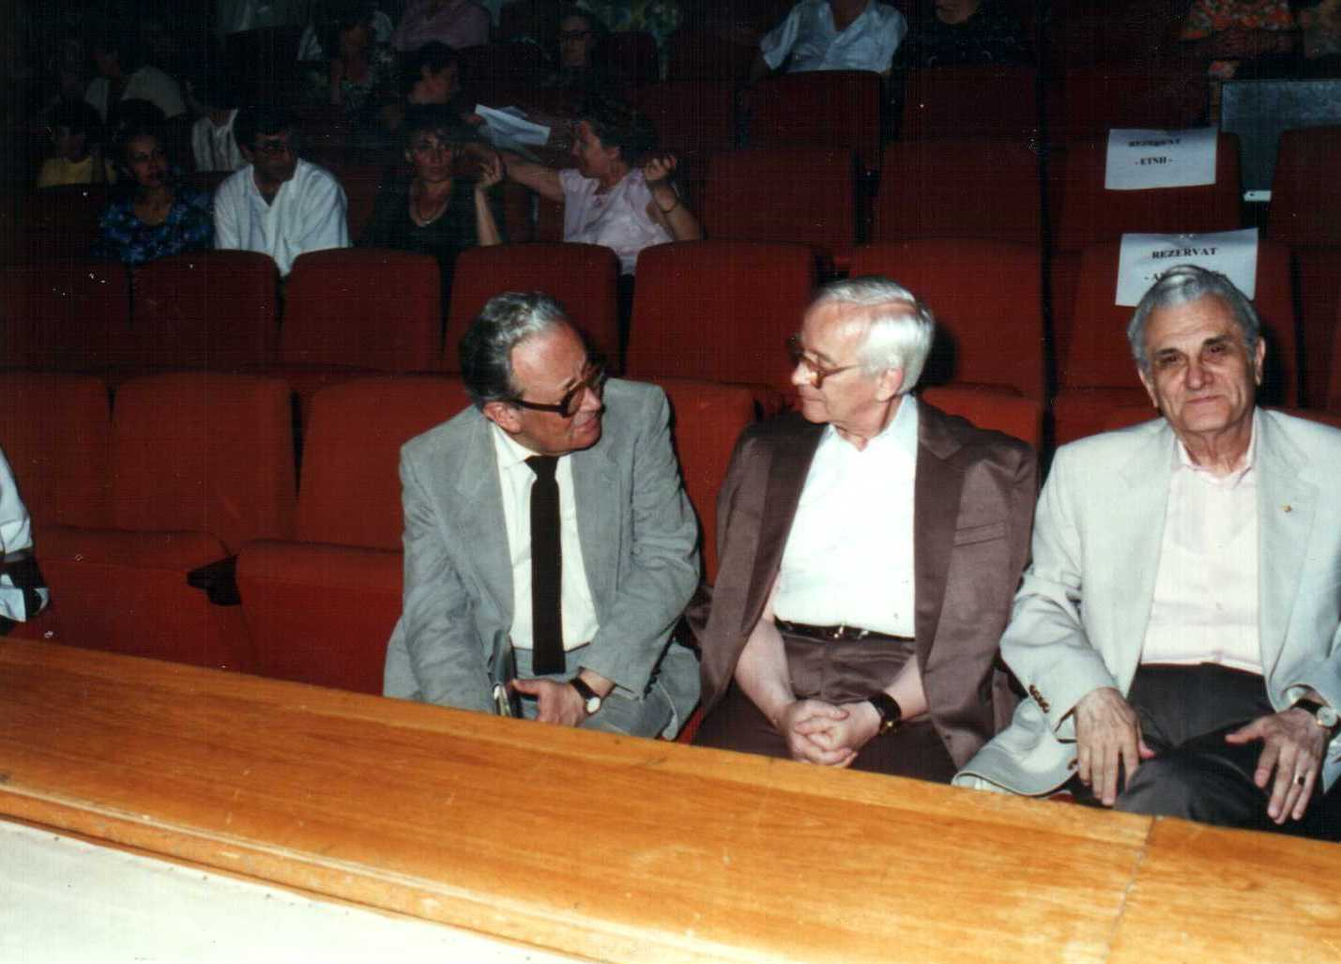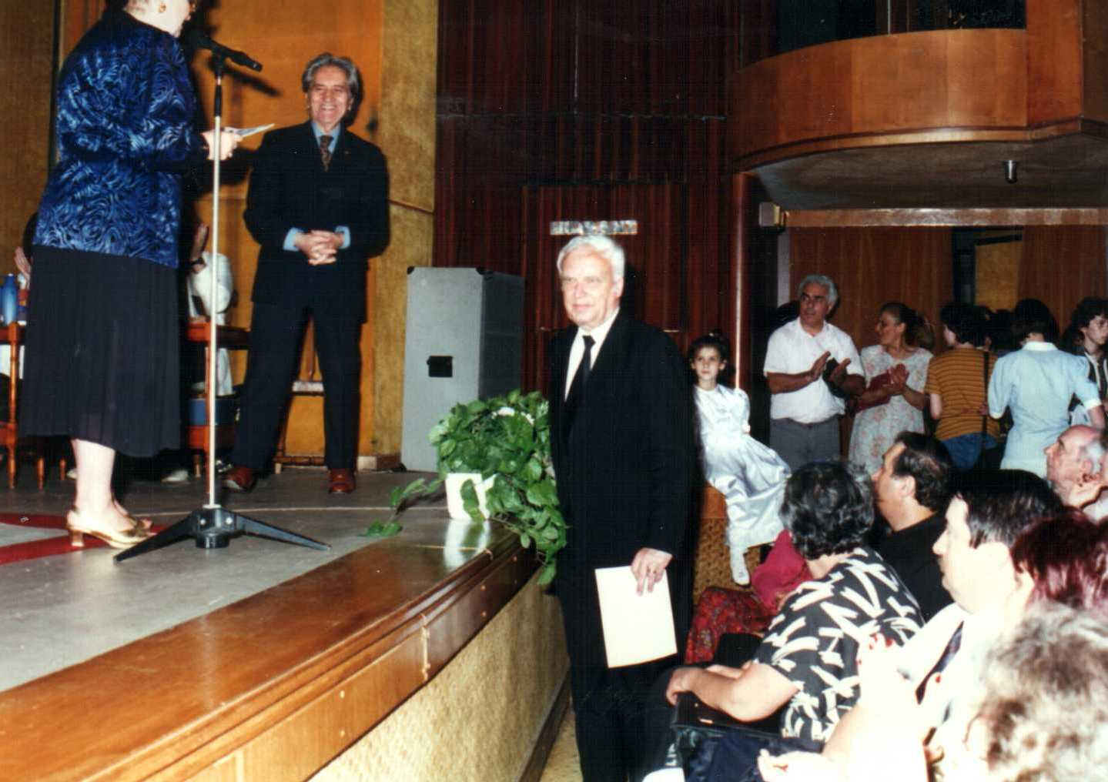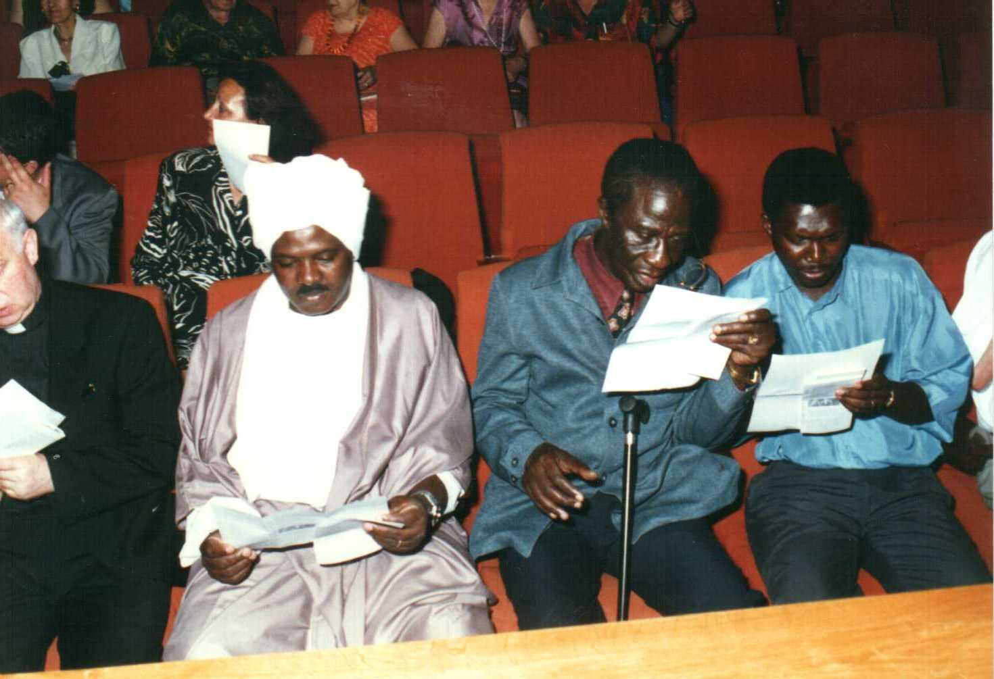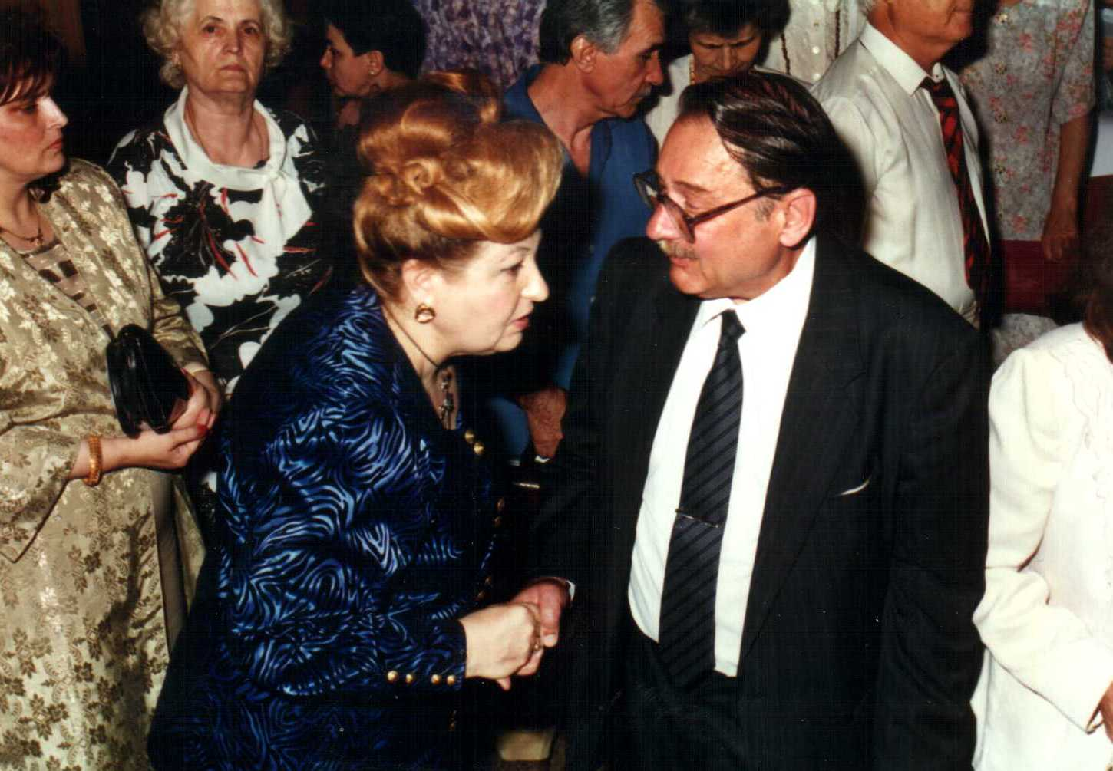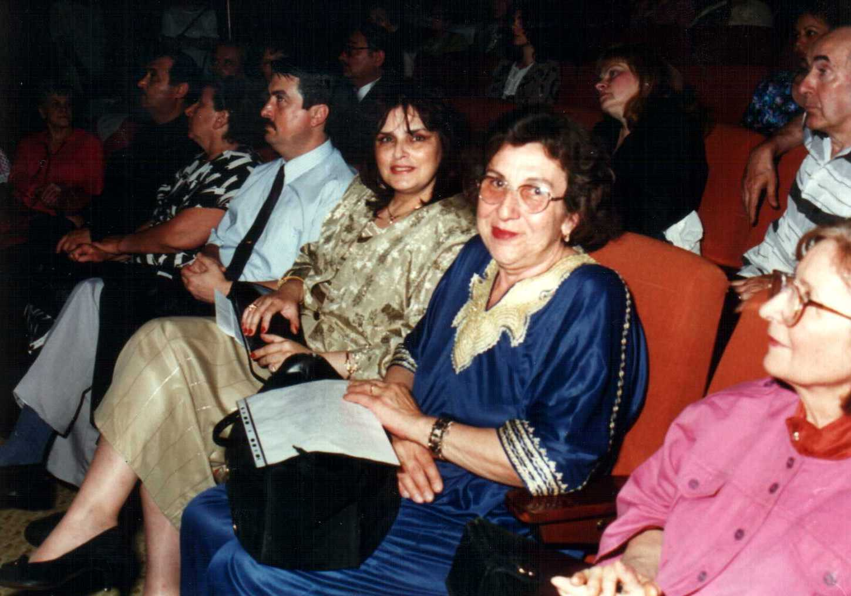
His Holiness Vicentiu Ploiesteanu, Archbishop Drair Mardikian, member of Parliament, Vozganian Pampuccian, Ambassador Ilinoiu, State Secretary of Cults Mr. Fonta Ilie - Ambassadors, Representatives of the Mosaic Cult, Lawyer Mr. Iulian Sorin, Mr. Imam Osman Azis and Muftiu from Constanta Mr. Osman Bezir Azis, Ft. Prof .Alnu Zoltan Zagani –Calvin Church, Ft. Mihai Cristescu – The Orthodox Church, Minister State Secretary Teodor Purcarea, Member of Parliament Oana Manolescu – Albanians, Ambassadors present at the “Religious Creation” Festivity, Mr. Albert Poch – Mosaic Cult, Albakim- representative of the Moslem Cult from Constanta city, the representative of the Apostolic Nuncio in Romania – Janusz Boloner, Representative of the Mosaic Cult, Miklos Peter – Ministry State Secretary.

Aspects from the jury deliberation upon the musical compositions

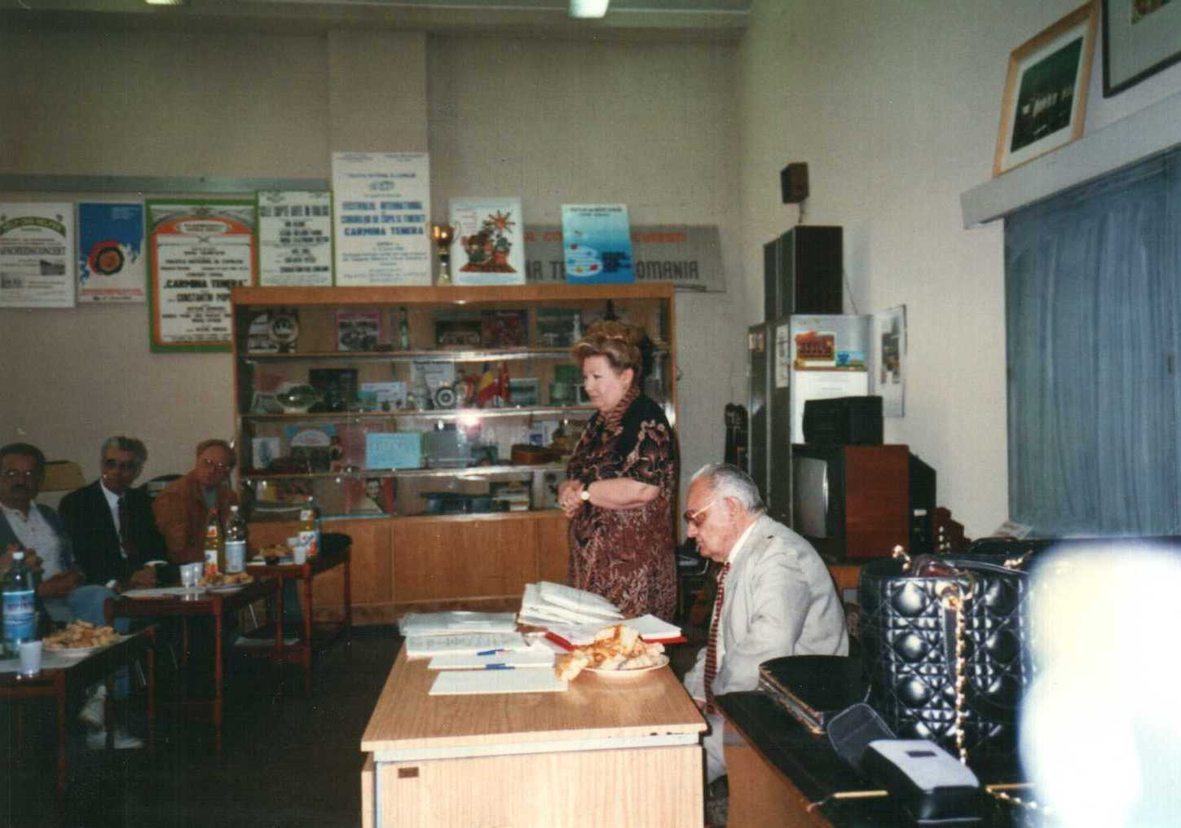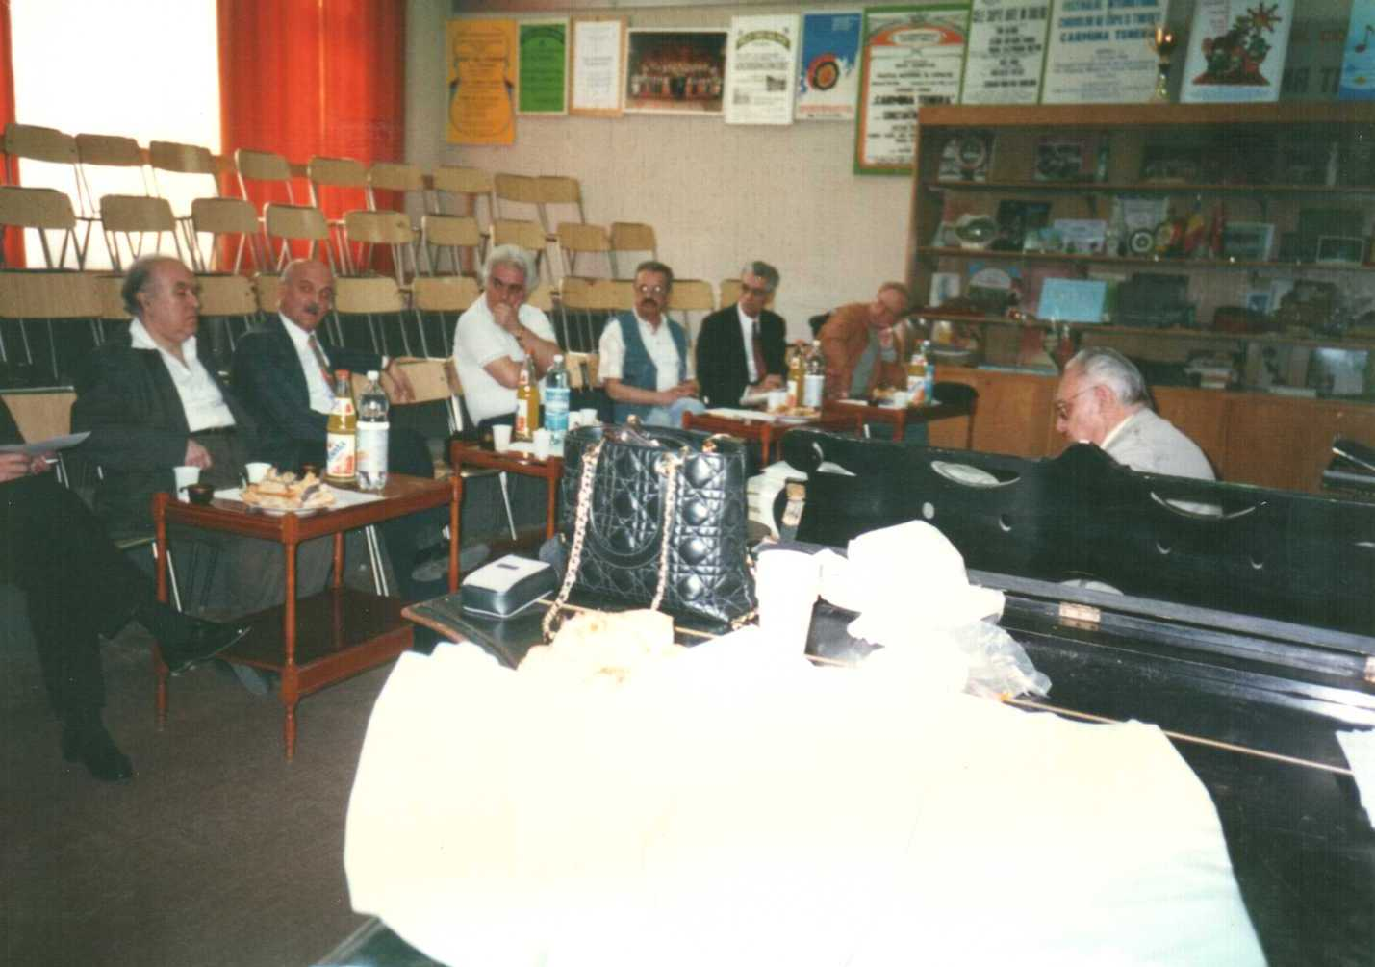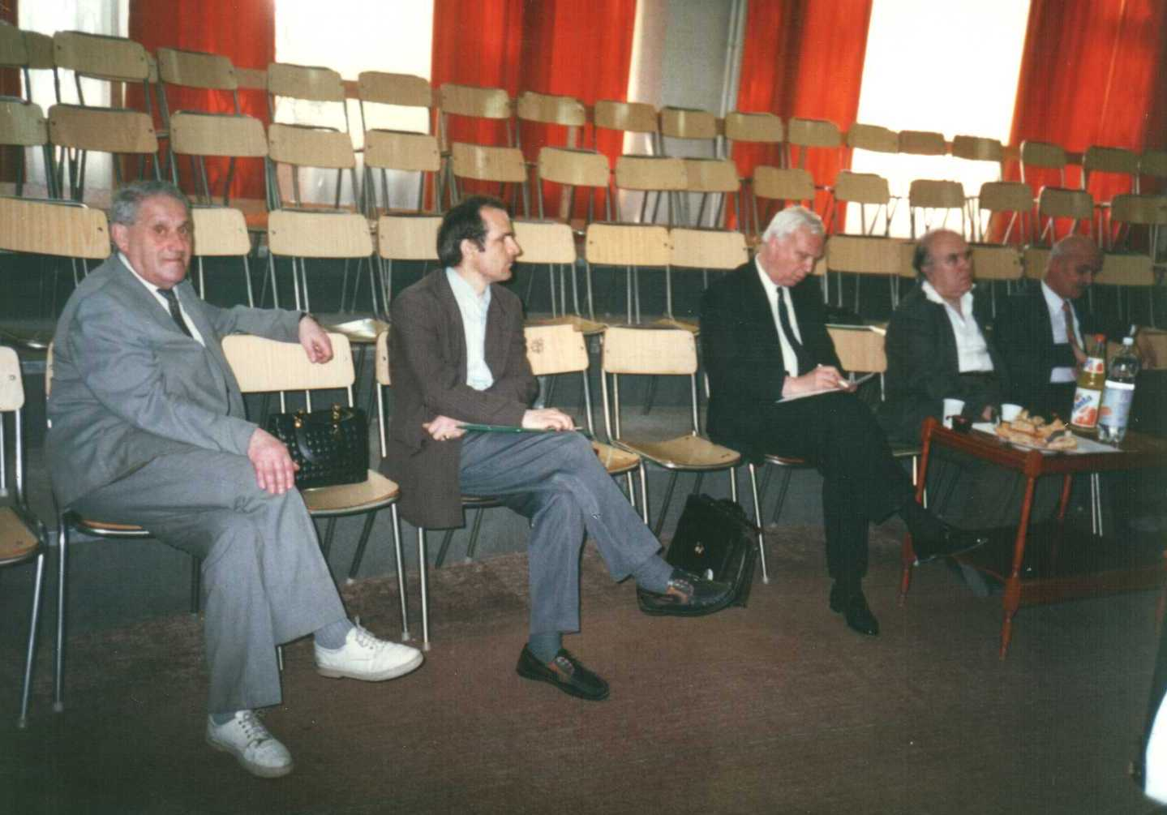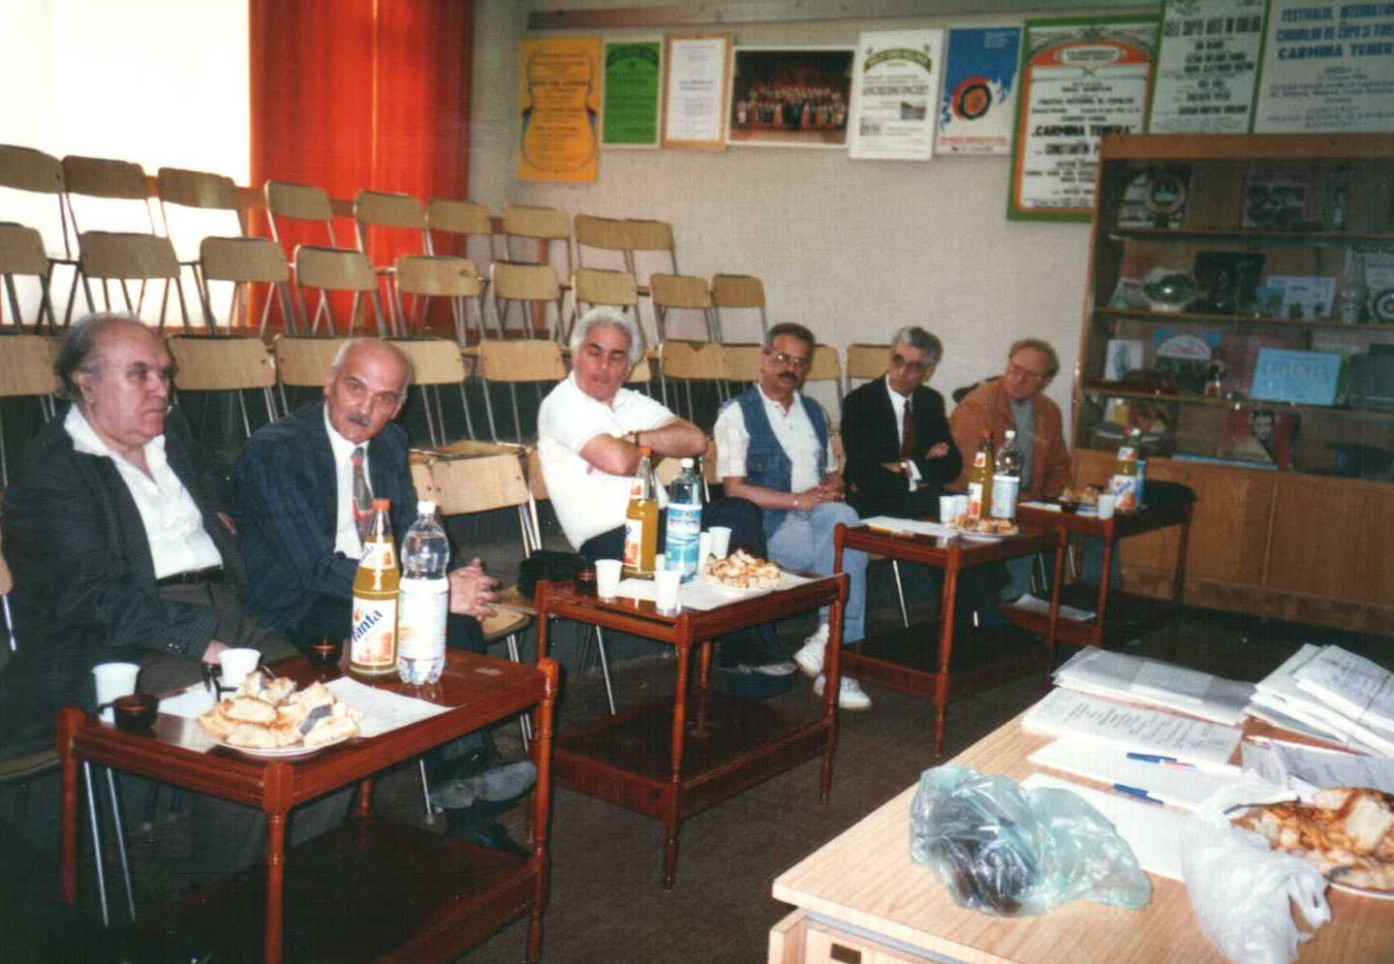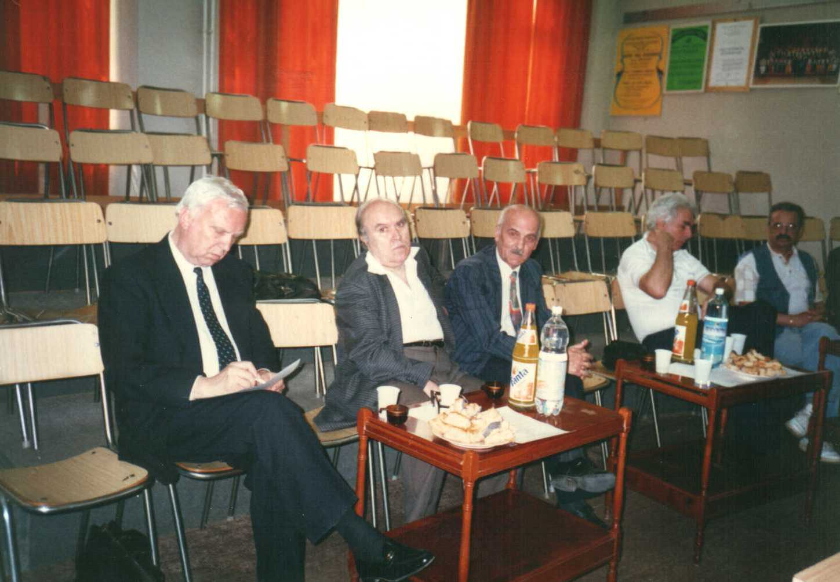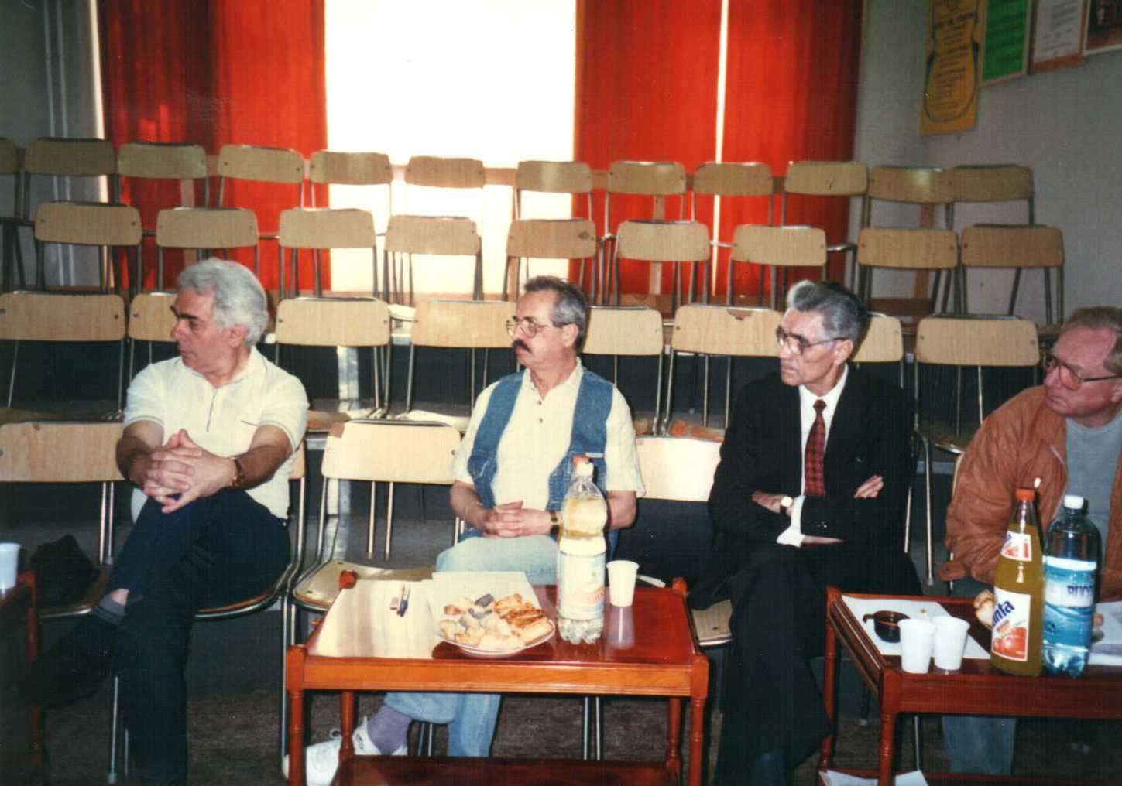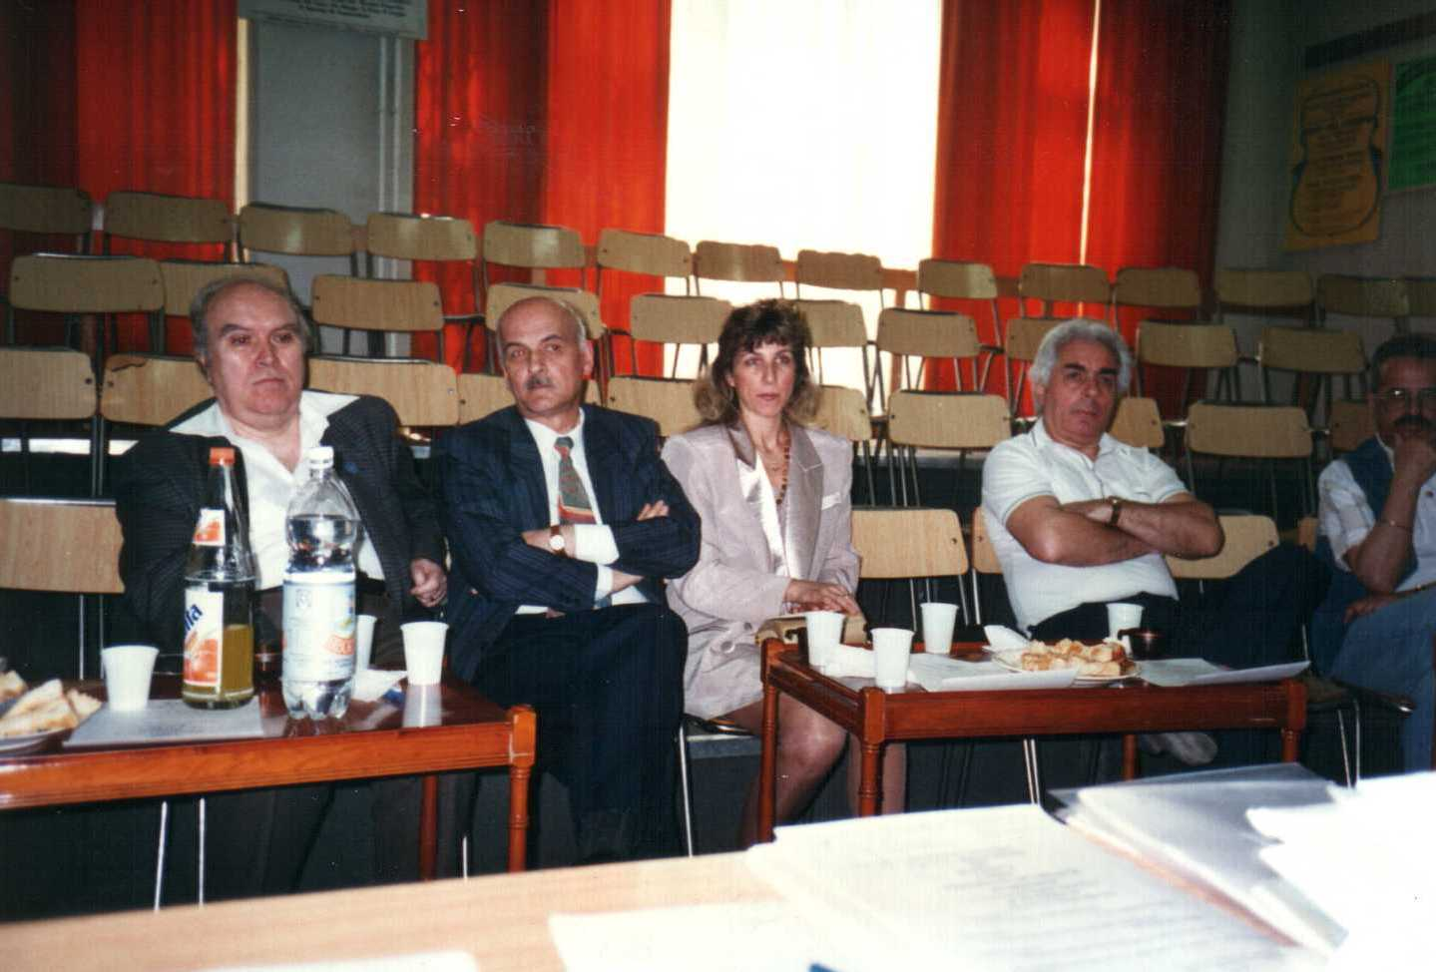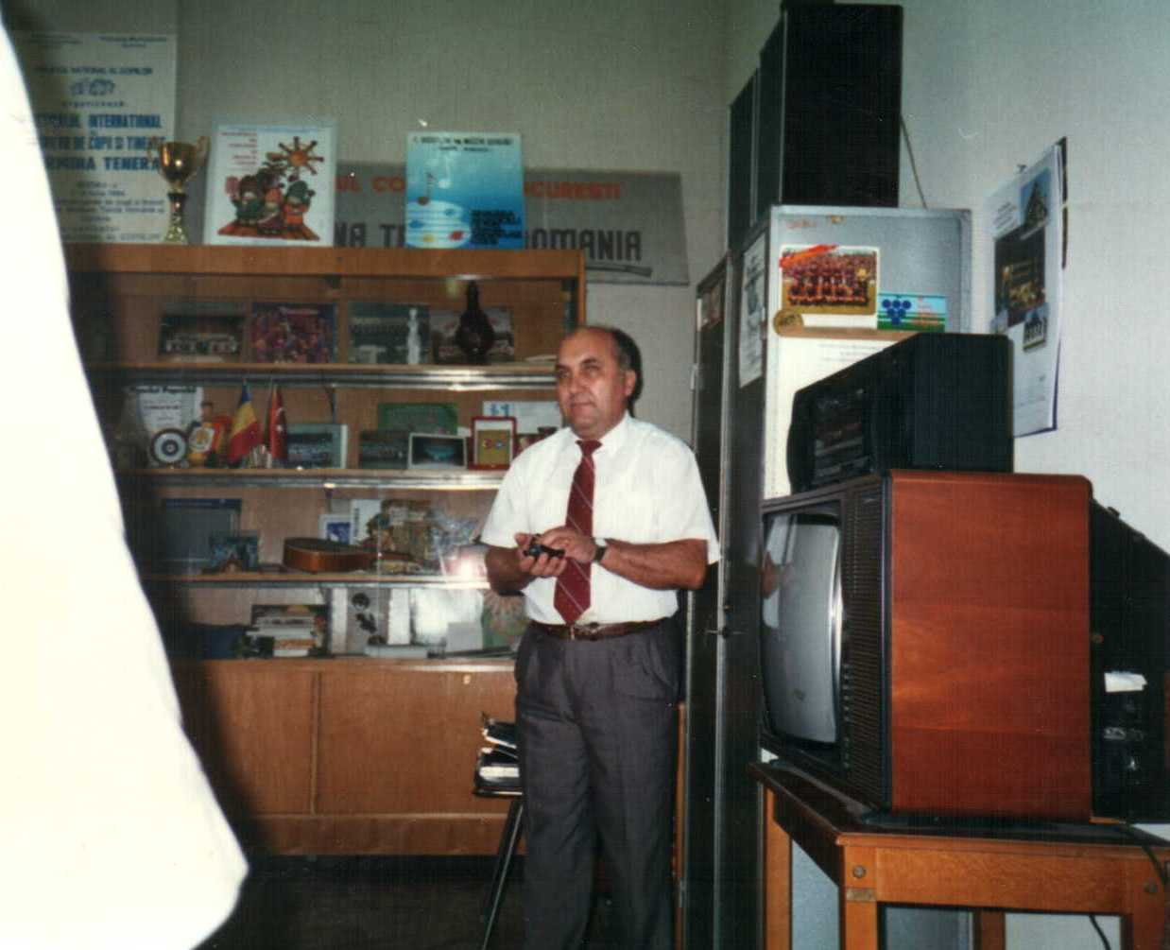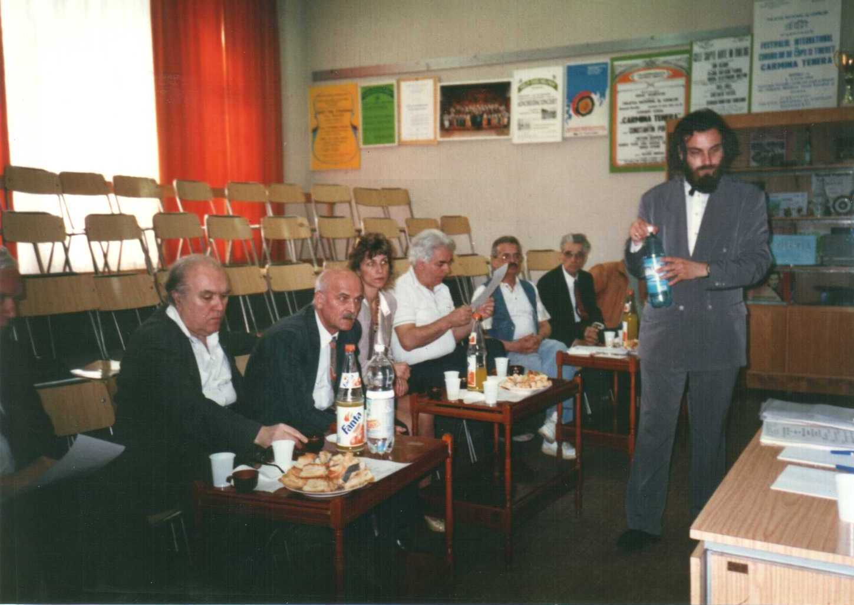
Gall Eugen – stage manager Doru Popovici, Ian Tugui, Mihaela Vozganian, Ioan Serbu, Carapanceanu Stefan, Constantin Dragusin- orthodox priest, Izu Gott, Ioan Serb- B’ahai, Doru Popovici- composer, Ion Tugui , Ft. Albu Zoltan Zagoni – Calvinist , Cati Camil, Constantin Popescu, Zavatte Lucian

Aspects from the art show and jury deliberation

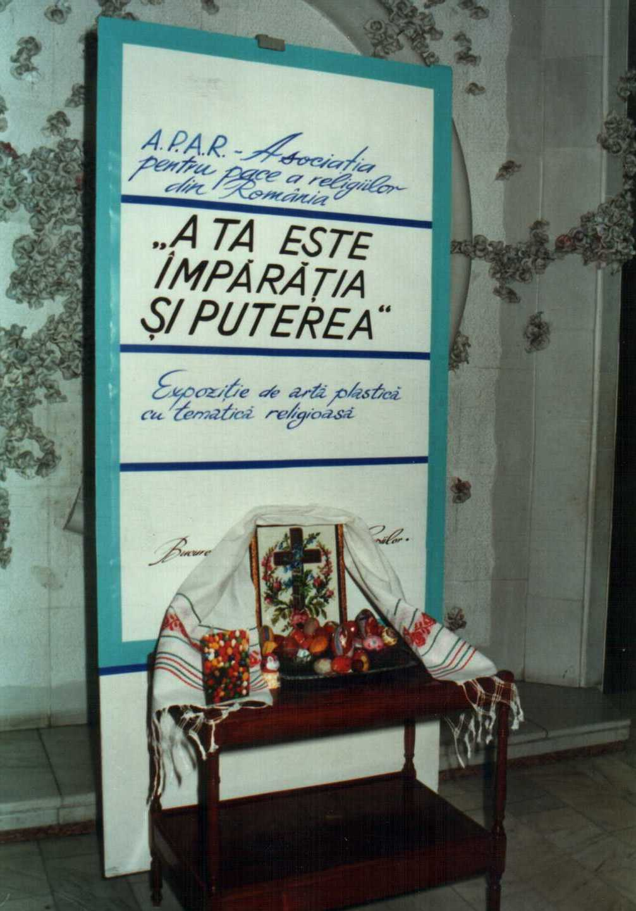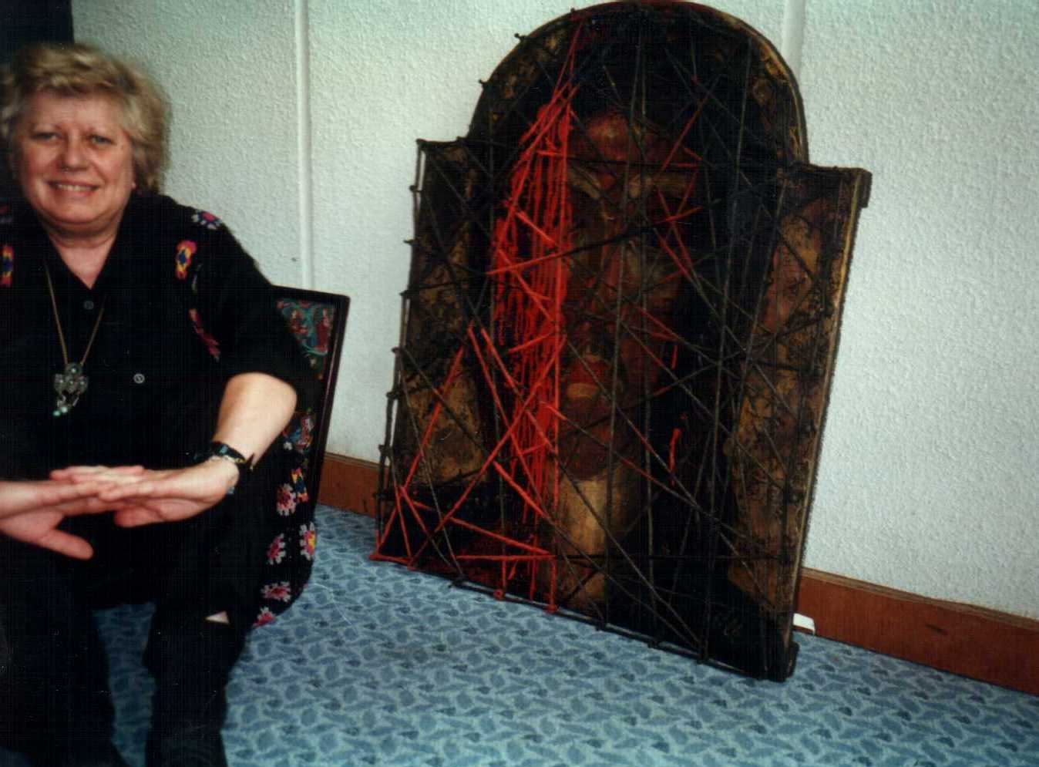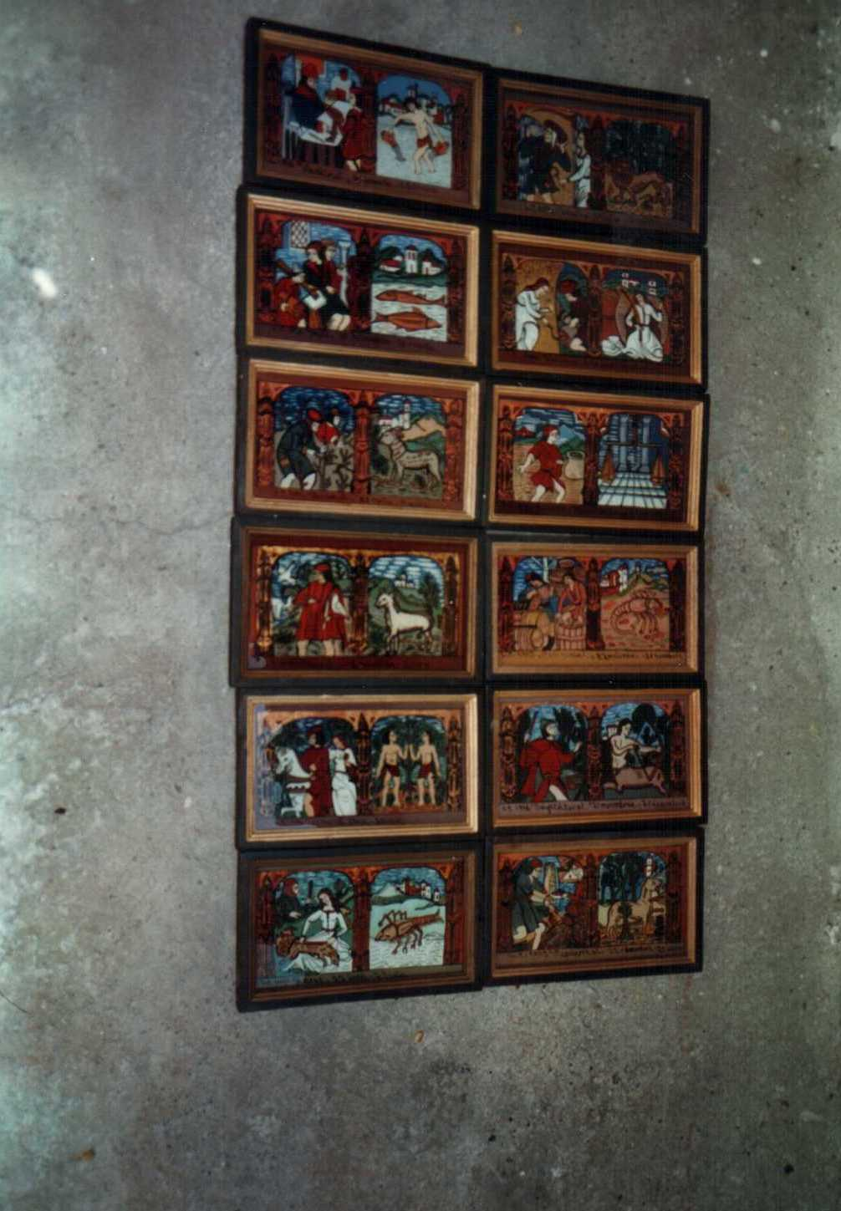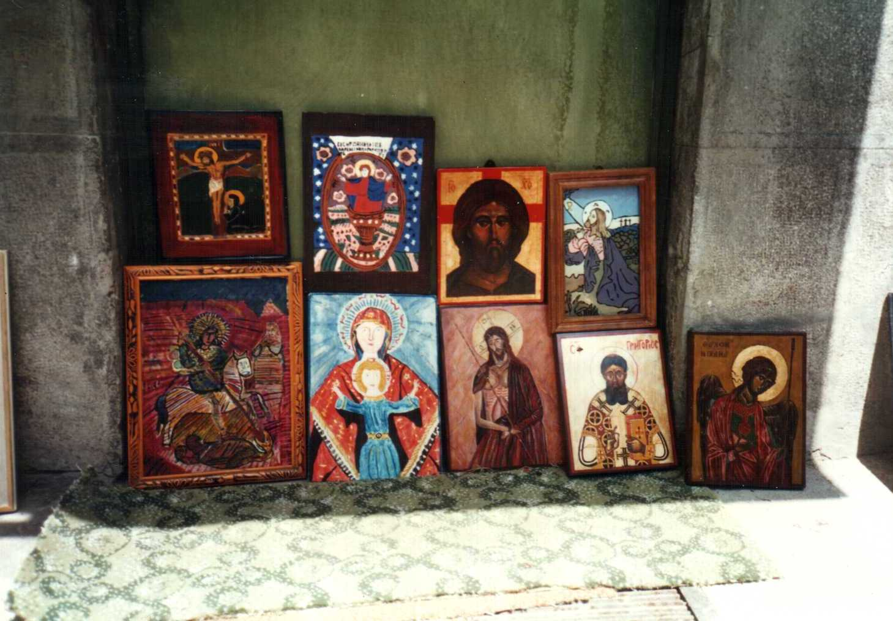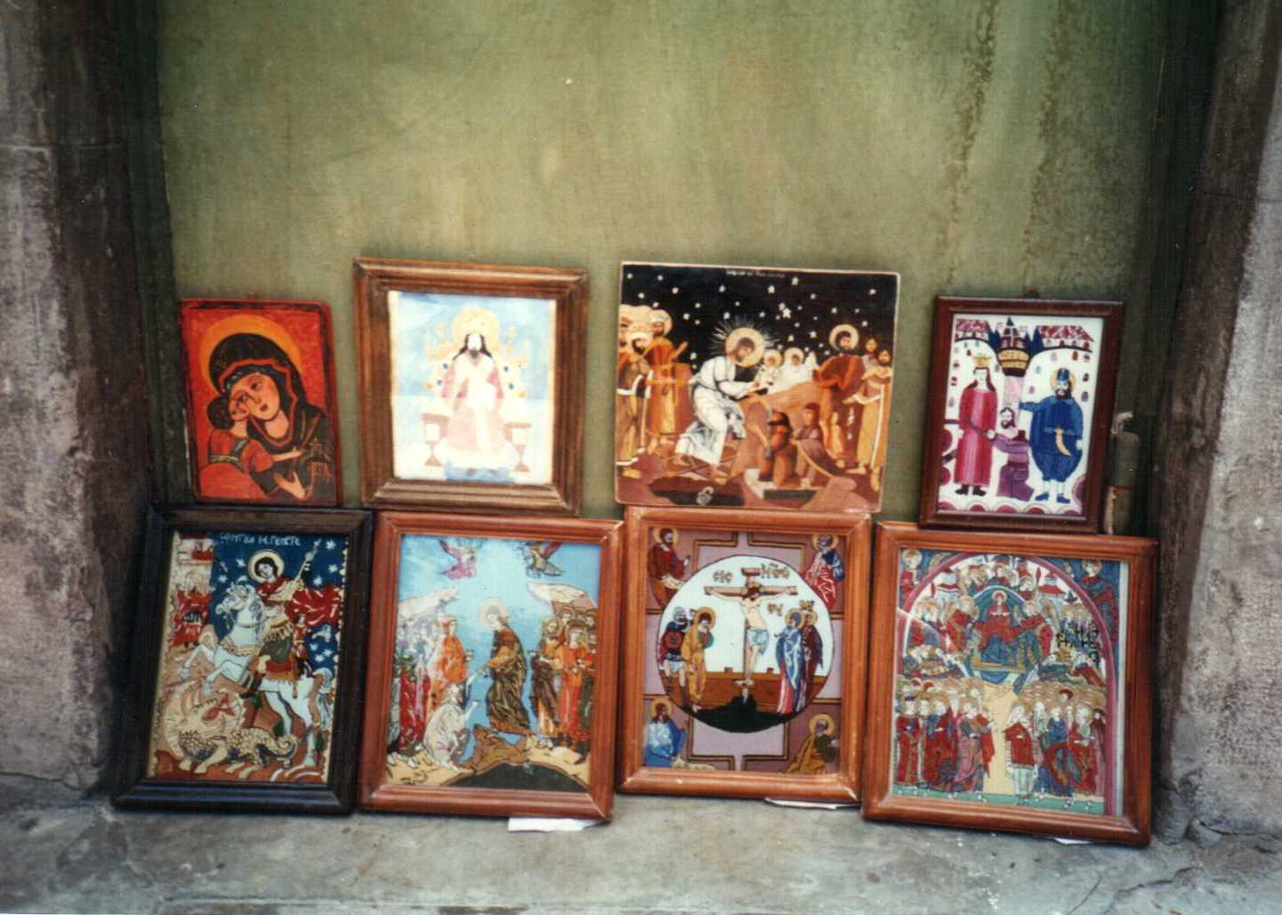
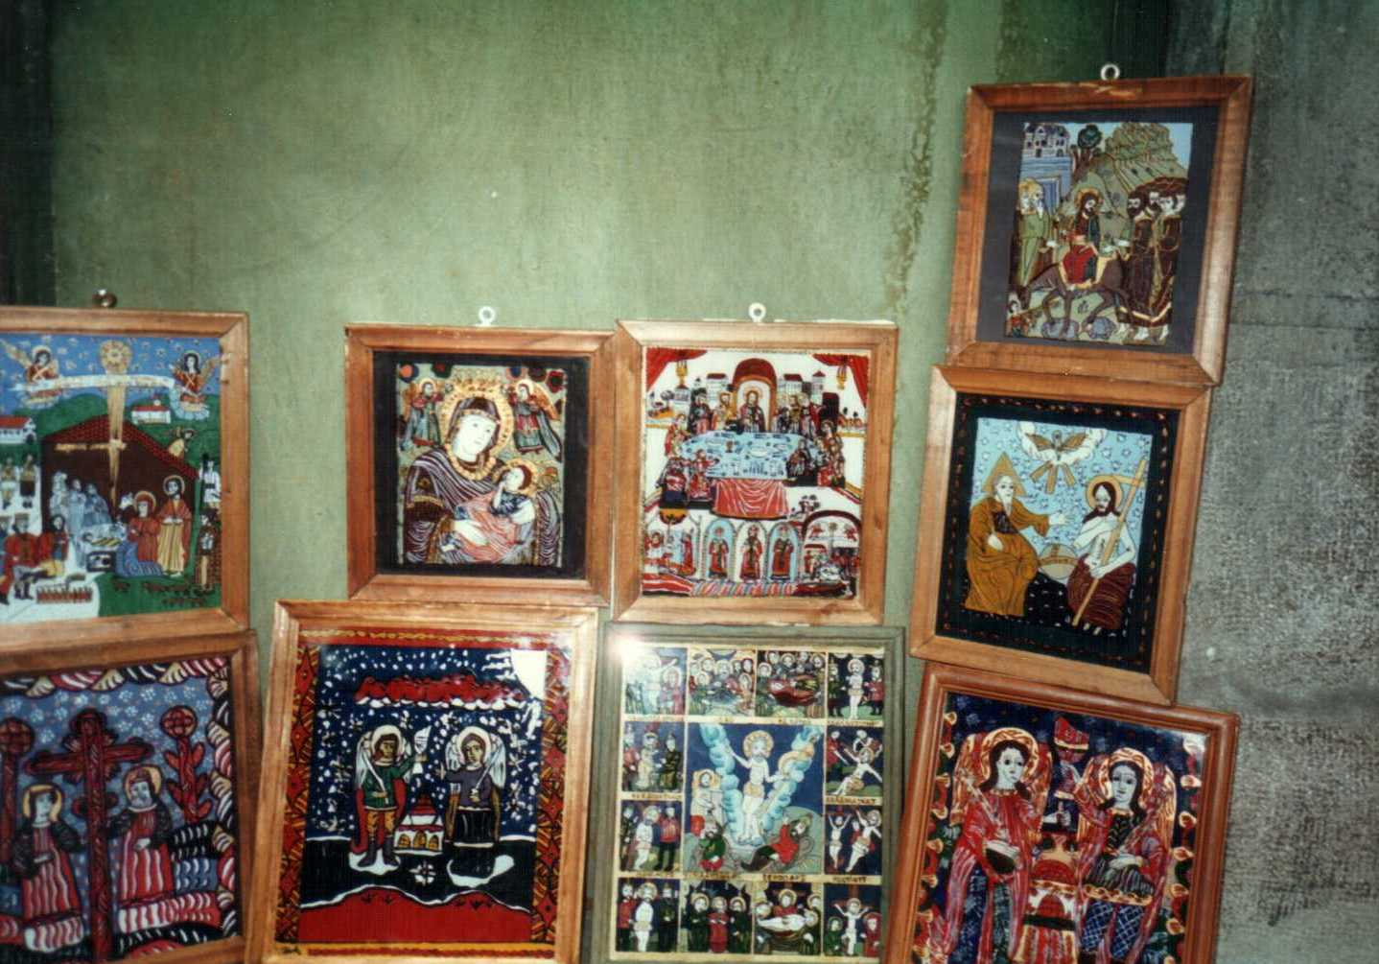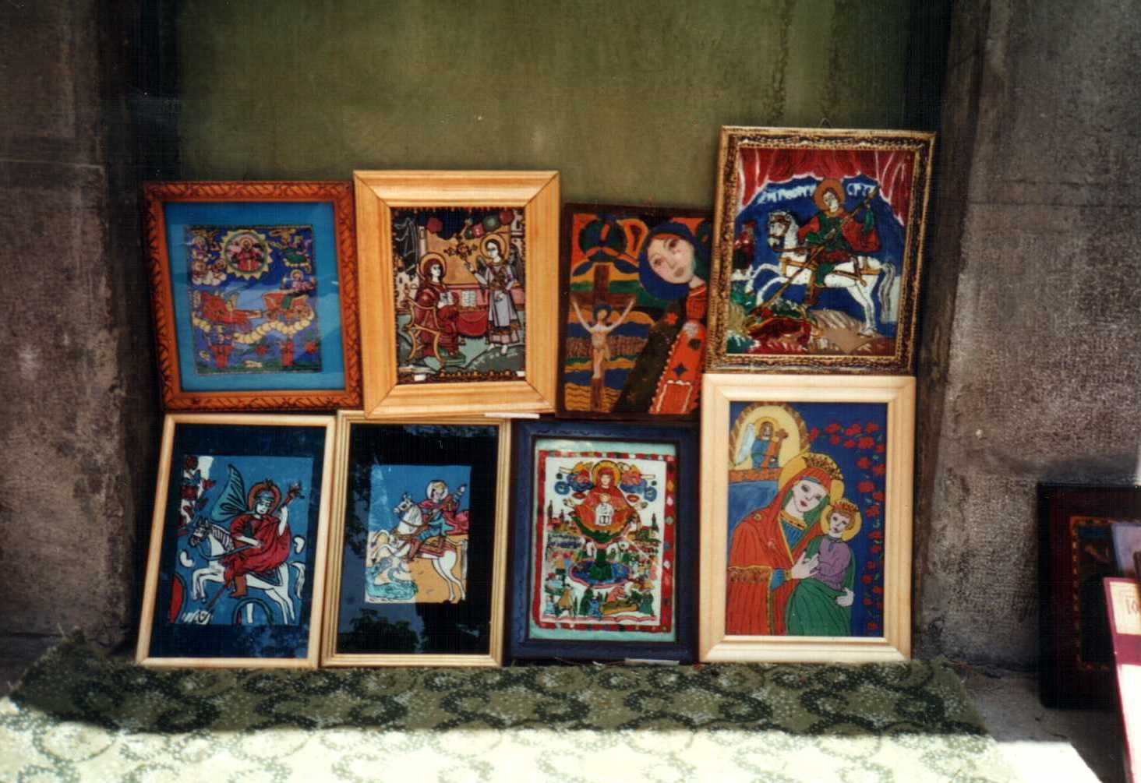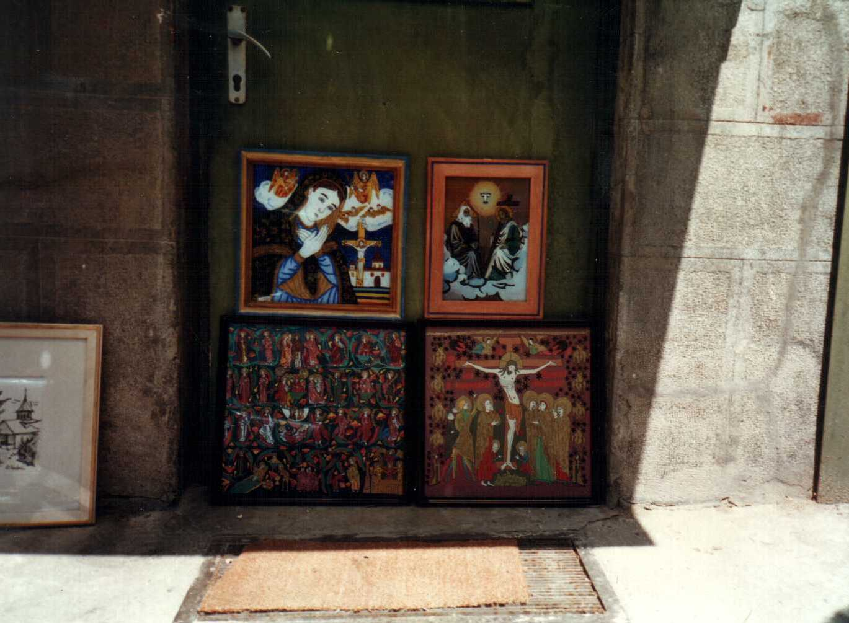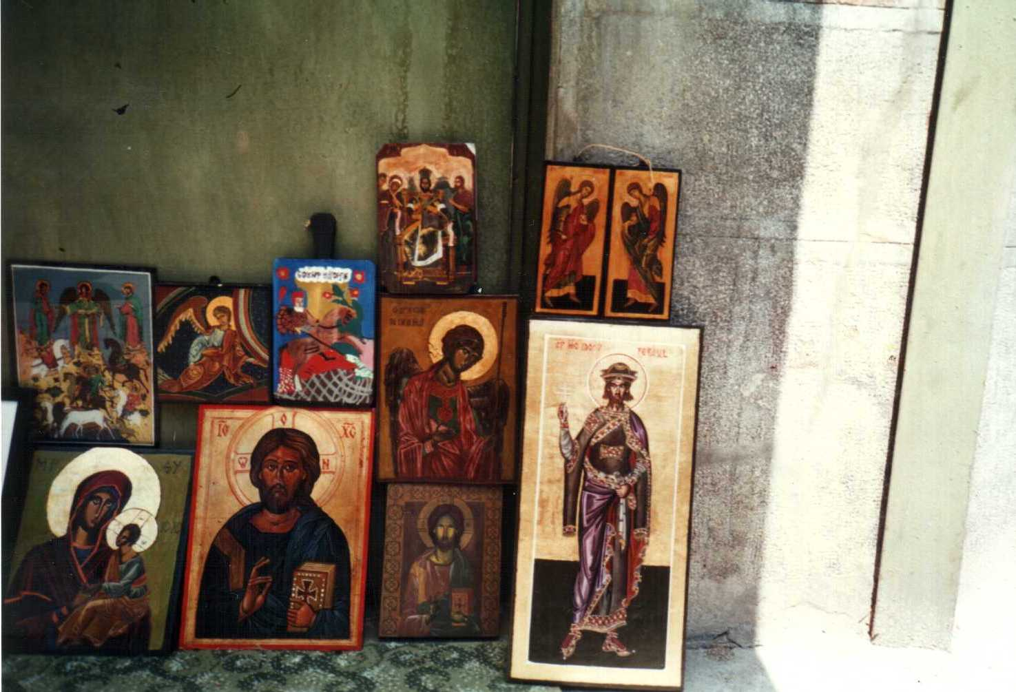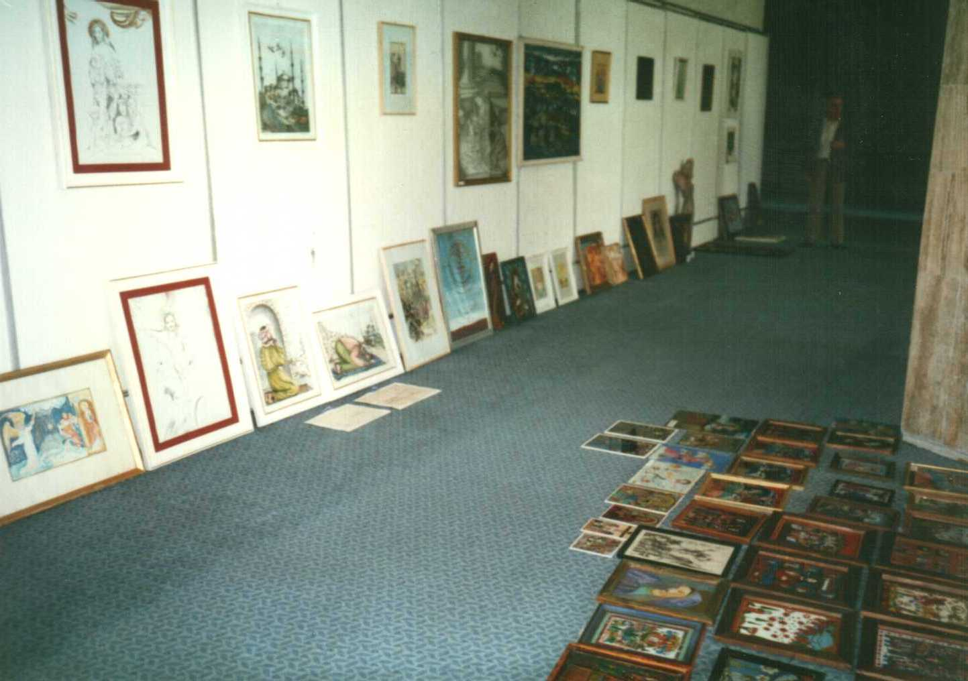
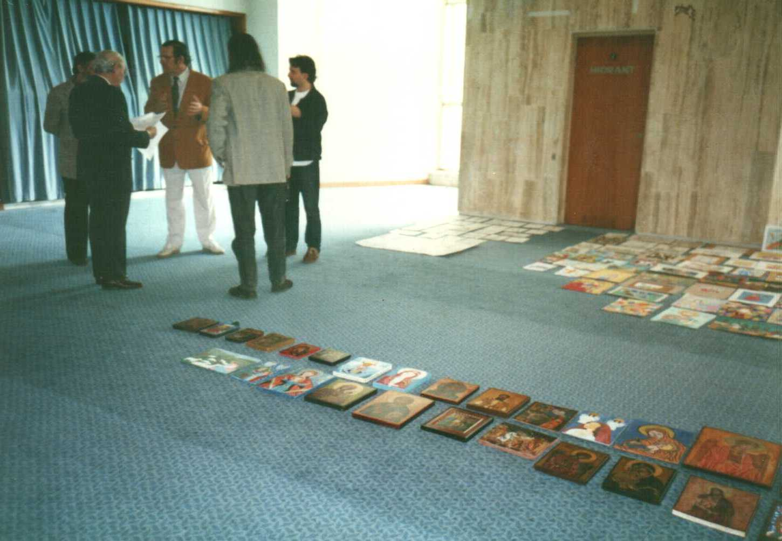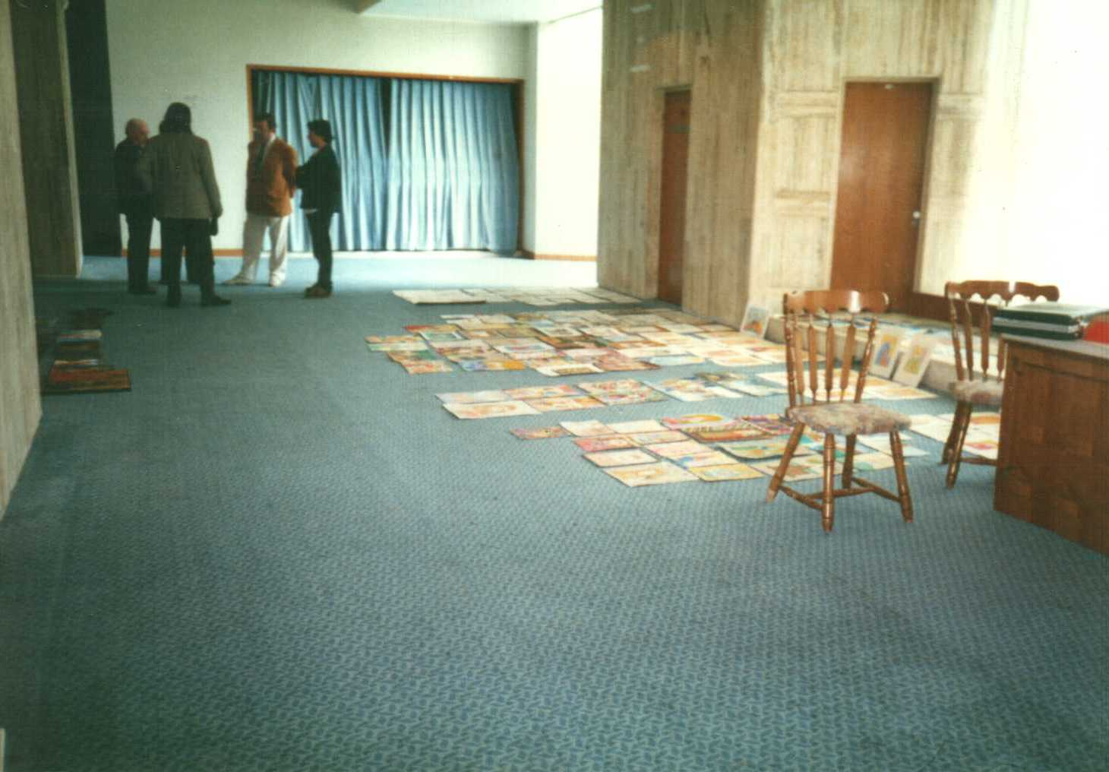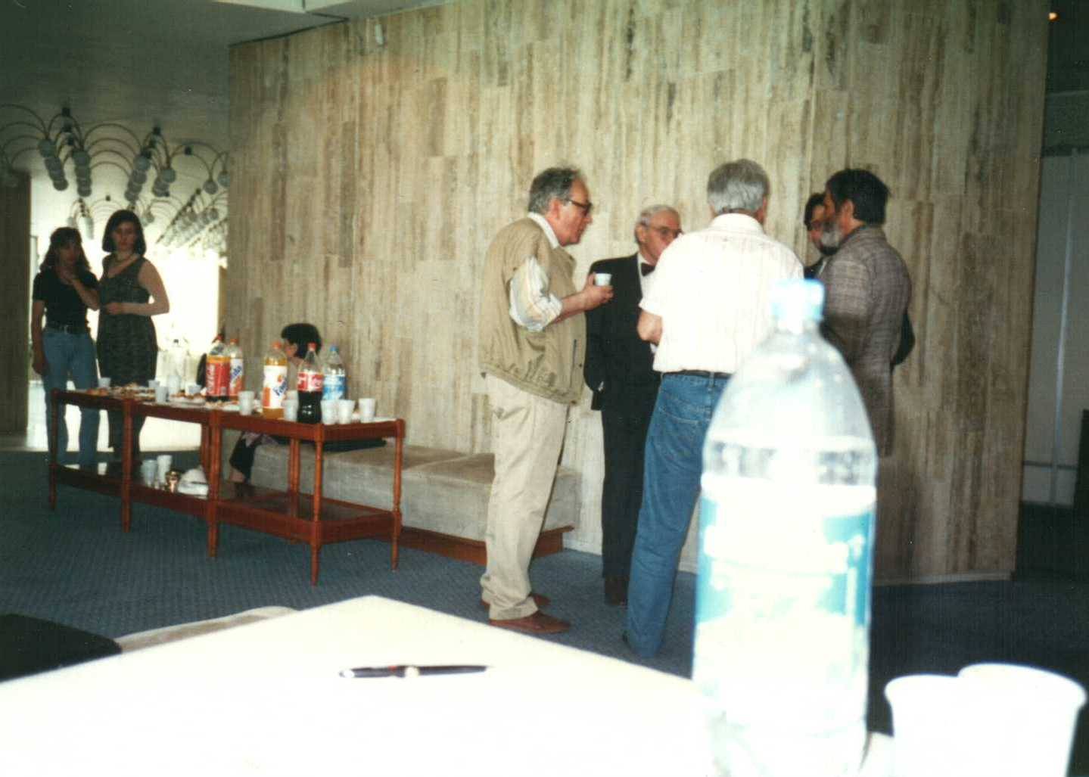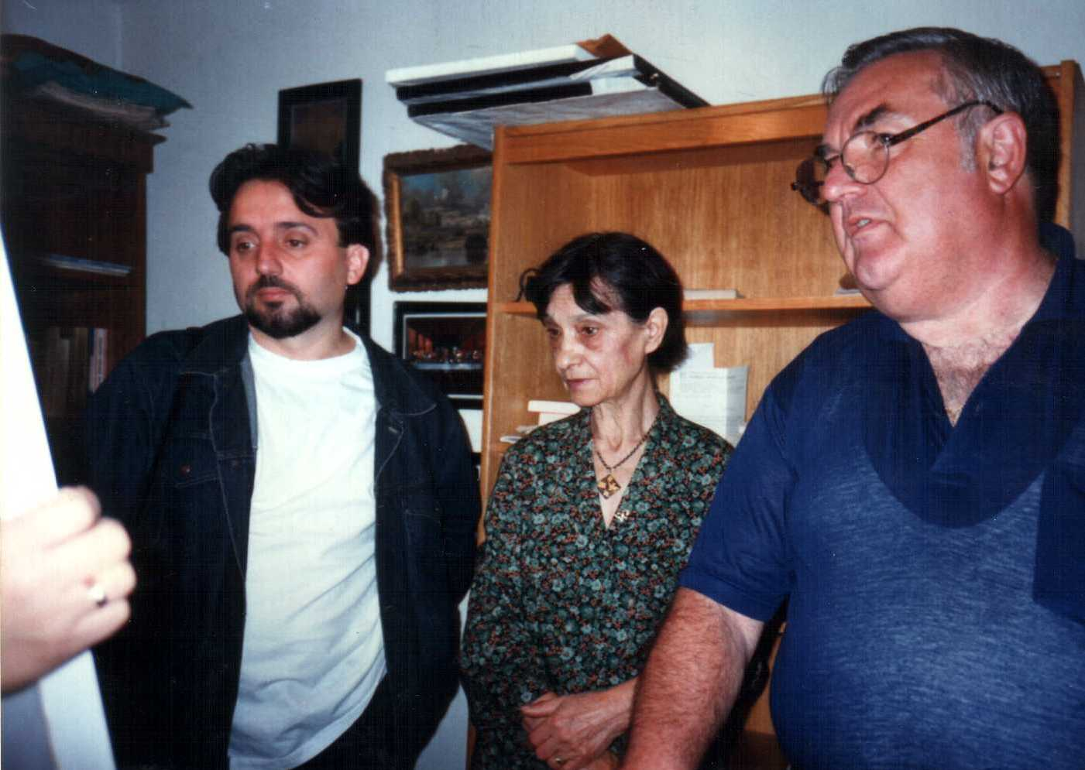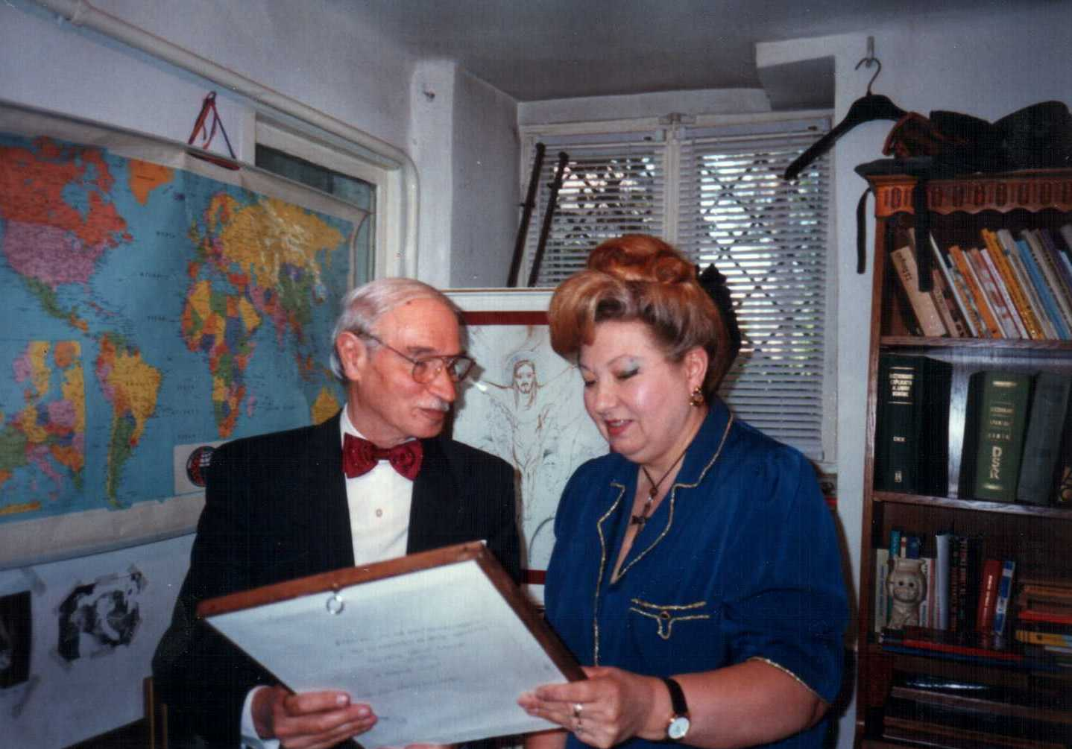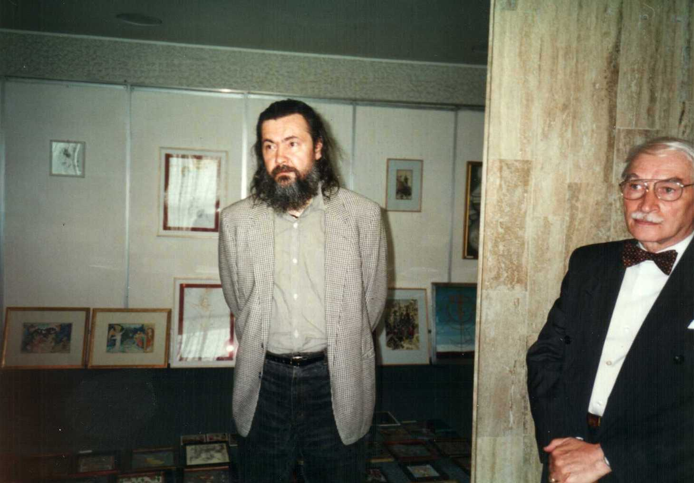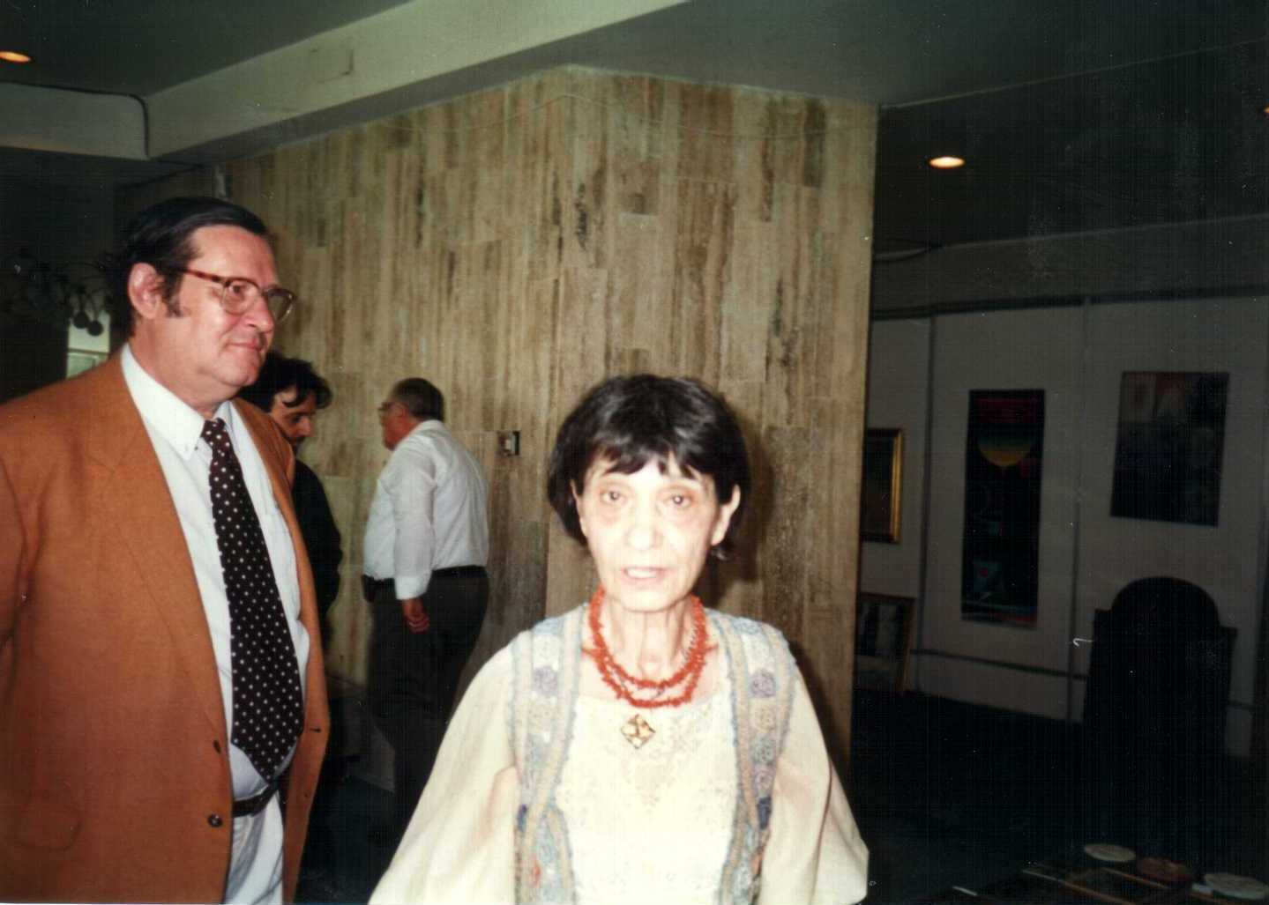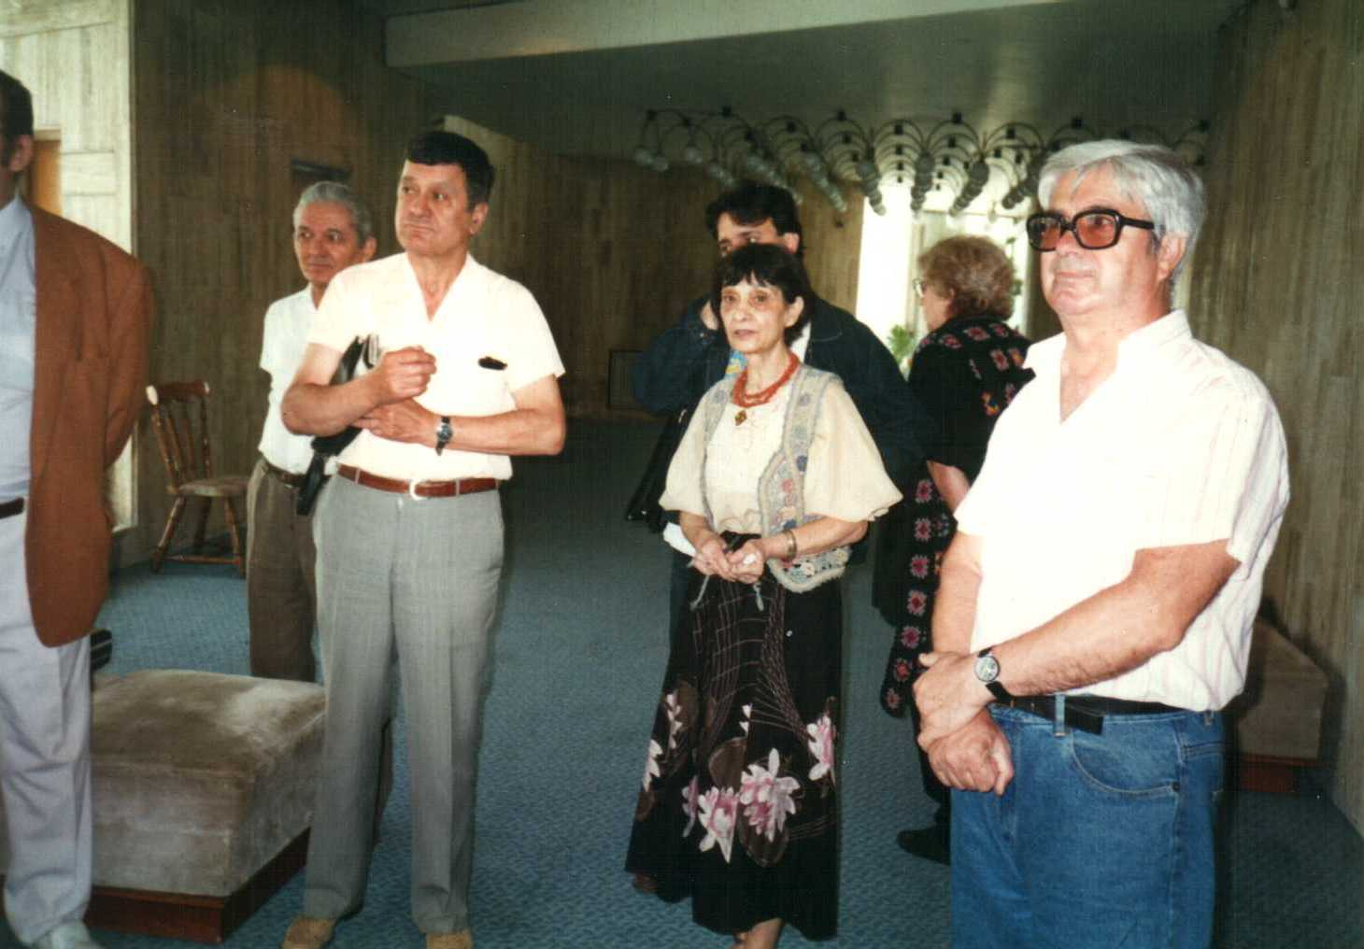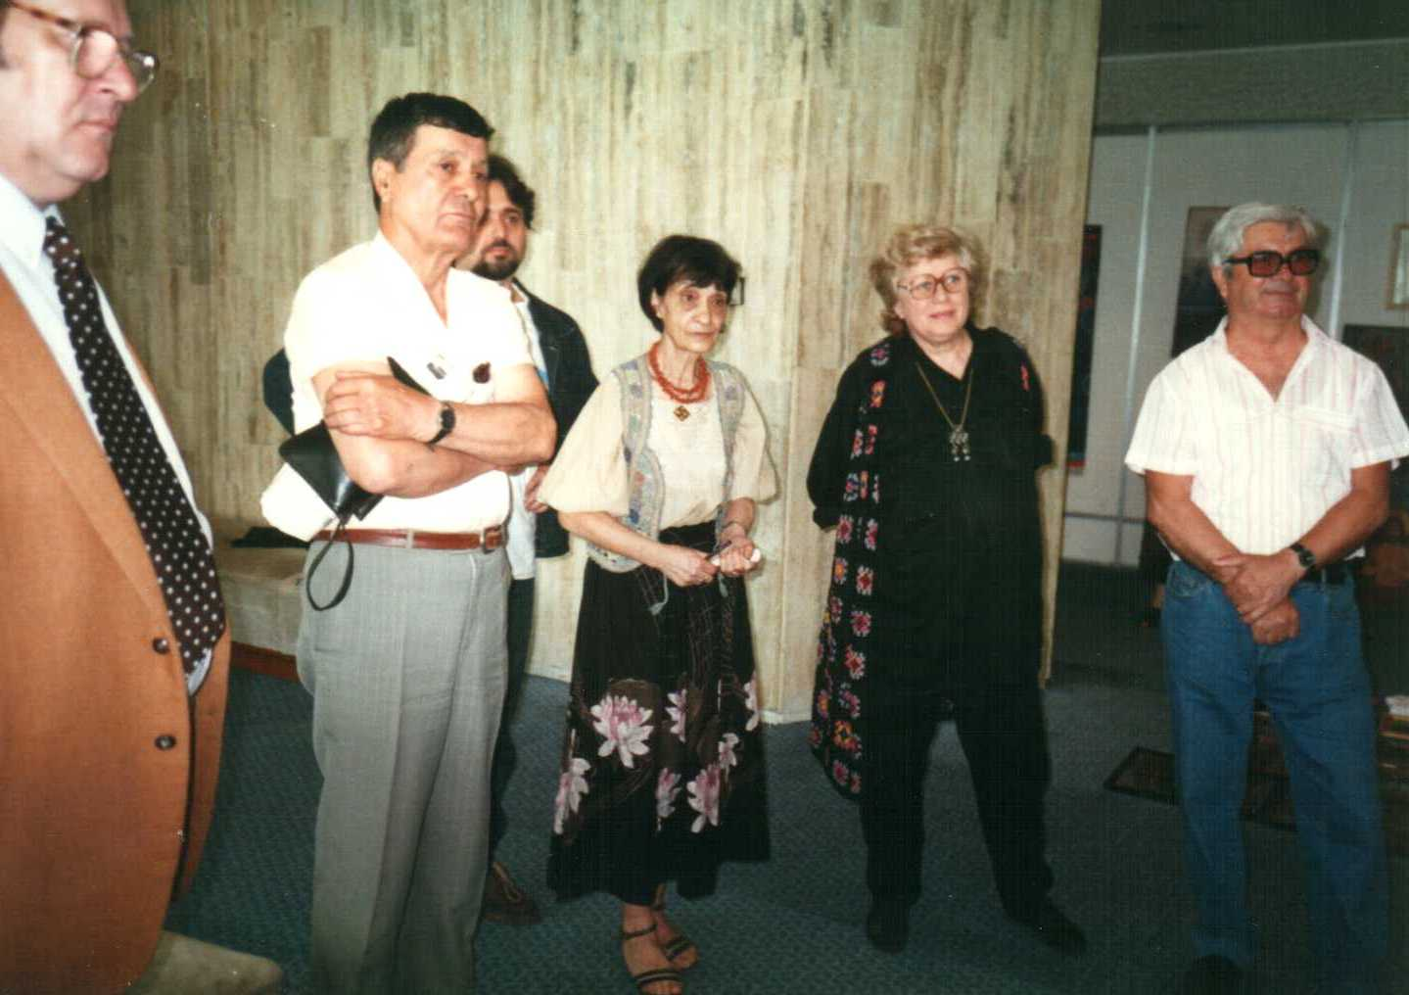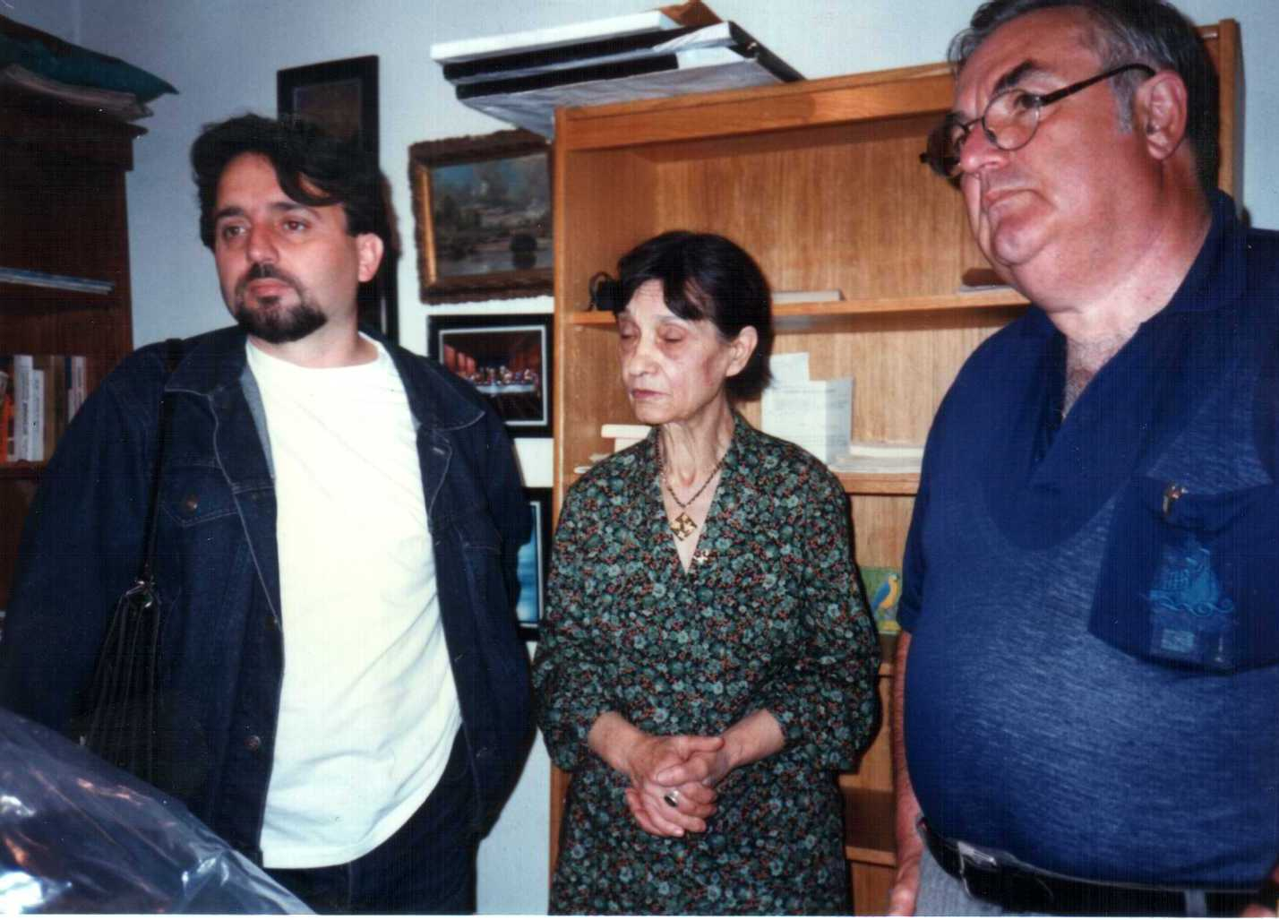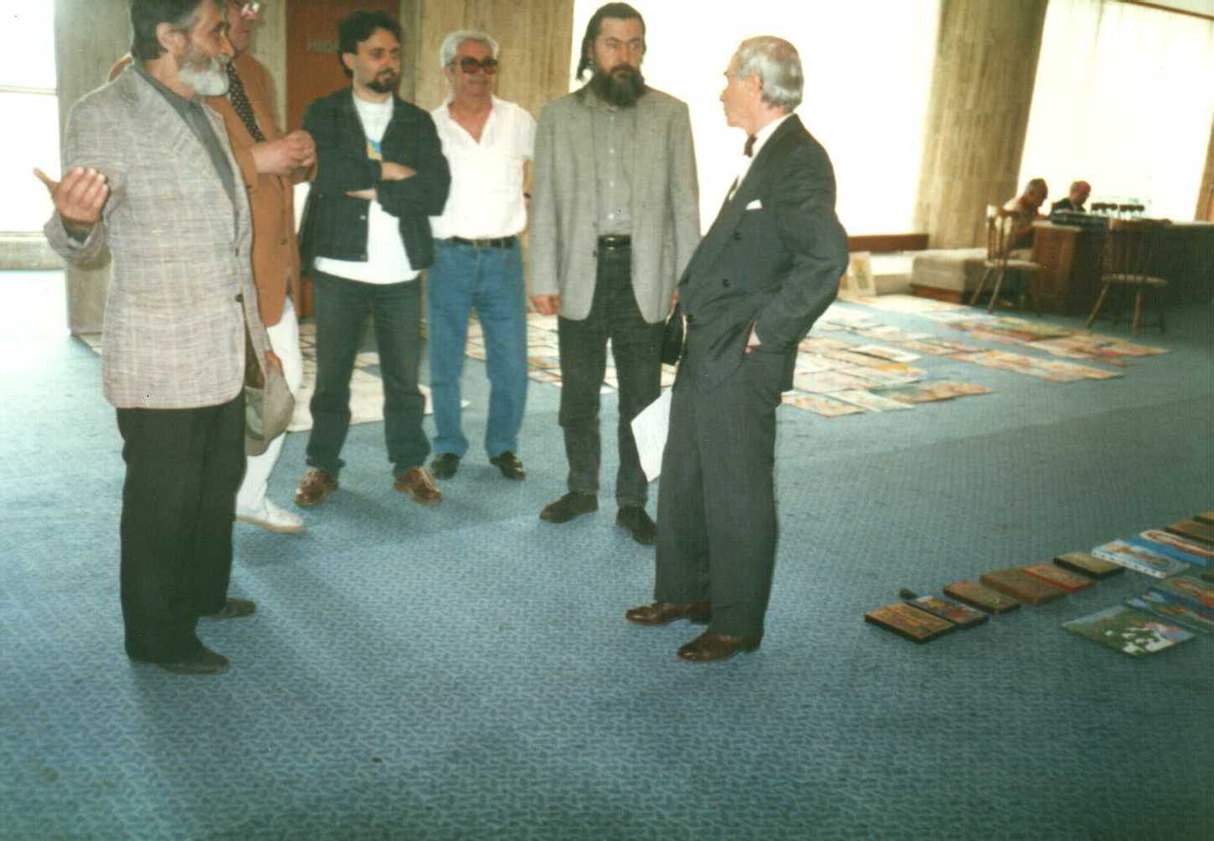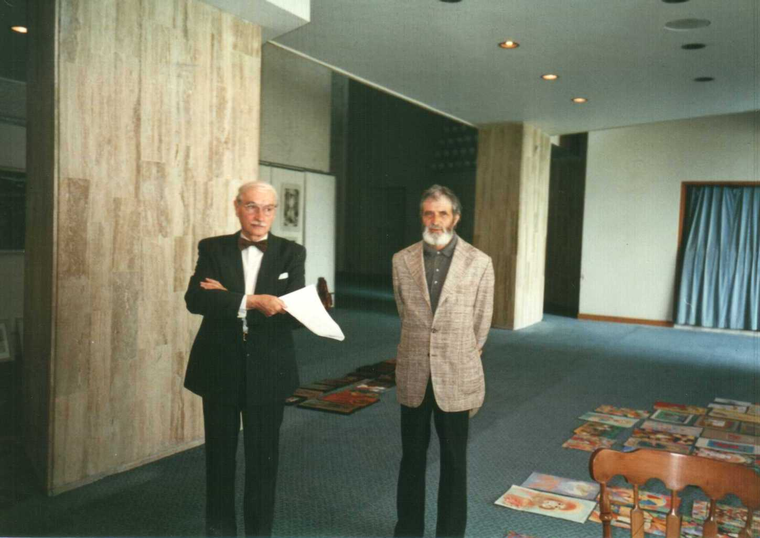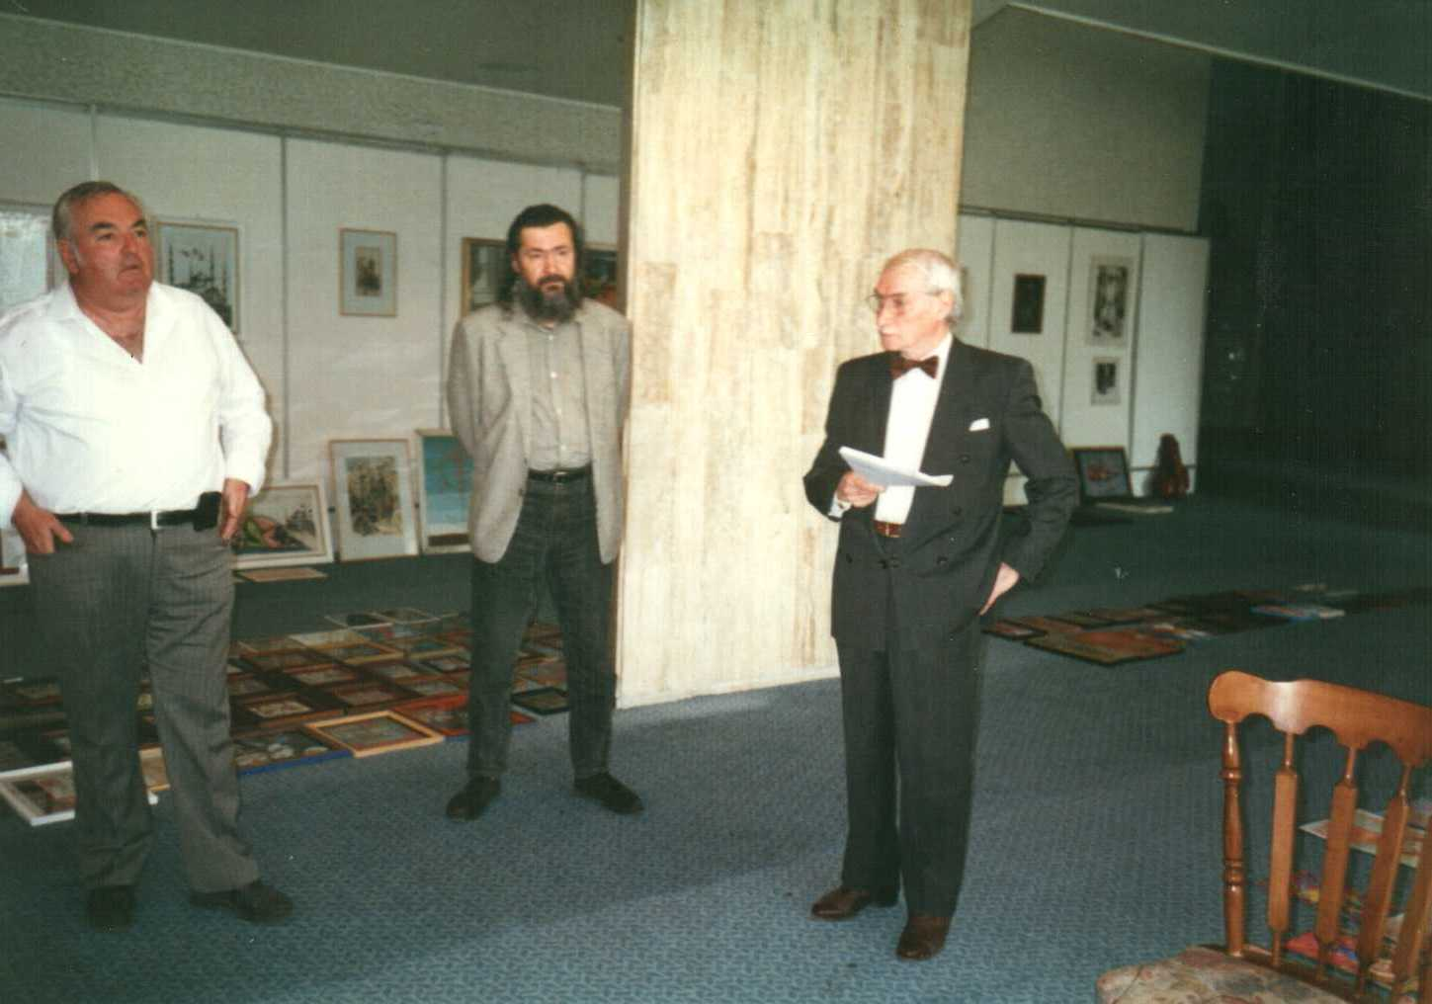
Adalbert Poch, Gheorghita Alexandru, Constantin Dumitru, Tudor Liviu Samoila, Mala Bediman Zamfirescu, Luan Topicu, Mr. general Parizescu – President of the jury, Augustin Costinescu, Rodica Xenia Constantin, Daradici Constantin. Cults Representatives from Romania took part in the jury comity.

Aspects from the awards ceremony

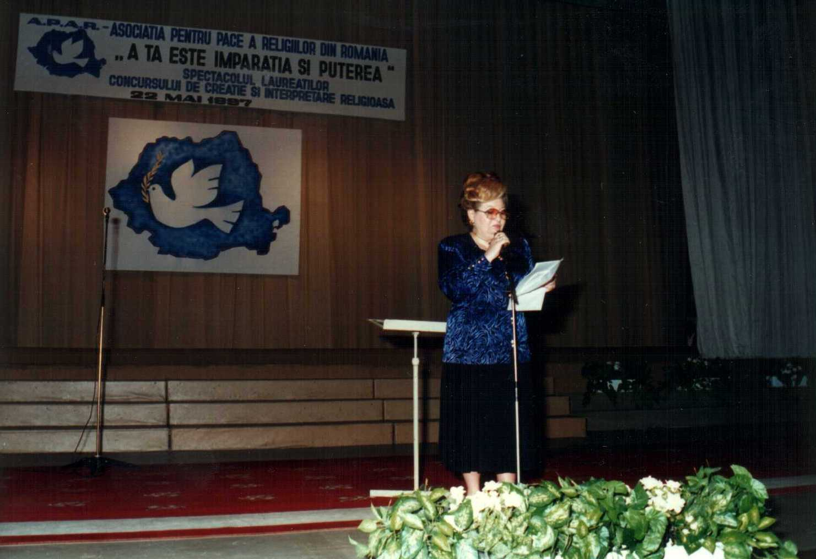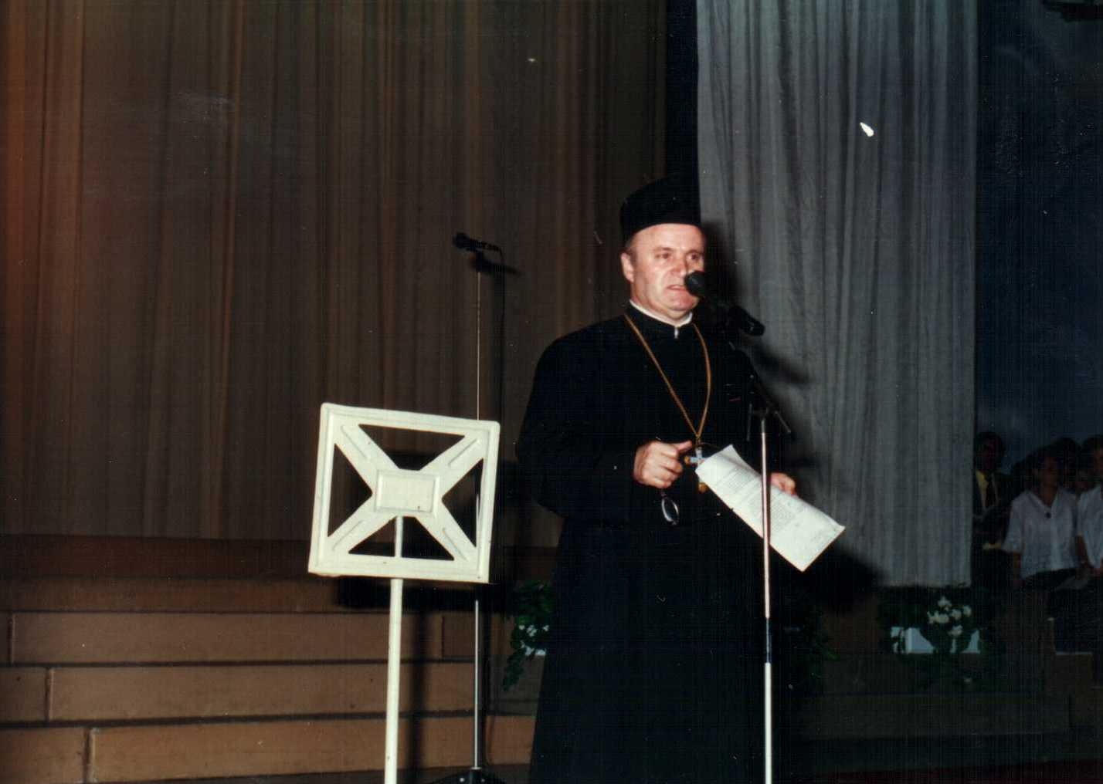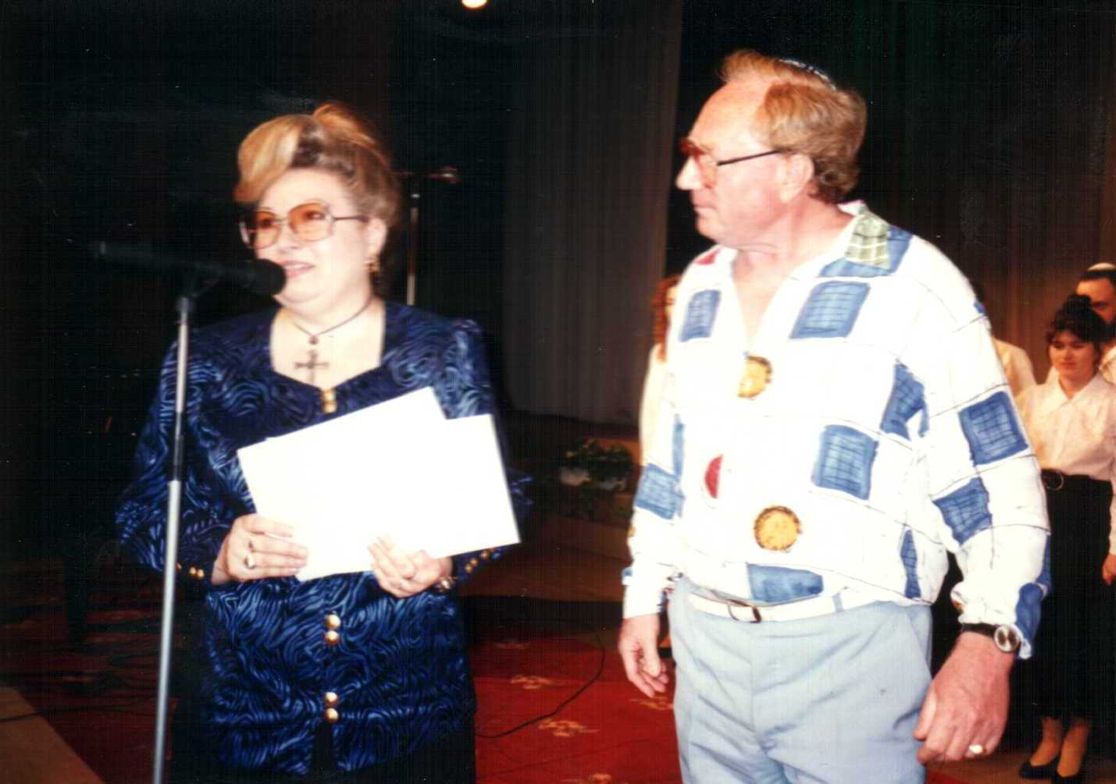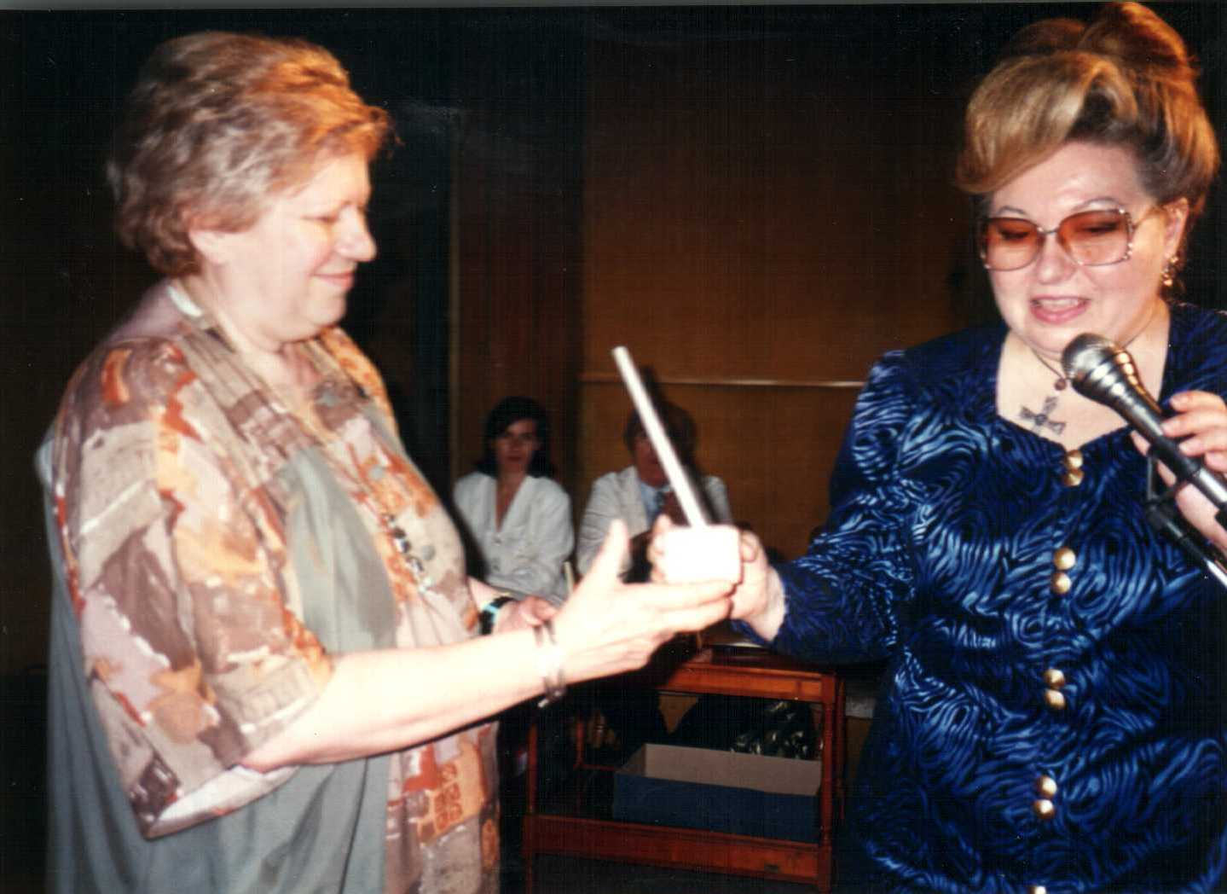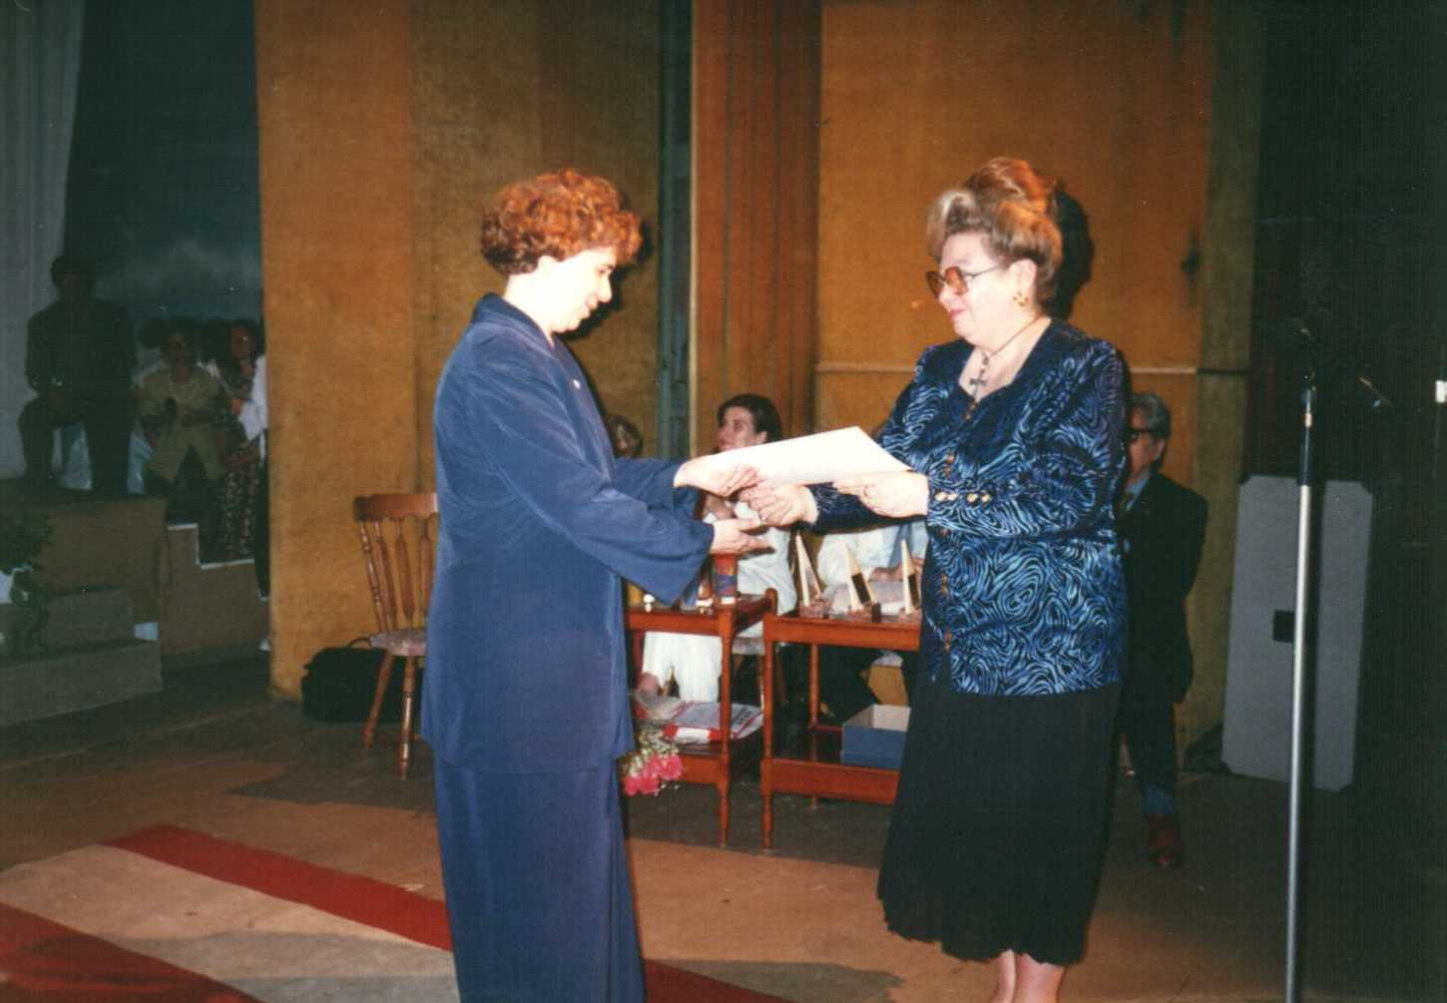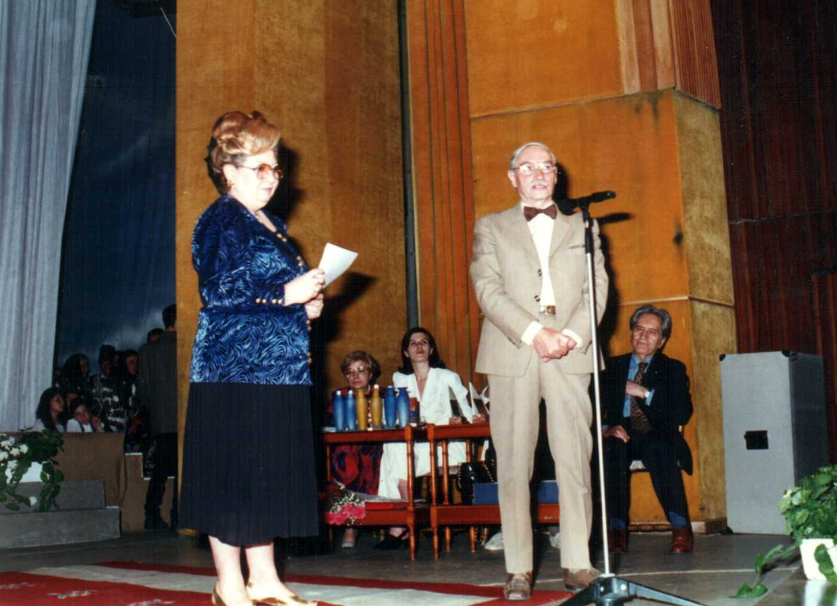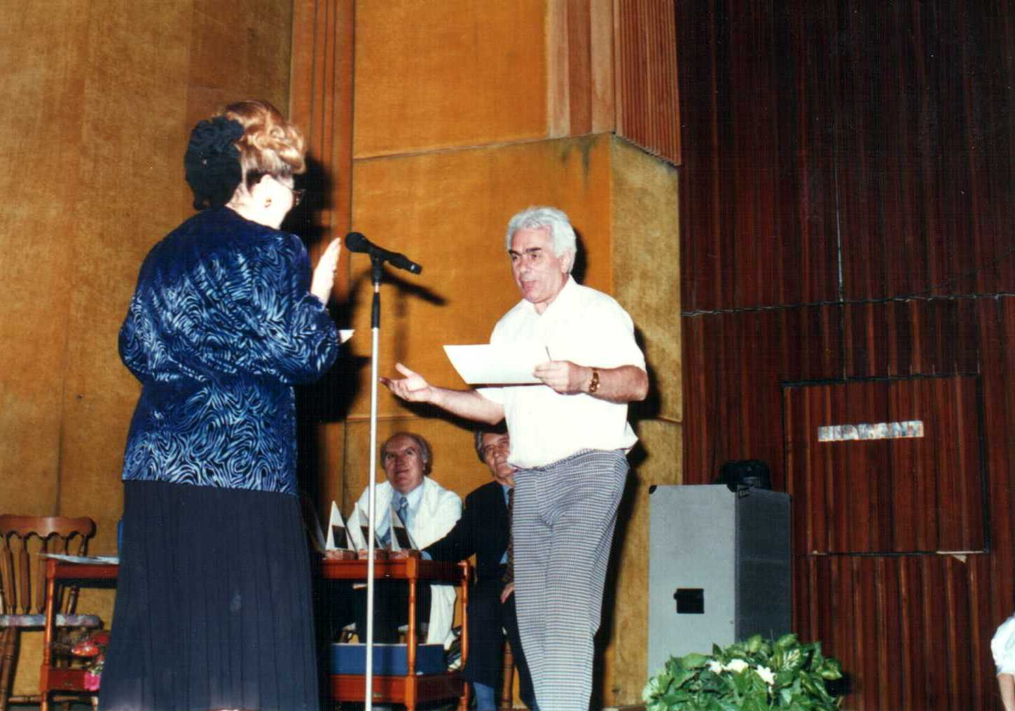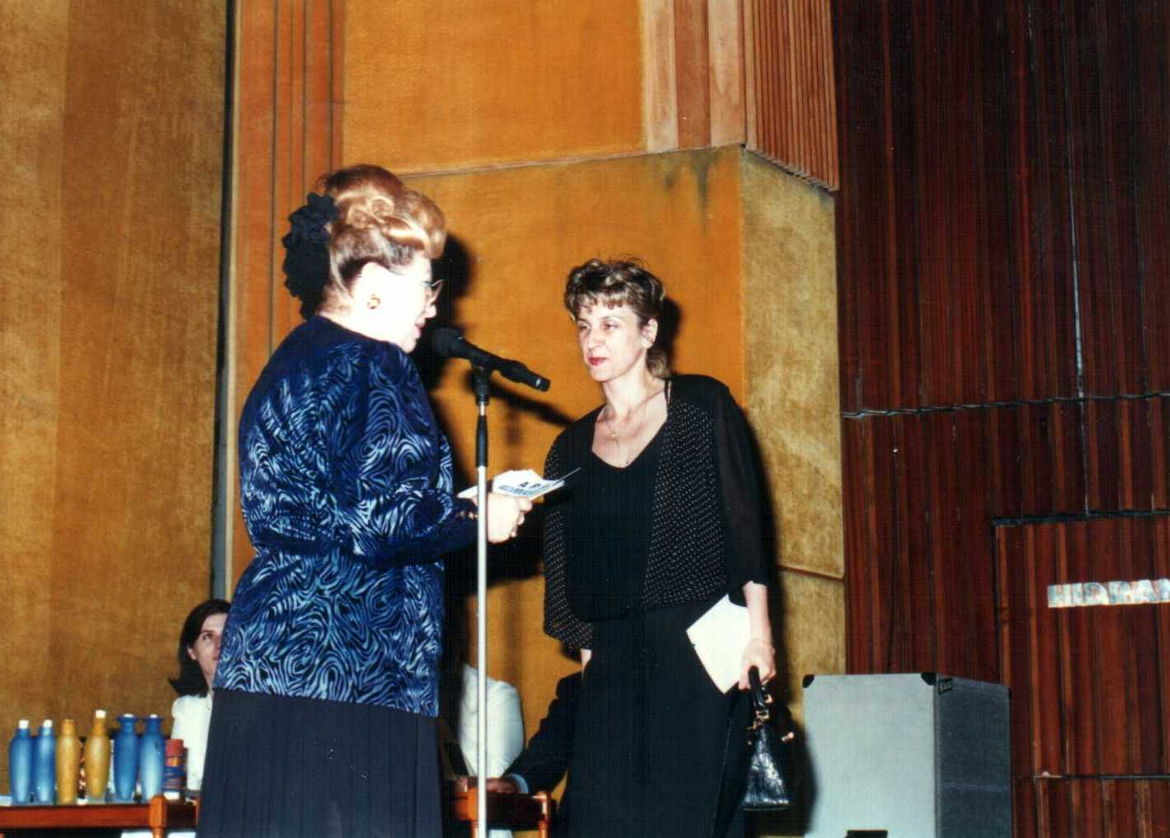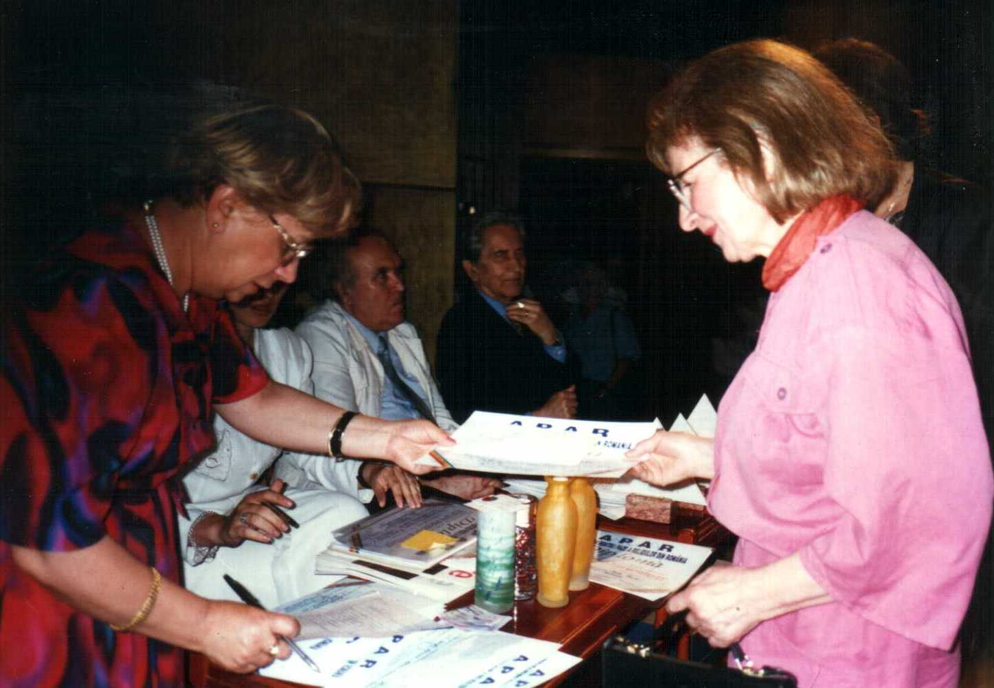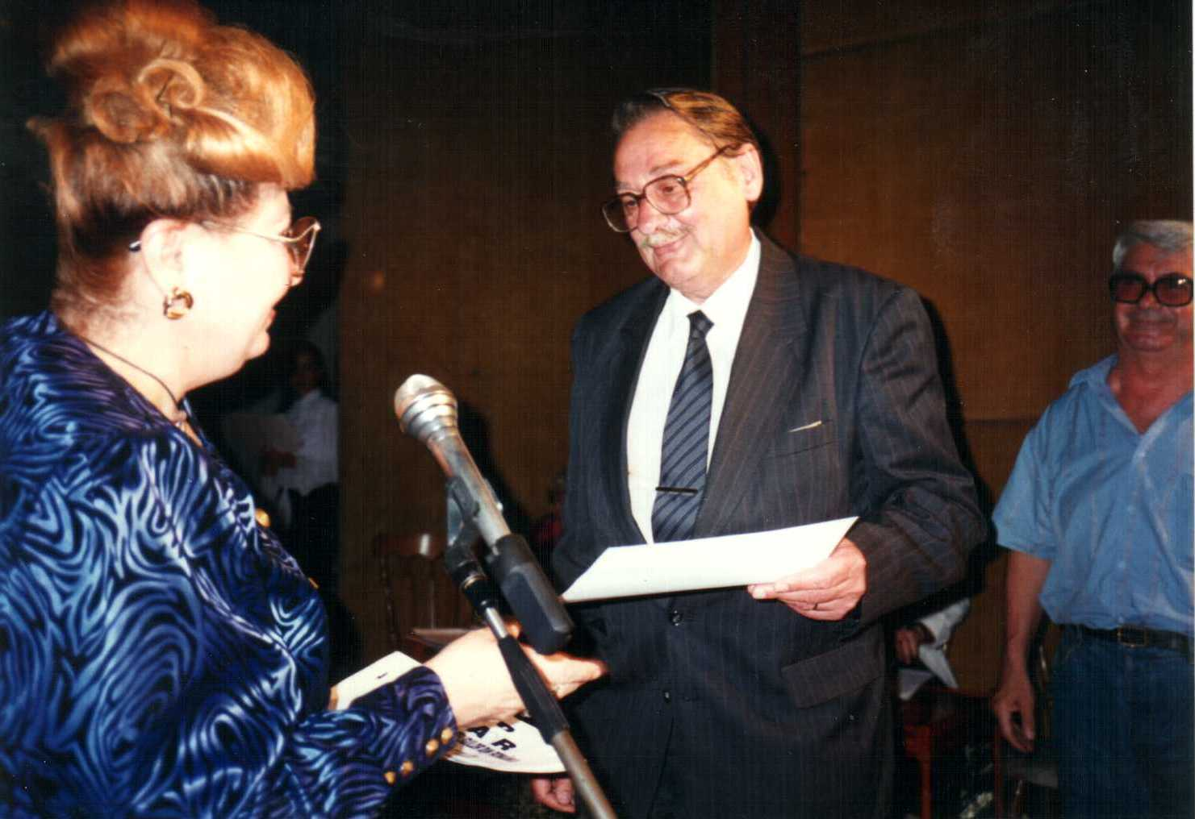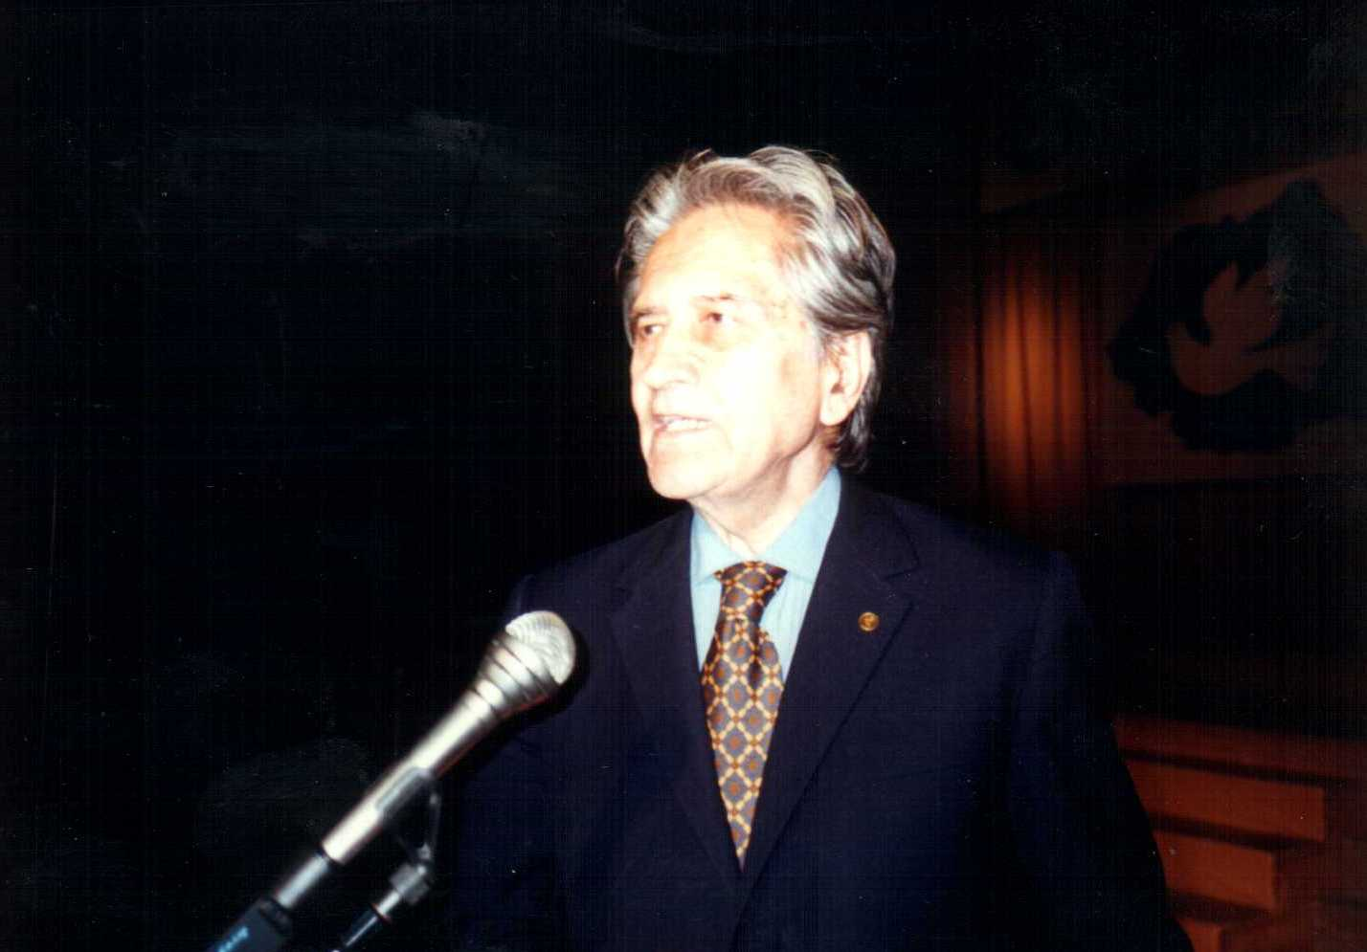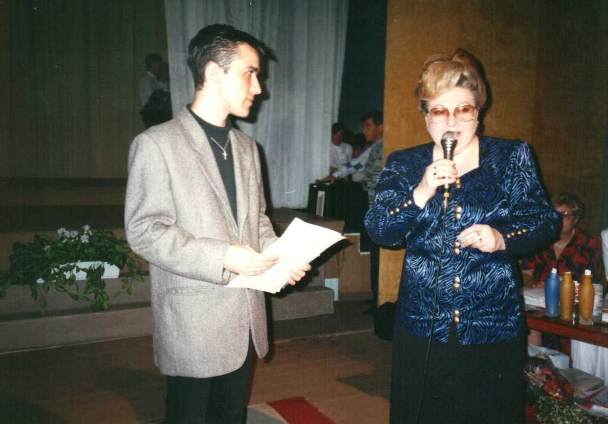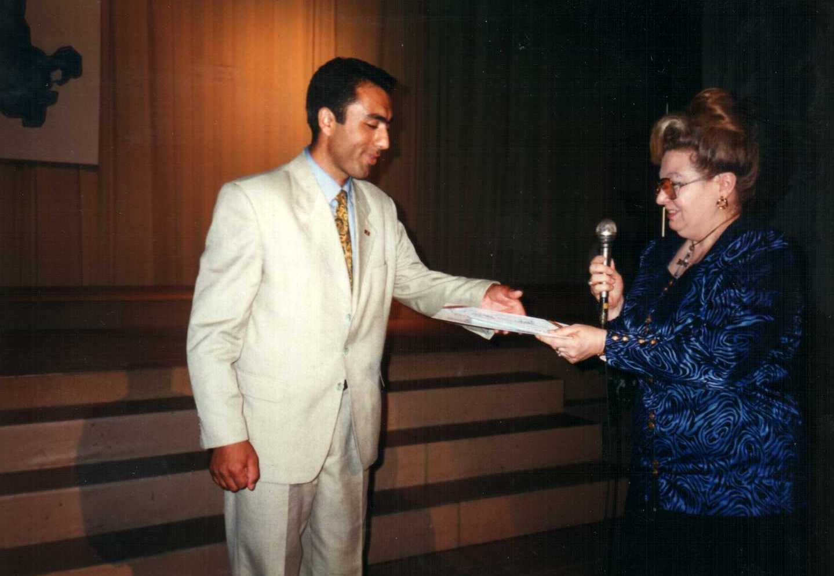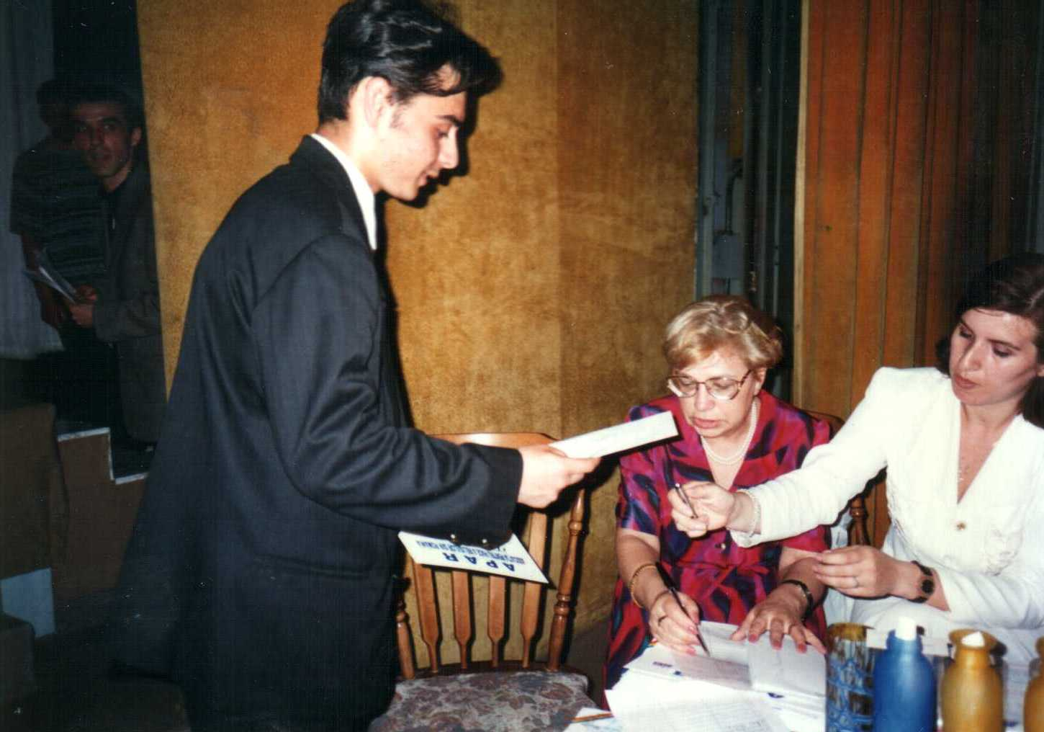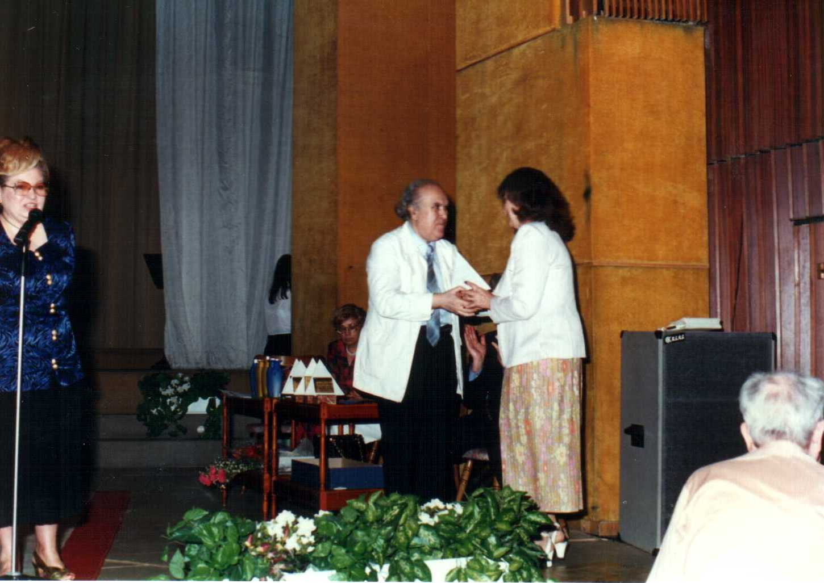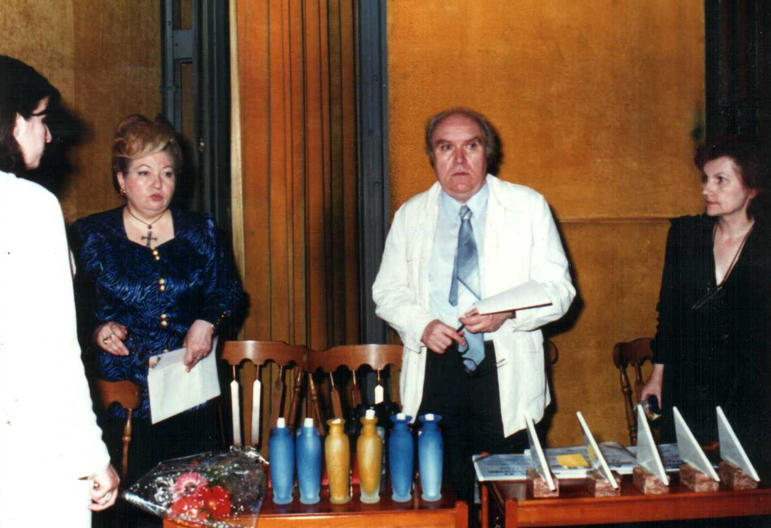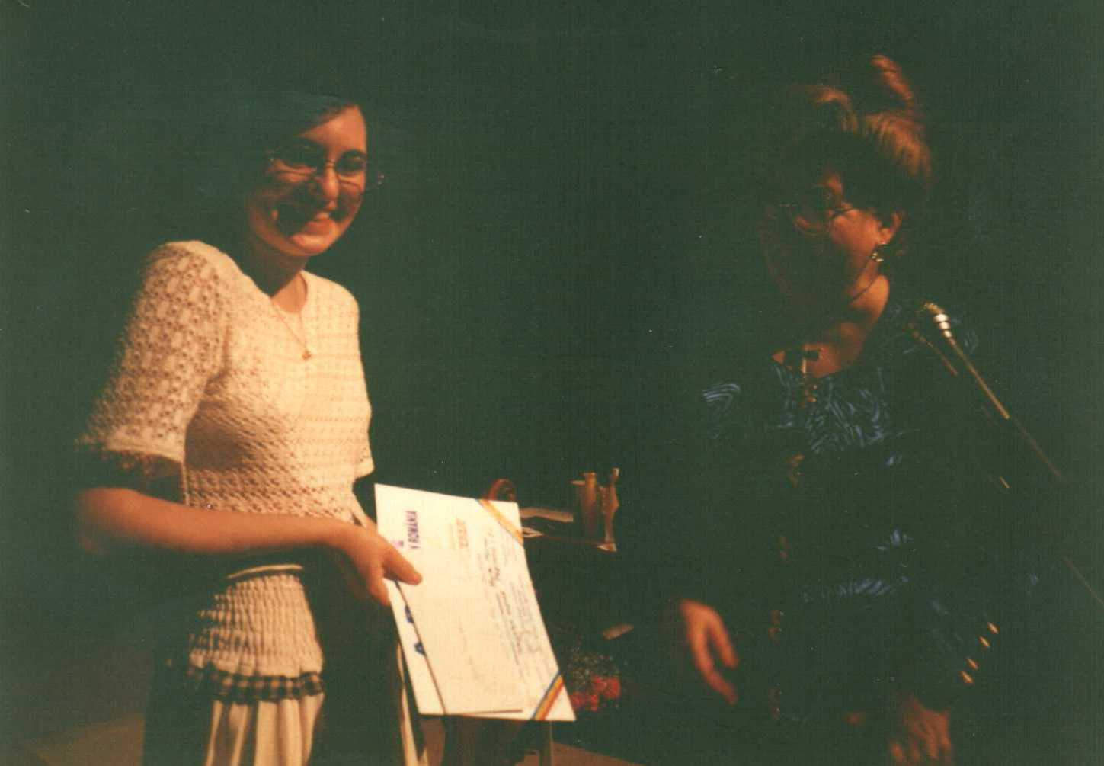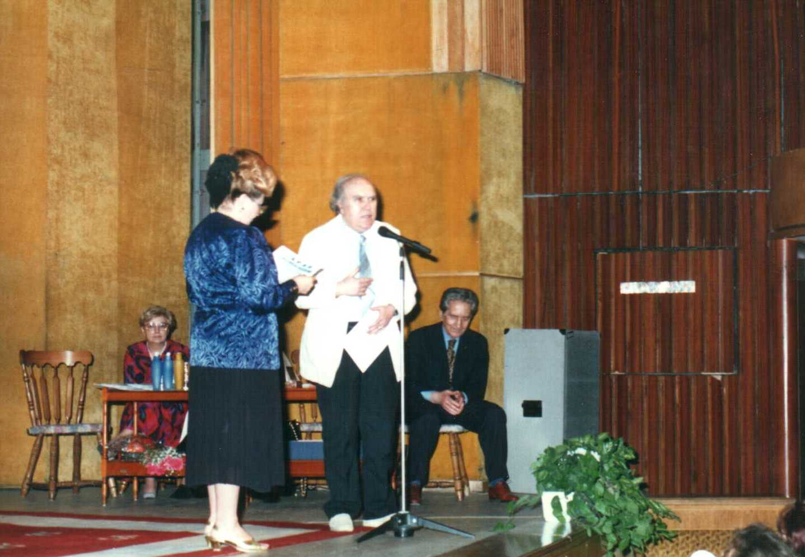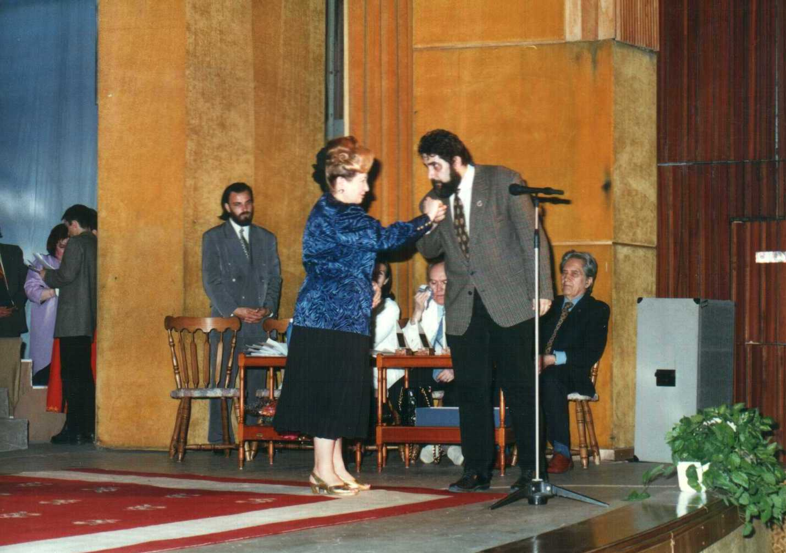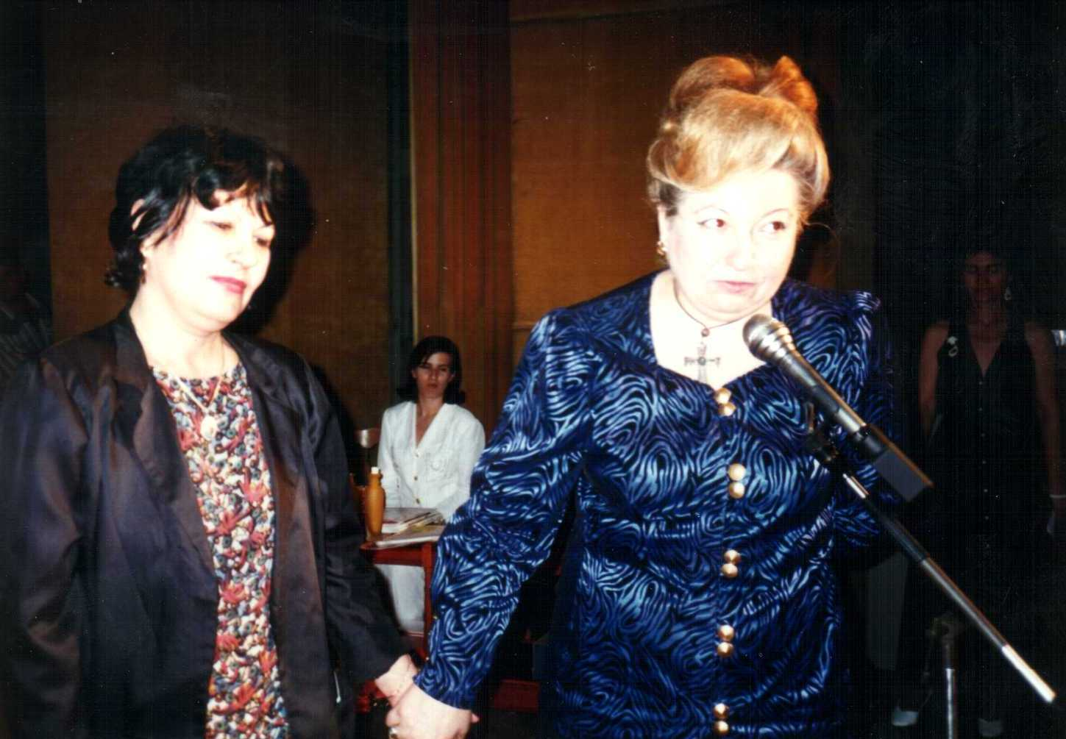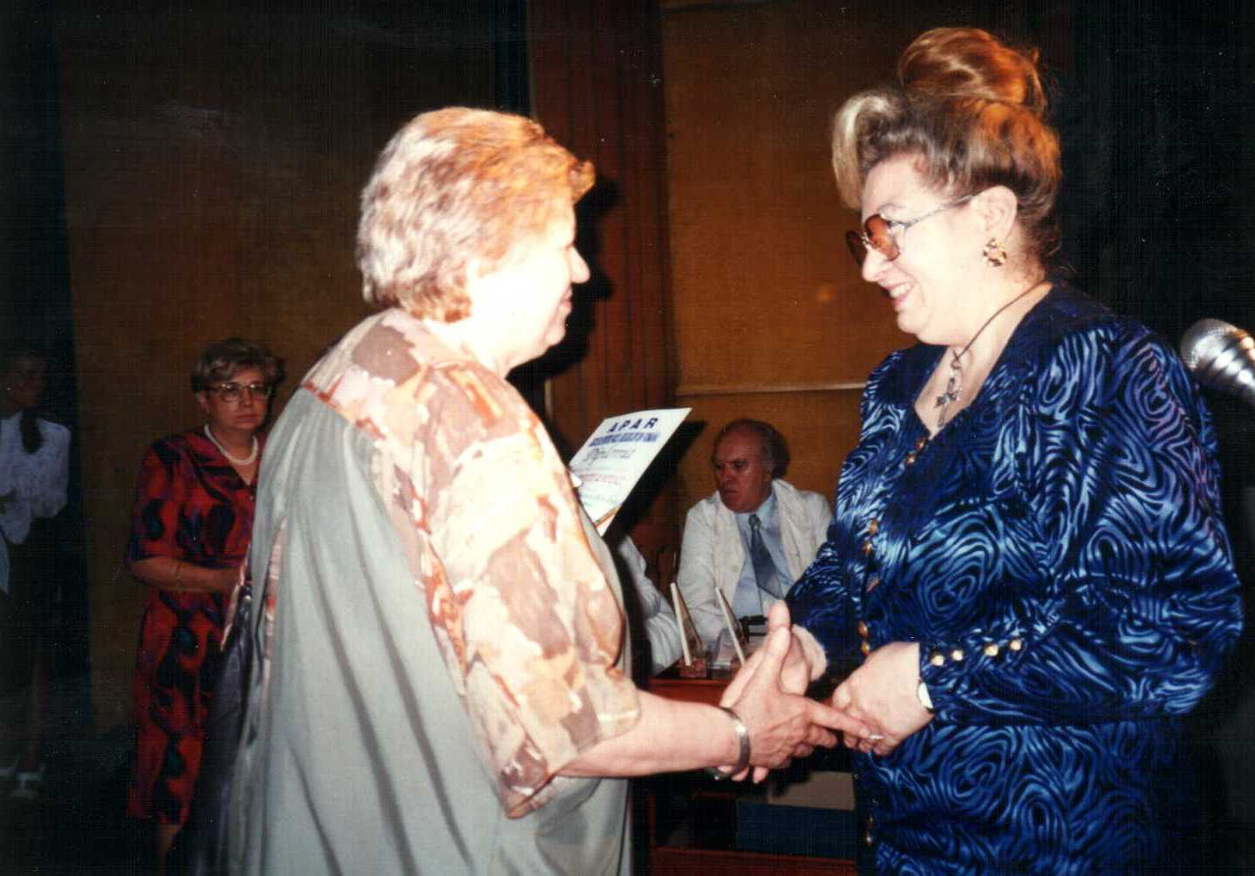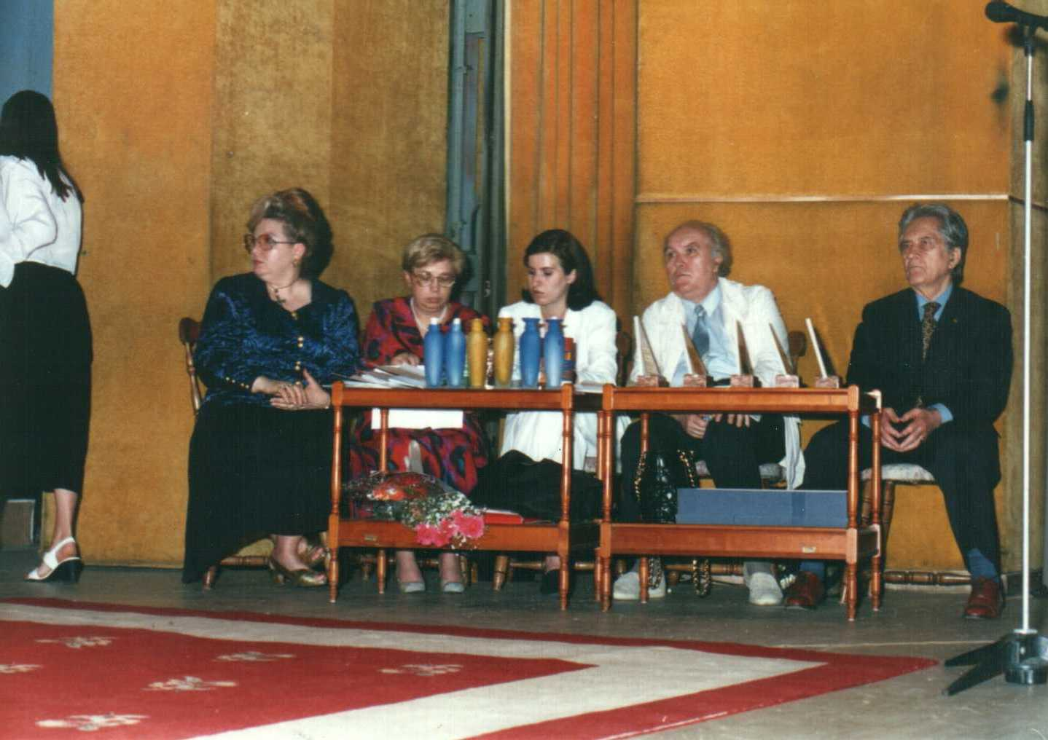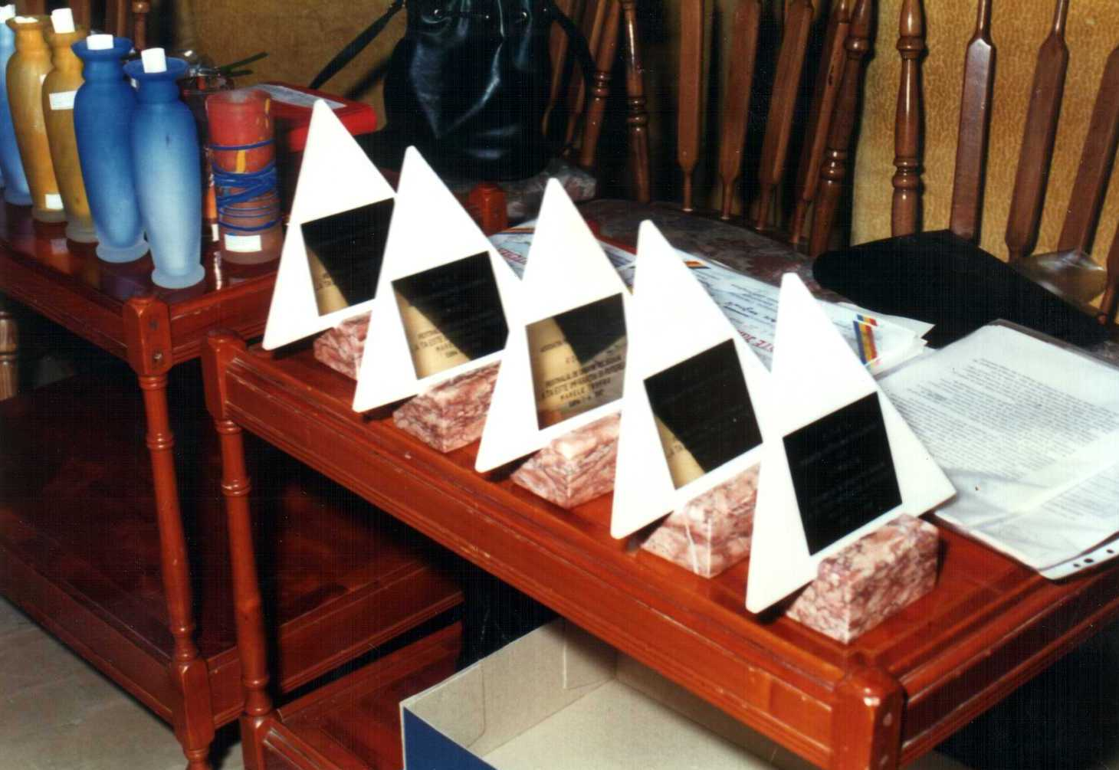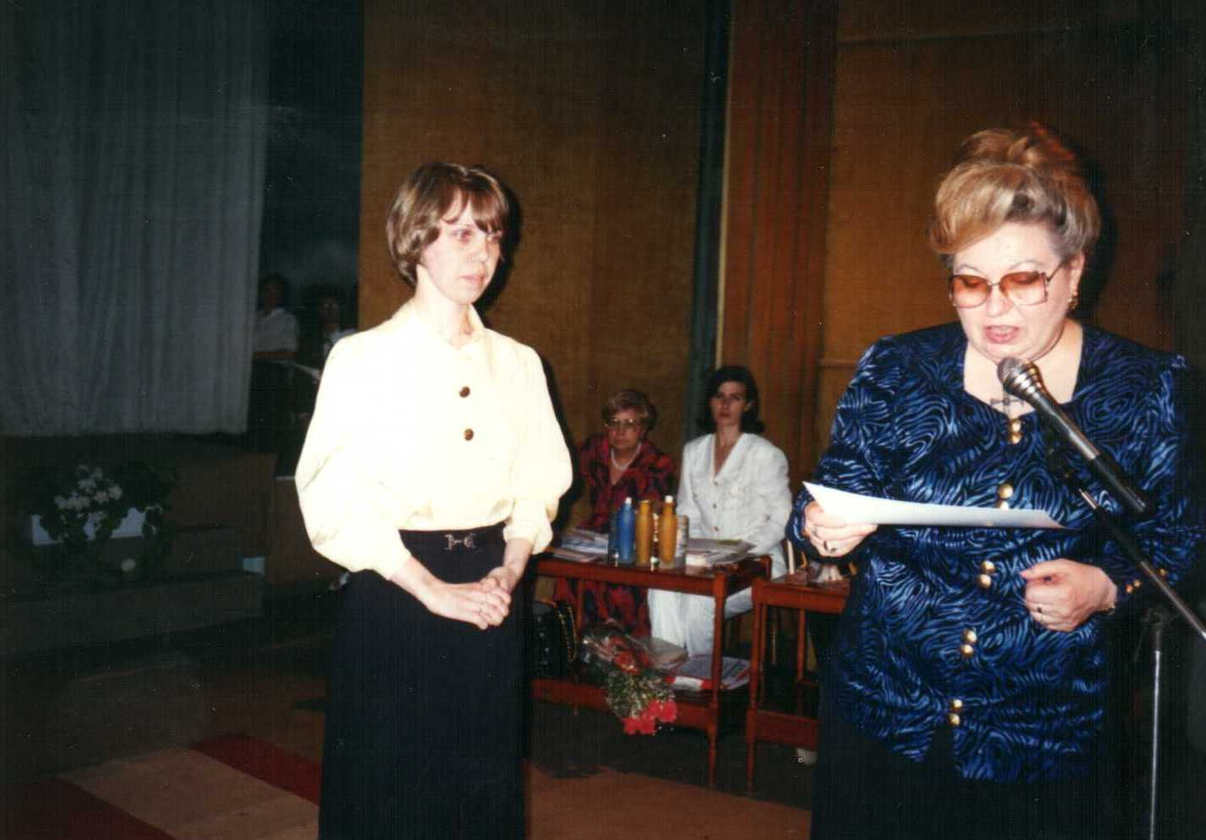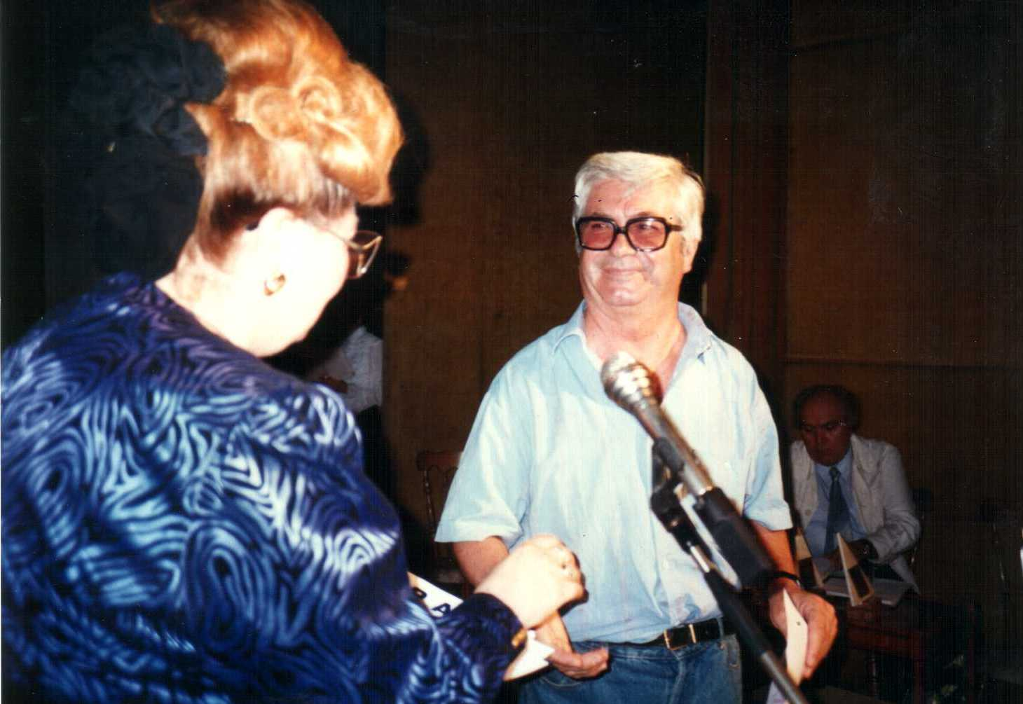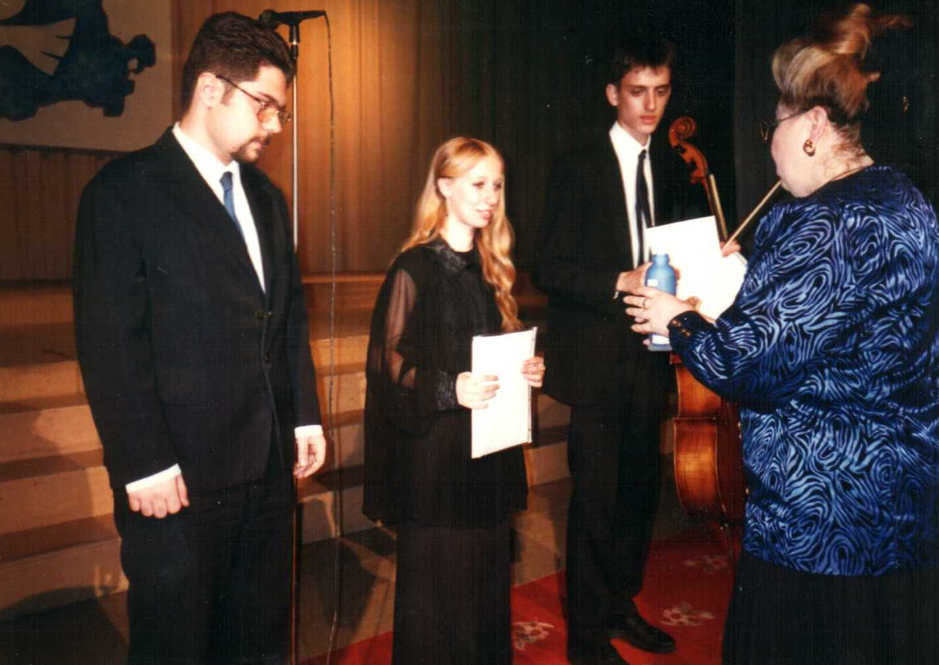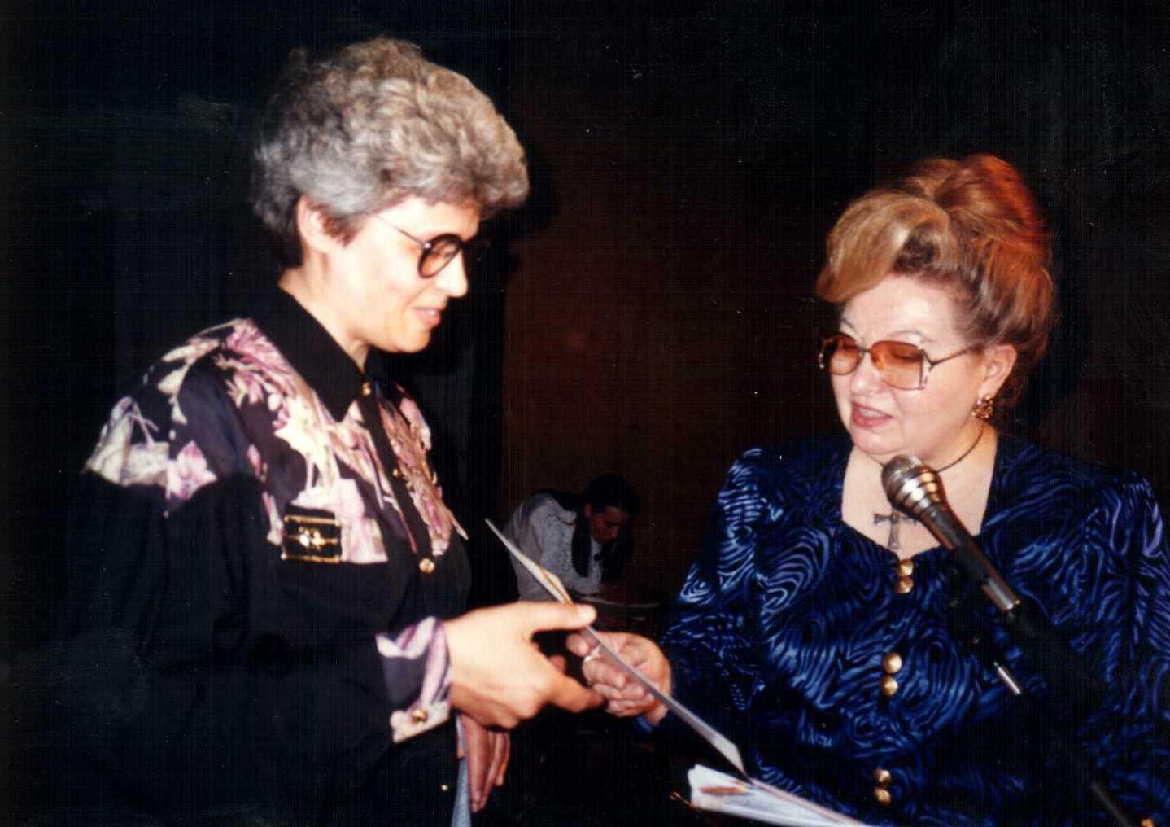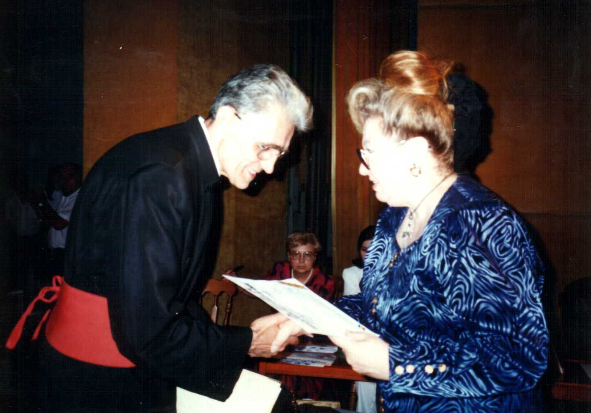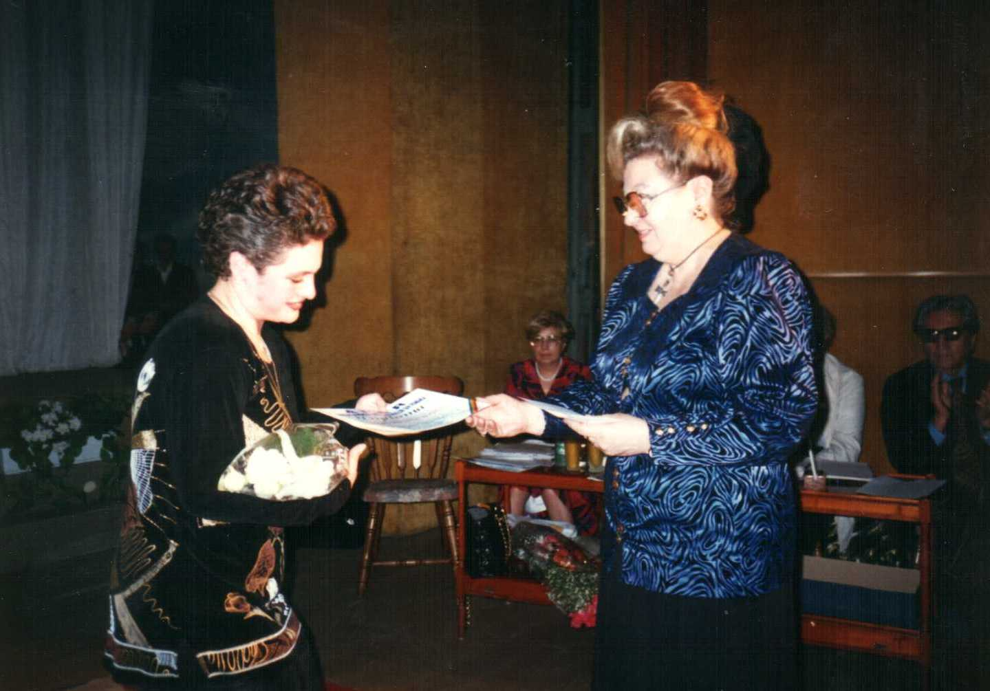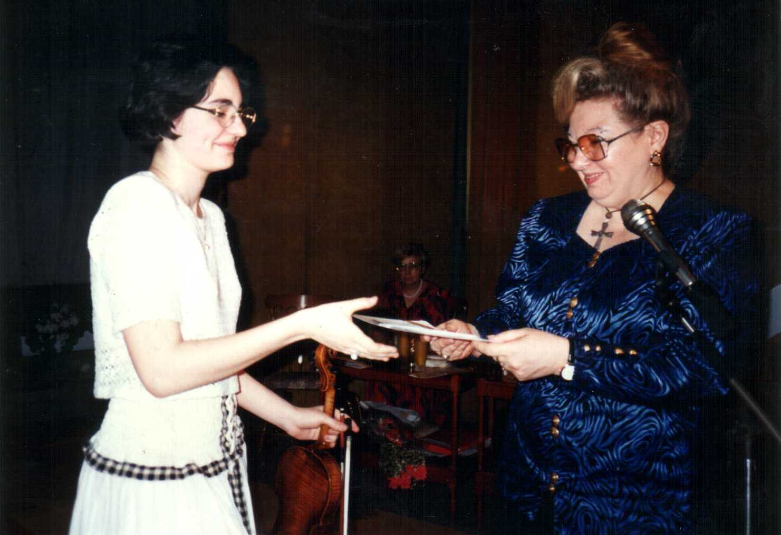

Were jury members, contestants or winners, as it shows in the pictures, the following: Conductor Izu Gott,
Rodica Xenia Constantin – plastic artist, conductor Carmen Stoica – Children Choir “Adventist Church the 7th day”, Mr. Parizescu Vasile – president of the art show jury, Serbu Ioan –Bahai Cult Representative, member of the musical jury of the Religious Creation Festival, Mrs. Mihaela Vozganian – member of the musical jury of the Religious Interpretation Festival, Mrs. Adalgiza Gealep and Mrs. Gabriele Manole Adoc – artist, Mr. Prof Univ. Peter Nicolas – Cluj Napoca city, Mr. Prof. Constantin Dumitru – Children’s Palace, Academician Mr. Alexandru Balaci, Festival Representative of the Religious Creation Contest – Mr. Valentin Ionescu, Yldiz Imdat – Moslem Cult, Aurelian Gugu Theology seminary Slobozia city, Mr. Popovici –Jury President and Mrs. Irina Odagescu, Elena Murnai Marta, Member of Parliament Mr. Pampuccian, Lucretia Craciun, Onisor Oana, Mihnea Anton Dragoi, Catana Maria, Pr. Constantin Dragusin, Crina Zancu.

October 1st 1997
26.- Ft. Univ. Prof. Mr. Galeriu Costache became President of Honor of the Foundation and proposed to change the name from “World Museum of Religions” in “Sacred Treasure of Religions ”Foundation. Marcela Ghiulbenghian is responsible with all the legal necessary steps.
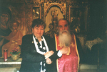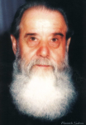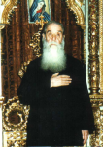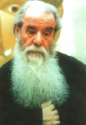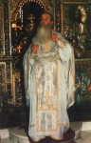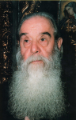
October 27th 1997
27.a.- The foundation "THE SACRED TREASURE OF RELIGIONS", which is a juridical person, was granted status through civil recognition nr.137 in October 27th 1997, of Courthouse of Sector 1 Bucharest.
27.b – President of the Foundation, Marcela Ghiulbenghian sponsored the Grigore Palama, Mr. Onu Constantin’s Foundation. Mrs. Marcela also baptized deaf-mute families educated by sign-language knowing teachers.

December 5th 1997
28.- The new A.P.A.R. seat was endowed and arranged in the Parochial House of the St.Stefan Church, Calea Calarasi nb. 83. Religions representatives and other Foundation members gathered to celebrate the inauguration, to discuss the opportunity and necessity of dialogue and cooperation between representatives of faiths. They established the organization of a religious creation festival.
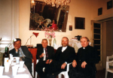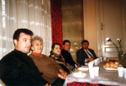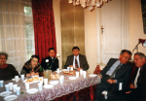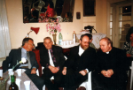

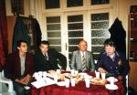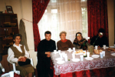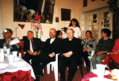

29.- In the second Sunday of December 1997, President of the Foundation, Marcela Ghiulbenghian and A.P.A.R. general secretary Ft. Univ. Prof. Dr. Alexandru I. Stan visited and blessed the nb.3 orphanage from Balta Alba and it’s children.
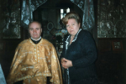

December 22nd 1997
30.- The Foundation offered Christmas gifts to the children and the stuff of nb.3 orphanage, and donated 10 million lei, radios, cassette players, clothes, food, etc.


